Git - Local Repository

commit hash

What is commit hash in Git?
# Source: AI Source: Provided by: [Data Path: Persons Table -> ID Column: 1, Name_En Column: Motasem Essam] -> From: [ChatGPT] on [2/19/2026]
A commit hash in Git is a unique identifier for a specific commit.
Think of it as the “ID card” for that commit. Every time you commit, Git generates a hash code (using SHA-1) that looks something like this:
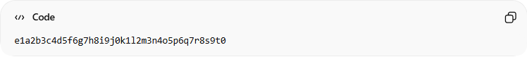
e1a2b3c4d5f6g7h8i9j0k1l2m3n4o5p6q7r8s9t0

Key Points
# Source: AI Source: Provided by: [Data Path: Persons Table -> ID Column: 1, Name_En Column: Motasem Essam] -> From: [ChatGPT] on [2/19/2026]
- Uniqueness – Every commit hash is (practically) guaranteed to be unique.
- Immutability – Once a commit is created, its hash never changes.
- Reference – You can use the hash to:
  - Checkout a commit:
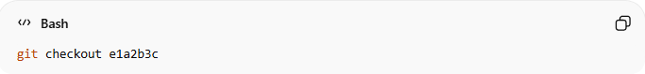
git checkout e1a2b3c
  - Reset to a commit:
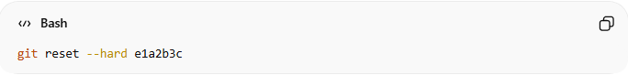
git reset --hard e1a2b3c
  - Compare changes between commits:
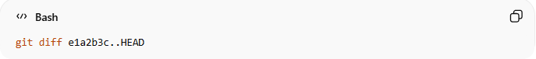
git diff e1a2b3c..HEAD

Why it’s useful
# Source: AI Source: Provided by: [Data Path: Persons Table -> ID Column: 1, Name_En Column: Motasem Essam] -> From: [ChatGPT] on [2/19/2026]
- You can go back in history to any specific point in your project.
- You can share exact commits with teammates or in pull requests.
- It ensures precise tracking of your project’s evolution.

Example in Git log:
# Source: AI Source: Provided by: [Data Path: Persons Table -> ID Column: 1, Name_En Column: Motasem Essam] -> From: [ChatGPT] on [2/19/2026]
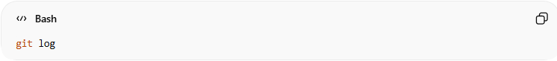
git log
Output:
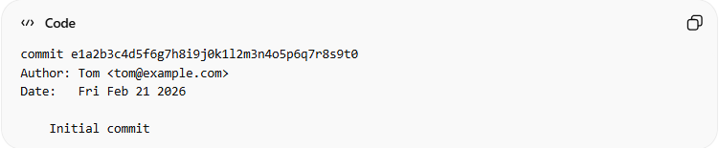
commit e1a2b3c4d5f6g7h8i9j0k1l2m3n4o5p6q7r8s9t0
Author: Tom <tom@example.com>
Date: Fri Feb 21 2026

Initial commit
Here, e1a2b3c… is the commit hash. You can use just the first 7–8 characters as a shorthand most of the time.

If you want, I can make a visual diagram showing commit hash and how commits link together in Git — it makes this concept very easy to remember.

HEAD~<number>

What is HEAD~<number> in Git?
# Source: AI Source: Provided by: [Data Path: Persons Table -> ID Column: 1, Name_En Column: Motasem Essam] -> From: [ChatGPT] on [2/19/2026]

HEAD~<number> is a way to Refer to a previous commit relative to where you are now.
- HEAD → points to your current commit, i.e., where you are in the branch right now.
- ~<number> → means “go back <number> commits from HEAD.”

HEAD~<number> can use any positive number, as long as that many commits exist behind HEAD.
There is no fixed maximum number. The maximum value depends entirely on: How many commits exist behind HEAD in the current branch history.

What it means
# Source: AI Source: Provided by: [Data Path: Persons Table -> ID Column: 1, Name_En Column: Motasem Essam] -> From: [ChatGPT] on [2/19/2026]
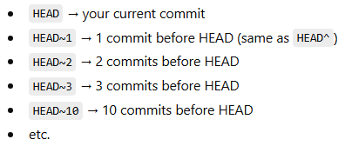
- HEAD → your current commit
- HEAD~1 → 1 commit before HEAD (same as HEAD^)
- HEAD~2 → 2 commits before HEAD
- HEAD~3 → 3 commits before HEAD
- HEAD~10 → 10 commits before HEAD
- etc.
So, the number can be anything like:
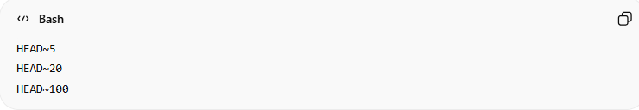
HEAD~5
HEAD~20
HEAD~100

Example
# Source: AI Source: Provided by: [Data Path: Persons Table -> ID Column: 1, Name_En Column: Motasem Essam] -> From: [ChatGPT] on [2/19/2026]
Suppose your branch history looks like this:
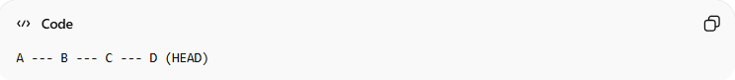
A --- B --- C --- D (HEAD)
- HEAD → D (current commit)
- HEAD~1 → C (one commit back)
- HEAD~2 → B (two commits back)
- HEAD~3 → A (three commits back)

Important limitation
# Source: AI Source: Provided by: [Data Path: Persons Table -> ID Column: 1, Name_En Column: Motasem Essam] -> From: [ChatGPT] on [2/19/2026]
It cannot exceed the number of commits available in the current branch history.
If you try something like:
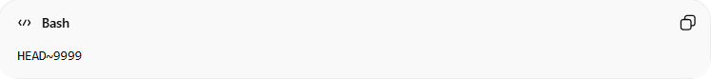
HEAD~9999
and there aren't that many commits, Git will error with something like:
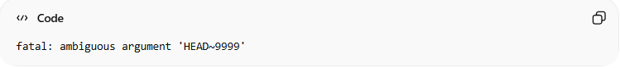
fatal: ambiguous argument 'HEAD~9999'

Small Detail: ~ vs ^
# Source: AI Source: Provided by: [Data Path: Persons Table -> ID Column: 1, Name_En Column: Motasem Essam] -> From: [ChatGPT] on [2/19/2026]
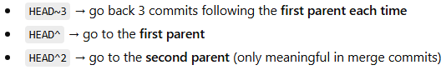
- HEAD~3 → go back 3 commits following the first parent each time
- HEAD^ → go to the first parent
- HEAD^2 → go to the second parent (only meaningful in merge commits)
For normal linear history, HEAD~3 and HEAD^^^ mean the same thing.

HEAD~<number> is used to refer to a commit in the past, relative to where you currently are.
In simple terms:
It lets you say “go back N commits from where I am now.”

What Is It Used For?
# Source: AI Source: Provided by: [Data Path: Persons Table -> ID Column: 1, Name_En Column: Motasem Essam] -> From: [ChatGPT] on [2/19/2026]
1️⃣ Interactive Rebase
Edit or clean up recent commits:
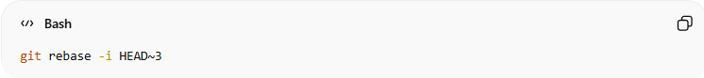
git rebase -i HEAD~3
→ Modify the last 3 commits.

2️⃣ Reset to an Older Commit
Move your branch backward:
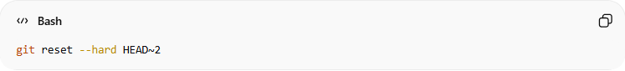
git reset --hard HEAD~2
→ Remove the last 2 commits.
= “Delete the last 2 commits and reset my project to that older state.”

3️⃣ Compare Changes
See what changed in recent commits:
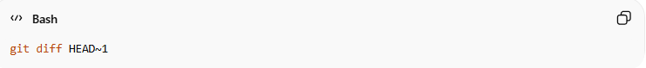
git diff HEAD~1
→ Compare current commit with the previous one.
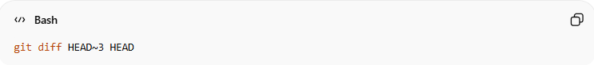
git diff HEAD~3 HEAD
→ See changes across last 3 commits.

4️⃣ Checkout an Older Commit
Temporarily move to a past commit:
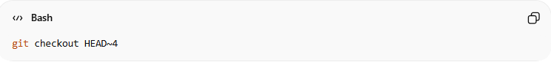
git checkout HEAD~4
→ View the project as it was 4 commits ago.
= “Show me the project exactly how it looked 4 commits ago.”
Nothing is deleted. You’re just viewing history.

5️⃣ Cherry-pick Relative Commits
Apply a recent commit somewhere else:
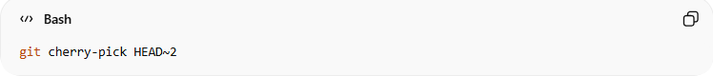
git cherry-pick HEAD~2
= “Take the changes from 2 commits ago and apply them again on top of where I am now I mean current branch.”

Why It’s Useful
# Source: AI Source: Provided by: [Data Path: Persons Table -> ID Column: 1, Name_En Column: Motasem Essam] -> From: [ChatGPT] on [2/19/2026]
Instead of remembering long commit hashes like:
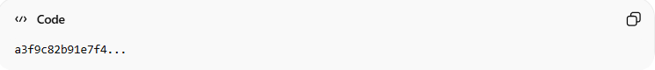
a3f9c82b91e7f4...
You can just say:
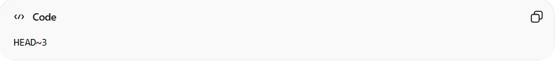
HEAD~3
Much easier and cleaner.

Simple Mental Model
# Source: AI Source: Provided by: [Data Path: Persons Table -> ID Column: 1, Name_En Column: Motasem Essam] -> From: [ChatGPT] on [2/19/2026]
Think of your commits like a stack:
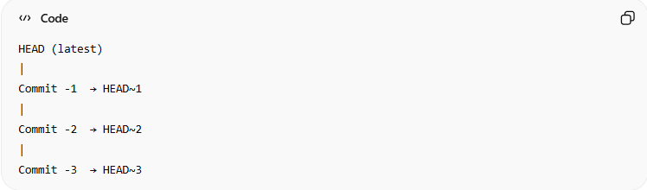
HEAD (latest)
|
Commit -1 → HEAD~1
|
Commit -2 → HEAD~2
|
Commit -3 → HEAD~3
It’s just a shortcut for navigating backward in history.

If you want, I can give a real-life workflow example (like cleaning up commits before pushing).

General rule
# Source: AI Source: Provided by: [Data Path: Persons Table -> ID Column: 1, Name_En Column: Motasem Essam] -> From: [ChatGPT] on [2/19/2026]
- branch~n → the commit that is n commits before the tip of the branch.
- HEAD~n → the commit that is n commits before the current commit (HEAD).
Example with numbers:
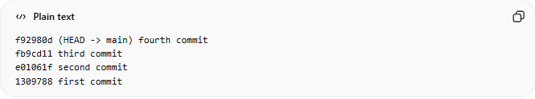
f92980d (HEAD -> main) fourth commit
fb9cd11 third commit
e01061f second commit
1309788 first commit
- HEAD or main → fourth commit (f92980d)
- HEAD~1 or main~1 → third commit (fb9cd11)
- HEAD~2 or main~2 → second commit (e01061f)
HEAD~3 or main~3 → first commit (1309788)

Interactive Rebase

What is Interactive Rebase?
# Source: AI Source: Provided by: [Data Path: Persons Table -> ID Column: 1, Name_En Column: Motasem Essam] -> From: [ChatGPT] on [2/19/2026]
Interactive rebase is a Git feature that lets you edit, reorganize, combine, or delete commits before finalizing your branch history.
You run it like this:
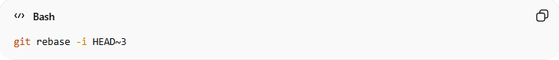
git rebase -i HEAD~3

If you want to rebase all commits starting from the first commit, use:
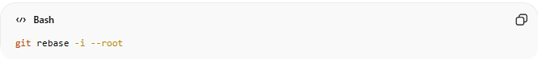
git rebase -i --root
This allows you to interactively rebase starting from the very first commit.

That means:
“Let me modify the last 3 commits.”
Git opens an editor showing something like:
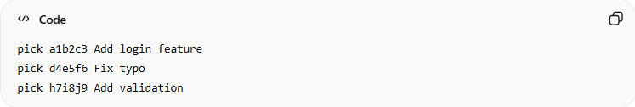
pick a1b2c3 Add login feature
pick d4e5f6 Fix typo
pick h7i8j9 Add validation
You can then change what happens to each commit.

What Is It Used For?
# Source: AI Source: Provided by: [Data Path: Persons Table -> ID Column: 1, Name_En Column: Motasem Essam] -> From: [ChatGPT] on [2/19/2026]
Interactive rebase is mainly used to clean up commit history before sharing code.
Here’s what you can do:

1️⃣ Combine Multiple Commits (Squash)
If you made:
- Commit 1 – Add feature
- Commit 2 – Fix bug
- Commit 3 – Fix small typo
You can squash them into one clean commit:
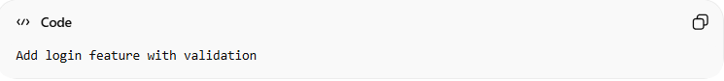
Add login feature with validation

2️⃣ Edit a Commit
You can:
- Change its content
- Add/remove files
- Modify code

3️⃣ Change Commit Messages
Example:
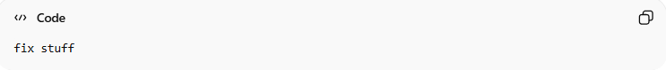
fix stuff
Can become:
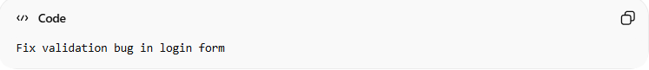
Fix validation bug in login form

4️⃣ Delete a Commit
If you accidentally committed debug code, you can remove it.

5️⃣ Reorder Commits
You can change the order if needed.

Why Developers Use It
# Source: AI Source: Provided by: [Data Path: Persons Table -> ID Column: 1, Name_En Column: Motasem Essam] -> From: [ChatGPT] on [2/19/2026]
Before pushing to a shared branch, developers often:
- Clean messy commits
- Remove “temporary” commits
- Create meaningful commit history
- Make code review easier
A clean history looks professional and is easier to understand later.

⚠ Important Warning
# Source: AI Source: Provided by: [Data Path: Persons Table -> ID Column: 1, Name_En Column: Motasem Essam] -> From: [ChatGPT] on [2/19/2026]
Interactive rebase rewrites history.
That means:
- Safe for local branches
- Be careful if already pushed
- Never casually rebase shared branches

Simple Analogy
# Source: AI Source: Provided by: [Data Path: Persons Table -> ID Column: 1, Name_En Column: Motasem Essam] -> From: [ChatGPT] on [2/19/2026]
Think of interactive rebase like editing your draft before submitting an assignment.
You rearrange paragraphs, fix mistakes, and combine ideas — then submit the final clean version.

Common Interactive Rebase Commands
# Source: AI Source: Provided by: [Data Path: Persons Table -> ID Column: 1, Name_En Column: Motasem Essam] -> From: [ChatGPT] on [2/19/2026]
- pick → Keep the commit as is
- reword → Change the commit message
- edit → Modify the commit’s contents
- squash → Combine with previous commit (keep both messages)
- fixup → Combine with previous commit (discard this message)
- drop → Delete the commit

Absolutely! Let’s go commit by commit and break down each interactive rebase command with what it is, what it’s used for, and a full example.

Common Interactive Rebase Commands
You typically start interactive rebase with:
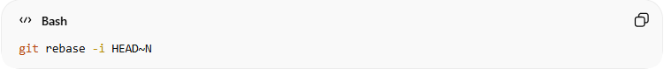
git rebase -i HEAD~N
Where N is the number of commits you want to edit. This opens a list of recent commits in an editor.

1️⃣ pick
# Source: AI Source: Provided by: [Data Path: Persons Table -> ID Column: 1, Name_En Column: Motasem Essam] -> From: [ChatGPT] on [2/19/2026]
- What it is: Keep the commit exactly as it is.
- What it’s used for: Use this for commits you don’t want to change during the rebase.
- Example:
Suppose your interactive rebase editor shows:
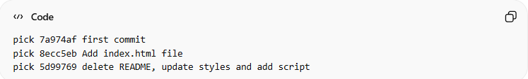
pick 7a974af first commit
pick 8ecc5eb Add index.html file
pick 5d99769 delete README, update styles and add script
pick means commit will remain unchanged.
No extra action is needed — just leave pick in front of the commit.

2️⃣ reword
# Source: AI Source: Provided by: [Data Path: Persons Table -> ID Column: 1, Name_En Column: Motasem Essam] -> From: [ChatGPT] on [2/19/2026]
- What it is: Keep the commit contents the same but change the commit message.
- What it’s used for: Correct typos, clarify commit messages, or follow message conventions.
- Example:
Interactive rebase editor:
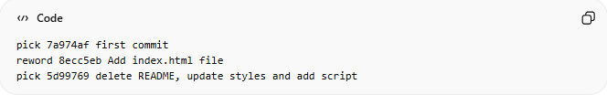
pick 7a974af first commit
reword 8ecc5eb Add index.html file
pick 5d99769 delete README, update styles and add script
After you save, Git will open a prompt to edit the commit message for 8ecc5eb.
You could change it to:
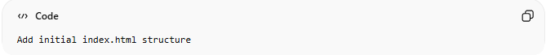
Add initial index.html structure

3️⃣ edit
# Source: AI Source: Provided by: [Data Path: Persons Table -> ID Column: 1, Name_En Column: Motasem Essam] -> From: [ChatGPT] on [2/19/2026]
- What it is: Pause at this commit so you can modify the files in it.
- What it’s used for: Add/remove changes, fix code, or adjust files in a commit.
- Example:
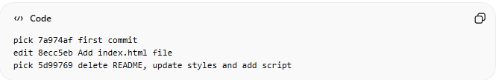
pick 7a974af first commit
edit 8ecc5eb Add index.html file
pick 5d99769 delete README, update styles and add script
Steps:
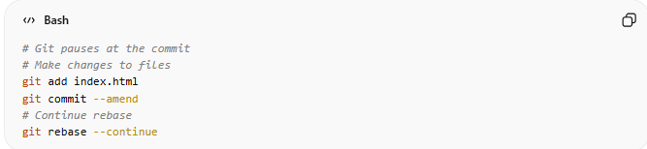
# Git pauses at the commit
# Make changes to files
git add index.html
git commit --amend
# Continue rebase
git rebase --continue

4️⃣ squash
# Source: AI Source: Provided by: [Data Path: Persons Table -> ID Column: 1, Name_En Column: Motasem Essam] -> From: [ChatGPT] on [2/19/2026]
- What it is: Combine this commit with the previous commit, keeping both commit messages.
- What it’s used for: Merge small commits into one for a cleaner history.
- Example:
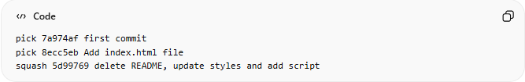
pick 7a974af first commit
pick 8ecc5eb Add index.html file
squash 5d99769 delete README, update styles and add script
Git will open an editor showing both messages:
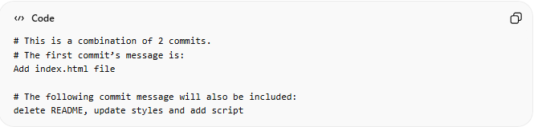
# This is a combination of 2 commits.
# The first commit’s message is:
Add index.html file

# The following commit message will also be included:
delete README, update styles and add script
You can edit the messages into one clean commit message:
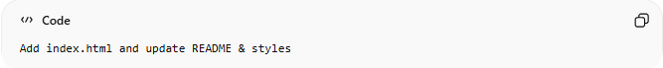
Add index.html and update README & styles

5️⃣ fixup
# Source: AI Source: Provided by: [Data Path: Persons Table -> ID Column: 1, Name_En Column: Motasem Essam] -> From: [ChatGPT] on [2/19/2026]
- What it is: Combine this commit with the previous commit, discarding this commit’s message.
- What it’s used for: Make minor corrections to a previous commit without cluttering the history.
- Example:
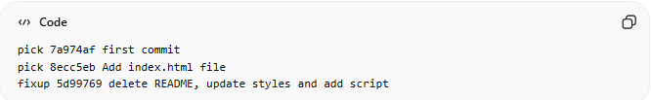
pick 7a974af first commit
pick 8ecc5eb Add index.html file
fixup 5d99769 delete README, update styles and add script
Git will merge the changes from 5d99769 into 8ecc5eb but keep only the message from 8ecc5eb.
Useful for tiny fixes, like formatting or typos.

6️⃣ drop
# Source: AI Source: Provided by: [Data Path: Persons Table -> ID Column: 1, Name_En Column: Motasem Essam] -> From: [ChatGPT] on [2/19/2026]
- What it is: Completely delete this commit from history.
- What it’s used for: Remove unnecessary commits, mistakes, or accidental files.
- Example:
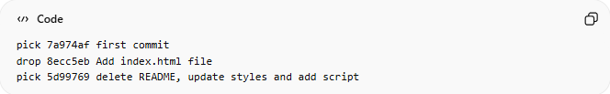
pick 7a974af first commit
drop 8ecc5eb Add index.html file
pick 5d99769 delete README, update styles and add script
After rebase, the commit 8ecc5eb will no longer exist in the history.

✅ Quick Reference Table
# Source: AI Source: Provided by: [Data Path: Persons Table -> ID Column: 1, Name_En Column: Motasem Essam] -> From: [ChatGPT] on [2/19/2026]
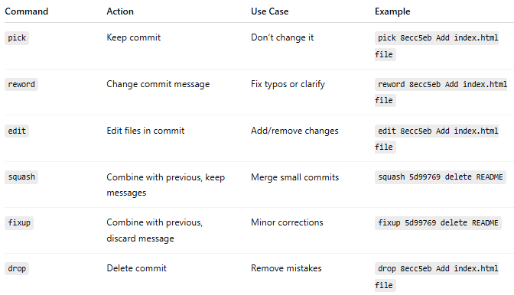
Command | Action | Use Case | Example
pick | Keep commit | Don’t change it | pick 8ecc5eb Add index.html file
reword | Change commit message | Fix typos or clarify | reword 8ecc5eb Add index.html file
edit | Edit files in commit | Add/remove changes | edit 8ecc5eb Add index.html file
squash | Combine with previous, keep messages | Merge small commits | squash 5d99769 delete README
fixup | Combine with previous, discard message | Minor corrections | fixup 5d99769 delete README
drop | Delete commit | Remove mistakes | drop 8ecc5eb Add index.html file

history of commits

what is git log
# Source: AI Source: Provided by: [Data Path: Persons Table -> ID Column: 1, Name_En Column: Motasem Essam] -> From: [ChatGPT] on [2/19/2026]
The command git log shows you the history of commits in your repository.
Think of it as Git’s timeline of changes.

When you run:
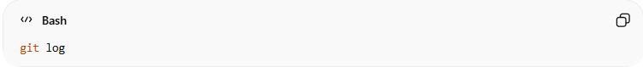
git log

What it does
Git displays a list of commits, typically showing for each commit:
- Commit hash – the unique ID of the commit
- Author – who made the commit
- Date – when it was made
- Commit message – the description of the changes

Example:
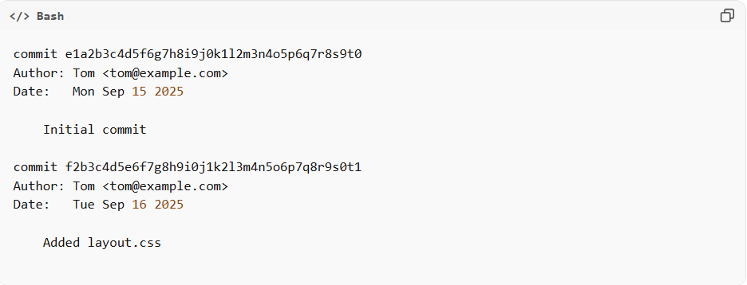
commit e1a2b3c4d5f6g7h8i9j0k1l2m3n4o5p6q7r8s9t0
Author: Tom <tom@example.com>
Date: Mon Sep 15 2025

Initial commit

commit f2b3c4d5e6f7g8h9i0j1k2l3m4n5o6p7q8r9s0t1
Author: Tom <tom@example.com>
Date: Tue Sep 16 2025

Added layout.css

Why it’s useful
- See the history of your project
- Find commit hashes to checkout or revert to a specific commit
- Track who made what changes and when

One-line per commit
# Source: AI Source: Provided by: [Data Path: Persons Table -> ID Column: 1, Name_En Column: Motasem Essam] -> From: [ChatGPT] on [2/19/2026]
is a shortcut version of git log that shows your commit history in a compact, single-line format per commit.

Syntax
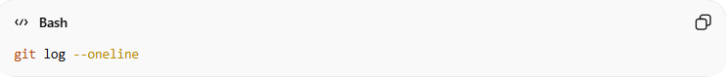
git log --oneline

Example output:
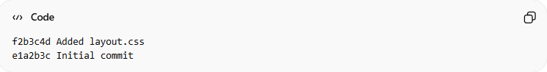
f2b3c4d Added layout.css
e1a2b3c Initial commit

What it does
- Shows only the first 7–8 characters of the commit hash (shorthand)
- Shows the commit message on the same line
- Makes it easy to read long histories quickly

Example
git log:
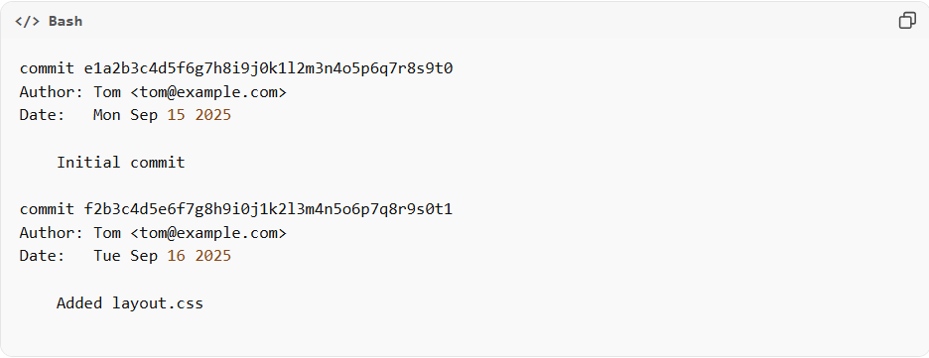
commit e1a2b3c4d5f6g7h8i9j0k1l2m3n4o5p6q7r8s9t0
Author: Tom <tom@example.com>
Date: Mon Sep 15 2025

Initial commit

commit f2b3c4d5e6f7g8h9i0j1k2l3m4n5o6p7q8r9s0t1
Author: Tom <tom@example.com>
Date: Tue Sep 16 2025

Added layout.css
git log --oneline:
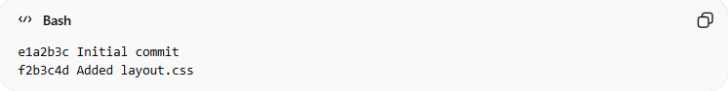
e1a2b3c Initial commit
f2b3c4d Added layout.css

Why it’s useful
- Quick overview of all commits
- Easier to copy commit hashes
- Great when you just need a summary instead of full details

Optional Add-ons
- Limit number of commits:
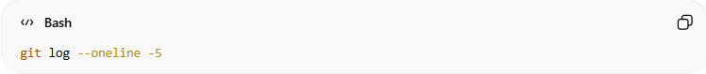
git log --oneline -5

What it does:
- Shows only the last 5 commits in the repository
- Combines --oneline (compact view) with -5 (limit to 5 commits)
This shows only the last 5 commits.

Example output:
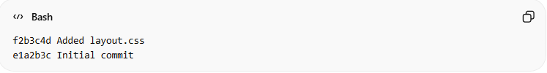
f2b3c4d Added layout.css
e1a2b3c Initial commit
You can change -5 to any number to see more or fewer recent commits.

- Graph view (shows branch structure):
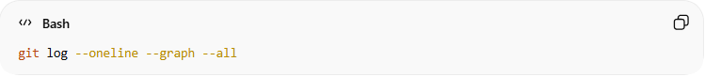
git log --oneline --graph –all
What it does:
- --oneline → shows each commit in one line (short hash + message)
- --graph → adds a visual ASCII graph for branches/merges
- --all → shows all branches (in this case, you only have main)

Example output:
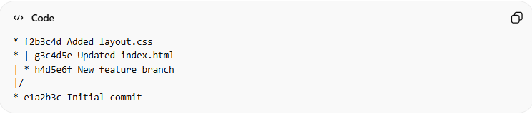
* f2b3c4d Added layout.css
* | g3c4d5e Updated index.html
| * h4d5e6f New feature branch
|/
* e1a2b3c Initial commit

Show history for a specific file
# Source: AI Source: Provided by: [Data Path: Persons Table -> ID Column: 1, Name_En Column: Motasem Essam] -> From: [ChatGPT] on [2/19/2026]
shows the commit history for a specific file — in this case, index.html.

Syntax
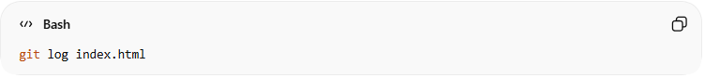
git log index.html

What it does
- Only lists commits that affected index.html
- Shows for each commit:
  - Commit hash
  - Author
  - Date
  - Commit message

Example
Suppose your project has these commits:
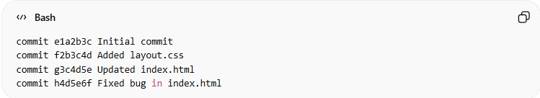
commit e1a2b3c Initial commit
commit f2b3c4d Added layout.css
commit g3c4d5e Updated index.html
commit h4d5e6f Fixed bug in index.html

If you run:
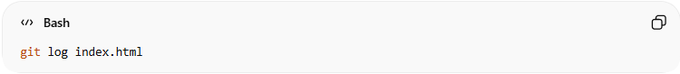
git log index.html

You would see only the commits that changed index.html:
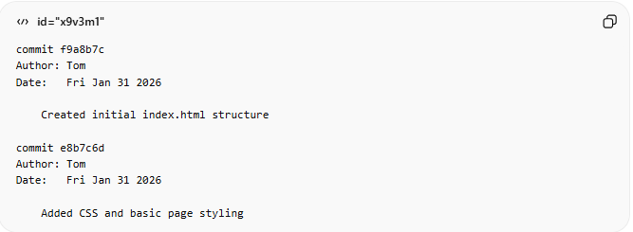
commit f9a8b7c
Author: Tom
Date: Fri Jan 31 2026

Created initial index.html structure

commit e8b7c6d
Author: Tom
Date: Fri Jan 31 2026

Added CSS and basic page styling

Fixed bug in index.html

Why it’s useful
- Track the history of a single file
- See who changed it and when
- Debug when a bug or change was introduced in a specific file

💡 Tip: Use q to exit the log view when it fills your terminal.

Example

1-git log
# Source: ScreenShots Source: Provided by: [Persons Table -> ID Column: 1, Name_En Column: Motasem Essam] -> Tool: [Lightshot Program] -> From [Operating System: Windows] on [2/19/2026]
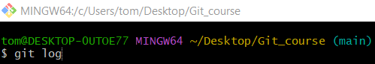
git log
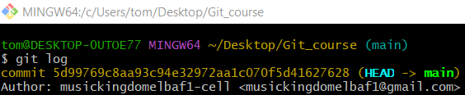

2- git log --oneline
# Source: ScreenShots Source: Provided by: [Persons Table -> ID Column: 1, Name_En Column: Motasem Essam] -> Tool: [Lightshot Program] -> From [Operating System: Windows] on [2/19/2026]
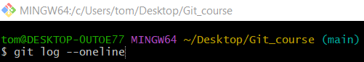
git log --oneline
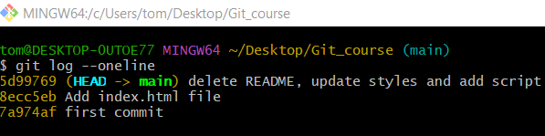

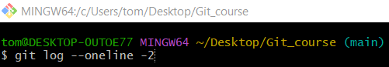
git log --oneline -2
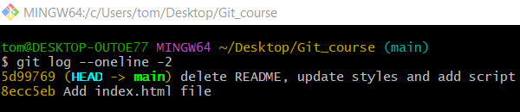

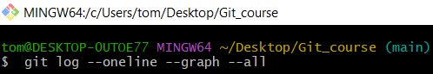
git log --oneline --graph --all
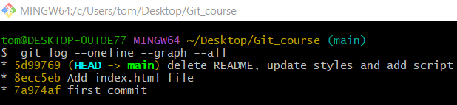

3- Show history for a specific file
# Source: ScreenShots Source: Provided by: [Persons Table -> ID Column: 1, Name_En Column: Motasem Essam] -> Tool: [Lightshot Program] -> From [Operating System: Windows] on [2/19/2026]
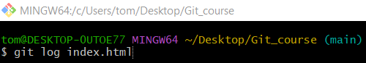
git log index.html
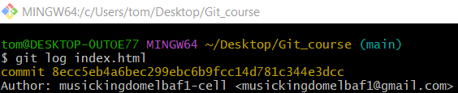

From staging to Local repository
# Source: AI Source: Provided by: [Data Path: Persons Table -> ID Column: 1, Name_En Column: Motasem Essam] -> From: [ChatGPT] on [2/19/2026]
Got it! You want to move changes from staging to your local repository — in Git terms, that means committing staged changes. Let’s go step by step.

Check staged changes
# Source: AI Source: Provided by: [Data Path: Persons Table -> ID Column: 1, Name_En Column: Motasem Essam] -> From: [ChatGPT] on [2/19/2026]
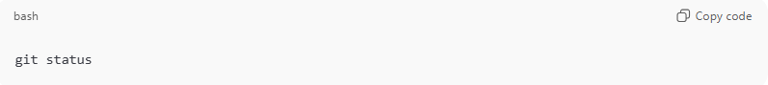
git status
You’ll see files under:
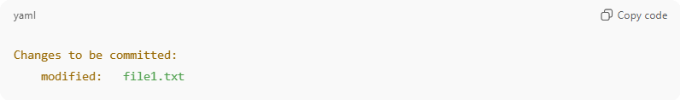
Changes to be committed:
modified: file1.txt
These are staged and ready to be committed.

Commit staged changes to local repository
# Source: AI Source: Provided by: [Data Path: Persons Table -> ID Column: 1, Name_En Column: Motasem Essam] -> From: [ChatGPT] on [2/19/2026]
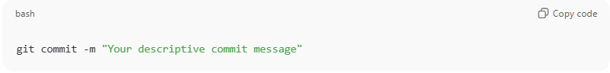
git commit -m "Your descriptive commit message"
- -m allows you to add a message describing your changes.
- After this, the changes move from staging to your local repository (they are saved in Git’s history but not yet on GitHub).
Example:
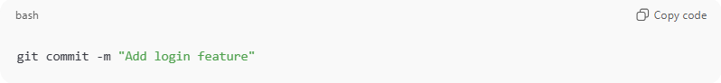
git commit -m "Add login feature"

Verify commit
# Source: AI Source: Provided by: [Data Path: Persons Table -> ID Column: 1, Name_En Column: Motasem Essam] -> From: [ChatGPT] on [2/19/2026]
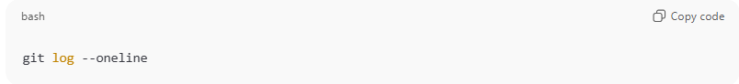
git log --oneline

What you’ll see:
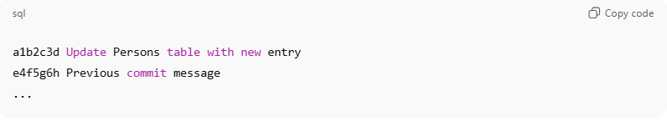
a1b2c3d Update Persons table with new entry
e4f5g6h Previous commit message
...

- The latest commit is at the top.
- Each line shows the commit hash and the message.
- This confirms your changes are now safely in your local repository.
You should see your latest commit at the top, meaning it’s now safely in your local repository.

Example

Check staged changes
# Source: ScreenShots Source: Provided by: [Persons Table -> ID Column: 1, Name_En Column: Motasem Essam] -> Tool: [Lightshot Program] -> From [Operating System: Windows] on [2/19/2026]
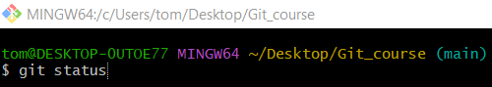
git status
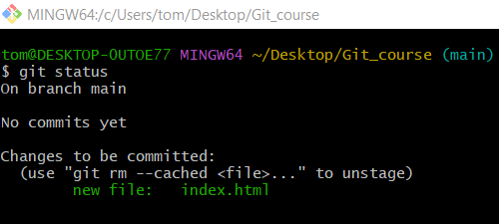

Commit staged changes to local repository
# Source: ScreenShots Source: Provided by: [Persons Table -> ID Column: 1, Name_En Column: Motasem Essam] -> Tool: [Lightshot Program] -> From [Operating System: Windows] on [2/19/2026]
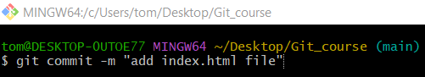
git commit -m "add index.html file"
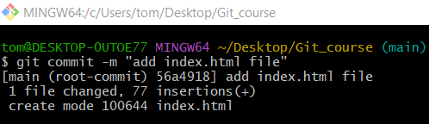

Verify commit
# Source: ScreenShots Source: Provided by: [Persons Table -> ID Column: 1, Name_En Column: Motasem Essam] -> Tool: [Lightshot Program] -> From [Operating System: Windows] on [2/19/2026]
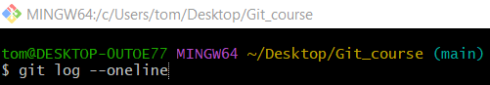
git log --oneline
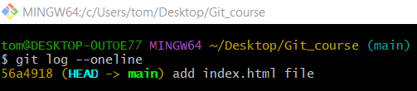

From Workspace to Local repository
# Source: AI Source: Provided by: [Data Path: Persons Table -> ID Column: 1, Name_En Column: Motasem Essam] -> From: [ChatGPT] on [2/19/2026]
Sure! Here’s a clean, concise guide for “From Workspace → Local Repository”, including all the different ways to do it, with commands in one line where possible.

Stage Changes and Commit (Standard Way)
# Source: AI Source: Provided by: [Data Path: Persons Table -> ID Column: 1, Name_En Column: Motasem Essam] -> From: [ChatGPT] on [2/19/2026]
git add <file_name>
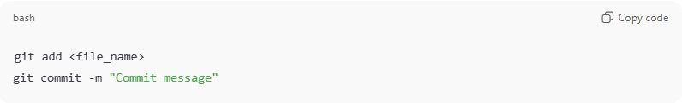
git commit -m "Commit message"
Example:
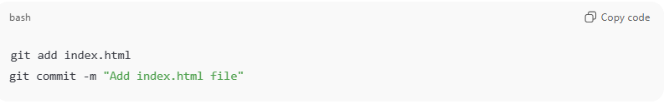
git add index.html
git commit -m "Add index.html file"
- Moves changes from workspace → staging → local repository.
- You can stage multiple files at once:
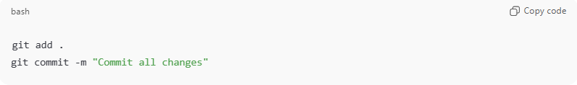
git add .
git commit -m "Commit all changes"

One-Line Commit (Tracked Files Only)

Option 1 - Tracked Modified and Deleted Files Only
# Source: AI Source: Provided by: [Data Path: Persons Table -> ID Column: 1, Name_En Column: Motasem Essam] -> From: [ChatGPT] on [2/19/2026]
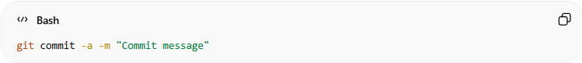
git commit -a -m "Commit message"
or equivalently:
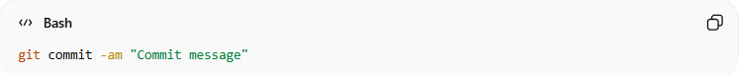
git commit -am "Commit message"
What it does:
- Automatically stages all modified and deleted tracked files not.
- Does not include new untracked files.
- Shortcut for git add + git commit for tracked files.

Example:
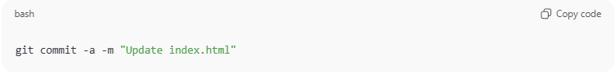
git commit -a -m "Update index.html"

Option 2 - Commit All Files (New, Modified, Deleted)
# Source: AI Source: Provided by: [Data Path: Persons Table -> ID Column: 1, Name_En Column: Motasem Essam] -> From: [ChatGPT] on [2/19/2026]
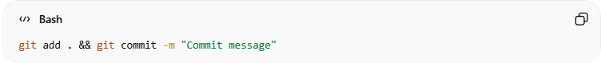
git add . && git commit -m "Commit message"
What it does:
- ✔ Adds new (untracked) files
- ✔ Stages modified files
- ✔ Stages deleted files
- Works in all situations
Example:
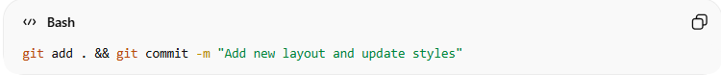
git add . && git commit -m "Add new layout and update styles"

Use when:
You want a one-step command that works every time, no matter the file status.

Verify Changes
# Source: AI Source: Provided by: [Data Path: Persons Table -> ID Column: 1, Name_En Column: Motasem Essam] -> From: [ChatGPT] on [2/19/2026]
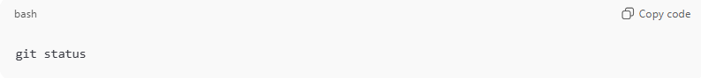
git status
- Shows which files are staged and which are still in the workspace.
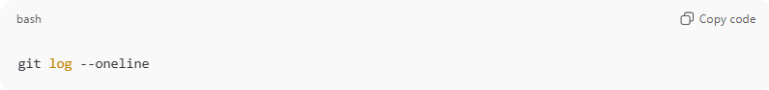
git log --oneline
- Shows your commit history in the local repository.

Summary of Commands
# Source: AI Source: Provided by: [Data Path: Persons Table -> ID Column: 1, Name_En Column: Motasem Essam] -> From: [ChatGPT] on [2/19/2026]
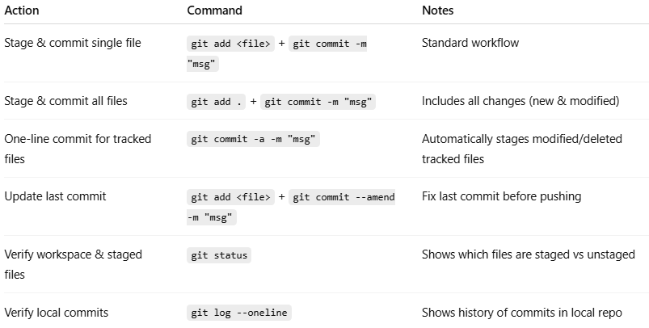
Action | Command | Notes
Stage & commit single file | git add <file> + git commit -m "msg" | Standard workflow
Stage & commit all files | git add . + git commit -m "msg" | Includes all changes (new & modified)
One-line commit for tracked files | git commit -a -m "msg" | Automatically stages modified/deleted tracked files
Update last commit | git add <file> + git commit --amend -m "msg" | Fix last commit before pushing
Verify workspace & staged files | git status | Shows which files are staged vs unstaged
Verify local commits | git log --oneline | Shows history of commits in local repo

💡 Tip:
- Use git commit -a for quick commits of tracked files.
- Use git add . if you have new files that need to be included.
For small fixes after committing, --amend keeps your history clean.

Example

Stage Changes and Commit
# Source: ScreenShots Source: Provided by: [Persons Table -> ID Column: 1, Name_En Column: Motasem Essam] -> Tool: [Lightshot Program] -> From [Operating System: Windows] on [2/19/2026]
Add two new files
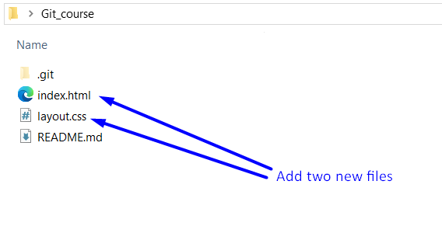
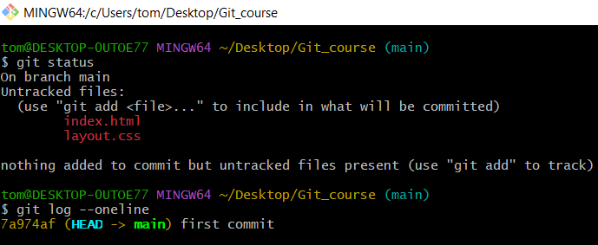
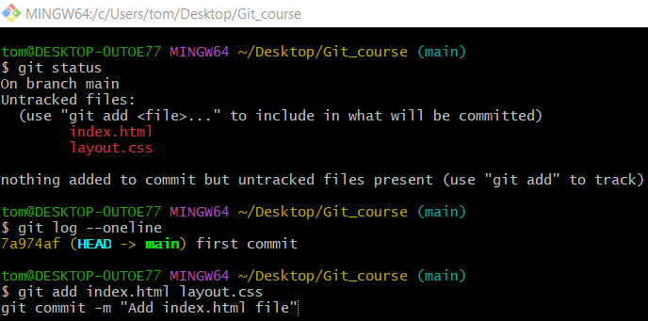
git add index.html layout.css
git commit -m "Add index.html file"
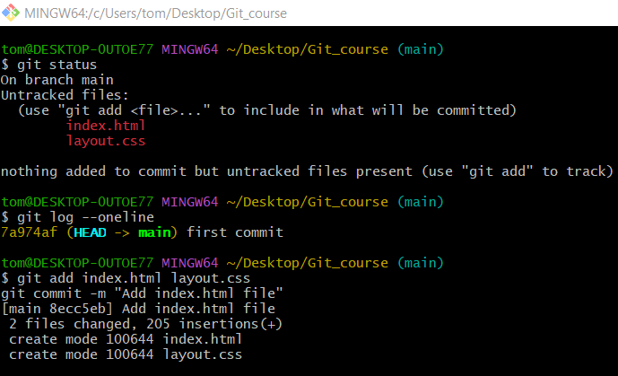
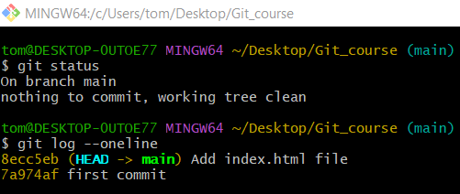

One-Line Commit (Tracked Files Only)

Option 1 - Tracked Modified and Deleted Files Only
# Source: ScreenShots Source: Provided by: [Persons Table -> ID Column: 1, Name_En Column: Motasem Essam] -> Tool: [Lightshot Program] -> From [Operating System: Windows] on [2/19/2026]
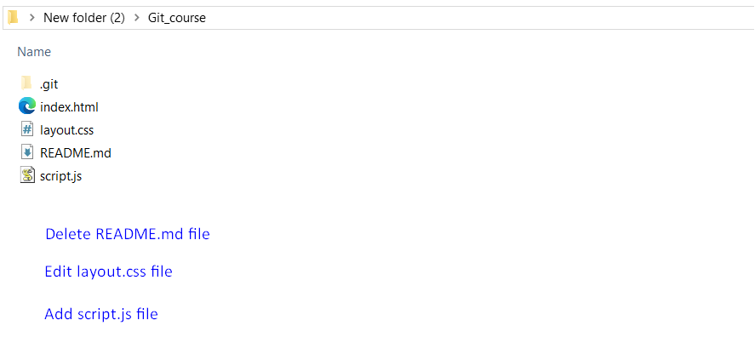
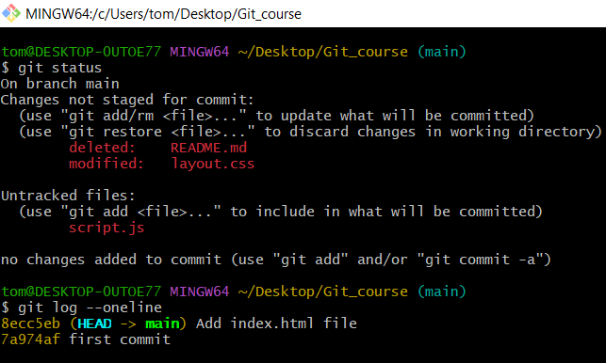
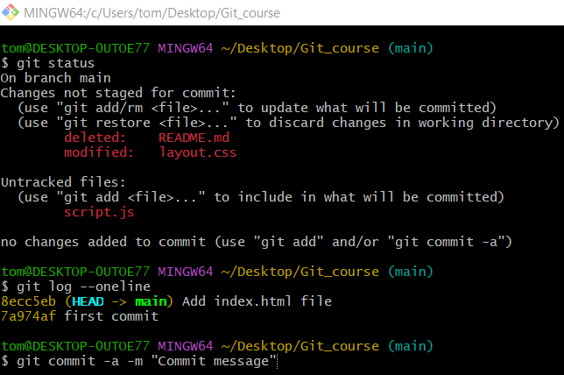
git commit -a -m "Commit message"
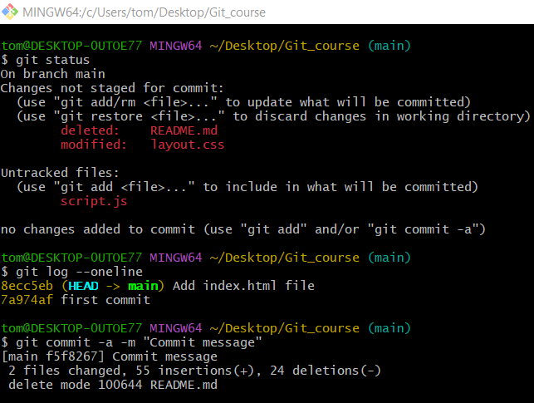
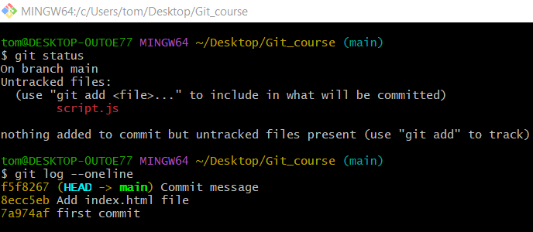

Option 2 - Commit All Files (New, Modified, Deleted)
# Source: AI Source: Provided by: [Data Path: Persons Table -> ID Column: 1, Name_En Column: Motasem Essam] -> From: [ChatGPT] on [2/19/2026]
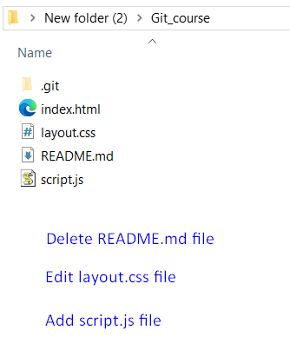
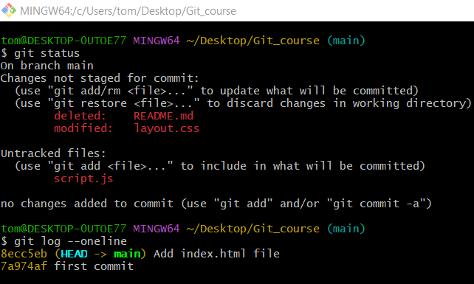
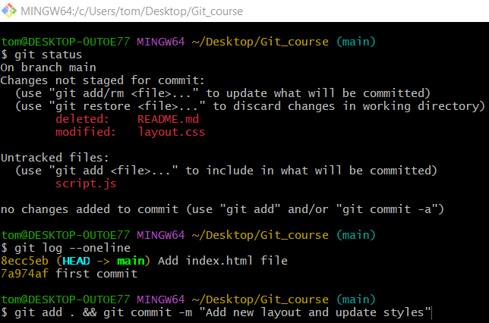
git add . && git commit -m "delete README, update styles and add script"
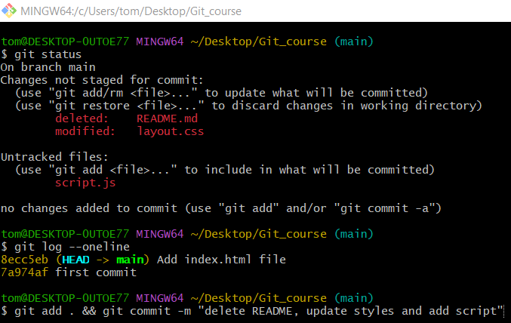
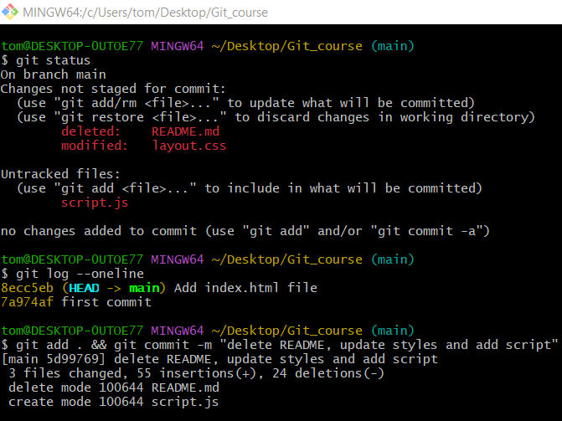

Verify Changes
# Source: ScreenShots Source: Provided by: [Persons Table -> ID Column: 1, Name_En Column: Motasem Essam] -> Tool: [Lightshot Program] -> From [Operating System: Windows] on [2/19/2026]
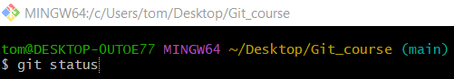
git status
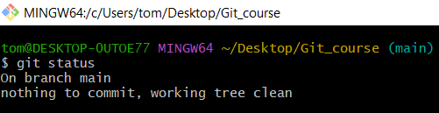
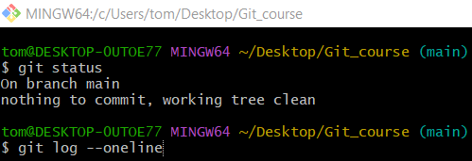
git log --oneline
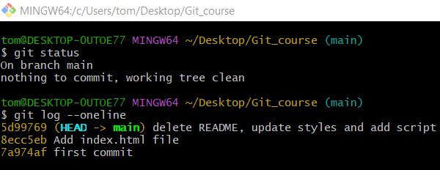

From Local repository to staging and workspace
# Source: AI Source: Provided by: [Data Path: Persons Table -> ID Column: 1, Name_En Column: Motasem Essam] -> From: [ChatGPT] on [2/19/2026]
Ah! You want to move changes from your local repository back to the staging area. In Git terms, this involves undoing a commit so you can edit, add, delete, or re-stage its changes. Let’s go through the process step by step.

Check commit history
# Source: AI Source: Provided by: [Data Path: Persons Table -> ID Column: 1, Name_En Column: Motasem Essam] -> From: [ChatGPT] on [2/19/2026]
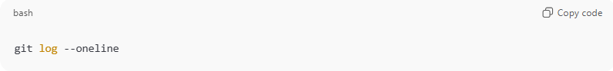
git log --oneline
Example output:
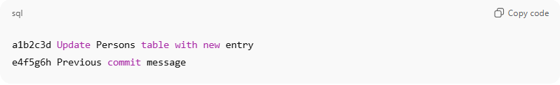
a1b2c3d Update Persons table with new entry
e4f5g6h Previous commit message
- Identify the commit you want to move back to staging.
- Note the commit hash (e.g., a1b2c3d).

Managing and Modifying Git Commits

Update commits

Method 1: Update the most recent commit
# Source: AI Source: Provided by: [Data Path: Persons Table -> ID Column: 1, Name_En Column: Motasem Essam] -> From: [ChatGPT] on [2/19/2026]
The amend case is when you want to update the most recent commit instead of creating a new one. This is useful in situations like:
- Forgot to add a file before committing.
- Need to change the commit message.
- Working in a single-commit repository, like the first commit in a new project.

Option 1: Amend and change the commit message
# Source: AI Source: Provided by: [Data Path: Persons Table -> ID Column: 1, Name_En Column: Motasem Essam] -> From: [ChatGPT] on [2/19/2026]
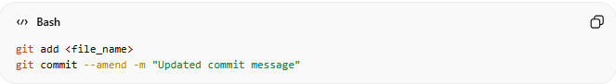
git add <file_name>
git commit --amend -m "Updated commit message"
Explanation:
- --amend → updates the most recent commit with the staged changes
- -m "message" → changes the commit message
- The commit hash will change because Git creates a new commit replacing the old one
Use Cases:
- First commit in a repo (no parent)
- Forgot to stage some files before committing
- Want to fix or clarify the commit message

Option 2: Amend without changing the commit message
# Source: AI Source: Provided by: [Data Path: Persons Table -> ID Column: 1, Name_En Column: Motasem Essam] -> From: [ChatGPT] on [2/19/2026]
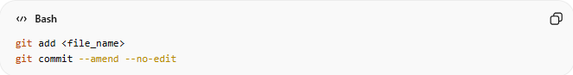
git add <file_name>
git commit --amend --no-edit
Explanation:
- --amend → updates the most recent commit with the staged changes
- --no-edit → keeps the existing commit message intact
- The commit hash will still change because Git replaces the old commit
Use Cases:
- Quickly add a forgotten file or fix small changes in the last commit
- Keep the original commit message exactly as it was
- Avoid opening the editor during amend

💡 Tips
- --amend is for fixing mistakes in the last commit, whether you have one commit or multiple
- For older commits, use interactive rebase:
git rebase -i HEAD~N
- After amending, if the commit has already been pushed, you may need to force push:
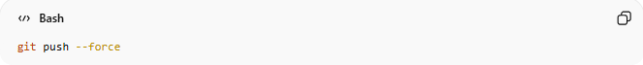
git push --force

If you want, I can make a small visual workflow showing Option 1 vs Option 2, which makes it very clear when to use -m vs --no-edit.
Do you want me to make that diagram?

Method 2: Update Older Commits
# Source: AI Source: Provided by: [Data Path: Persons Table -> ID Column: 1, Name_En Column: Motasem Essam] -> From: [ChatGPT] on [2/19/2026]
- git commit --amend can only change the last commit.
- If you want to edit a commit that is not the most recent, you use interactive rebase.
- Interactive rebase lets you rewrite commit history safely before pushing.

What Rebase Does
# Source: AI Source: Provided by: [Data Path: Persons Table -> ID Column: 1, Name_En Column: Motasem Essam] -> From: [ChatGPT] on [2/19/2026]
- Rebase moves commits – it temporarily removes the commits starting from the parent of the one you want to edit.
- Pauses at the commit you want to change – you can modify files and stage changes.
- Amends the paused commit – you update its content or message.
- Re-applies the later commits – after editing, Git “replays” the remaining commits on top of the amended commit.
Effect:
- The commit you edited is replaced with a new commit.
- Later commits are replayed with new commit hashes.
- Earlier commits (before the commit you edited) remain unchanged.
- Overall, history is rewritten for the commits you touched.

Step-by-Step
# Source: AI Source: Provided by: [Data Path: Persons Table -> ID Column: 1, Name_En Column: Motasem Essam] -> From: [ChatGPT] on [2/19/2026]
There are two options
Option A — Change only commit message
Option B — Modify files and/or message

Option 1: Modify files and/or message
# Source: AI Source: Provided by: [Data Path: Persons Table -> ID Column: 1, Name_En Column: Motasem Essam] -> From: [ChatGPT] on [2/19/2026]
Suppose your history:
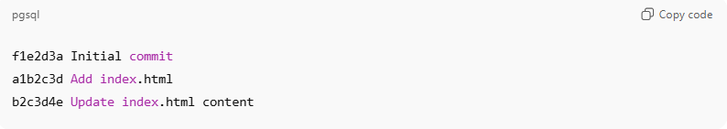
f1e2d3a Initial commit
a1b2c3d Add index.html
b2c3d4e Update index.html content

You want to edit a1b2c3d (not the last commit).
- Start interactive rebase from its parent:
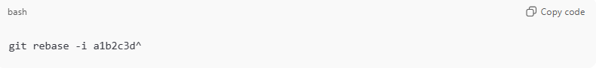
git rebase -i a1b2c3d^
- Choose what you want to modify in the commit:
✅ What exactly do you mean by "modifying"?
You are modifying the commit a1b2c3d — for example:
- Fix a mistake in the file(s) added in that commit
- Add something you forgot to include
- Remove something that shouldn’t be there
Change the commit message (optional)
In the editor that opens, change:
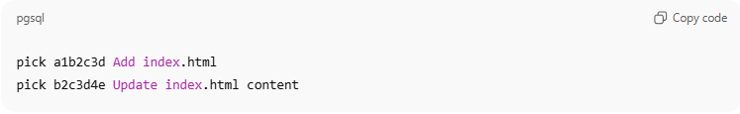
pick a1b2c3d Add index.html
pick b2c3d4e Update index.html content
to:
Option B — Modify files and/or message
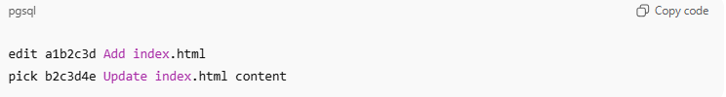
edit a1b2c3d Add index.html
pick b2c3d4e Update index.html content
- Save and close editor. Git pauses at the commit.
- Make changes in the workspace.
- Stage changes:
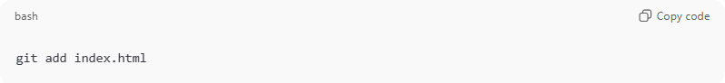
git add index.html
- Amend the commit:
Option A — Modify files without change commit message
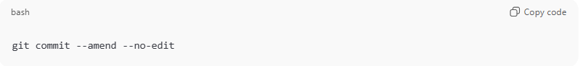
git commit --amend --no-edit

Option B — Modify files with change commit message
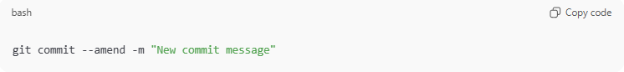
git commit --amend -m "New commit message"

- Continue rebase:
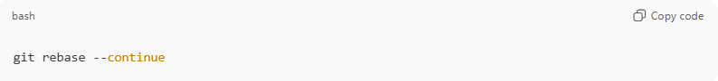
git rebase --continue
- Git re-applies the later commits on top of your amended commit.

Notes
- After rewriting commits that have been pushed before, you will need to force push:
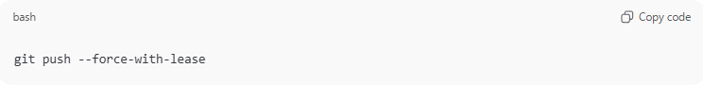
git push --force-with-lease
- Overwrites remote only if no one else has pushed in the meantime
- Safer when collaborating

Option 2: Change only commit message
# Source: AI Source: Provided by: [Data Path: Persons Table -> ID Column: 1, Name_En Column: Motasem Essam] -> From: [ChatGPT] on [2/19/2026]
Suppose your history:
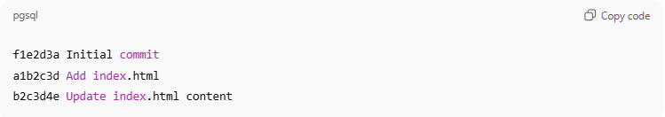
Suppose your history is:
f1e2d3a Initial commit
a1b2c3d Add index.html
b2c3d4e Update index.html content
You want to change only the commit message of a1b2c3d.

1️⃣ Start interactive rebase
Run:
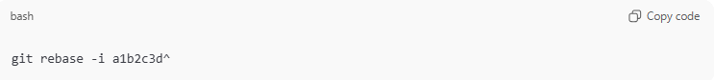
git rebase -i a1b2c3d^

2️⃣ Mark commit to reword
In the editor that opens, change:
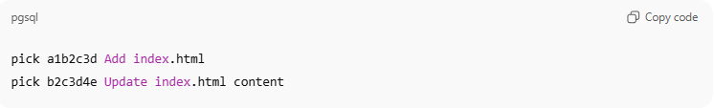
pick a1b2c3d Add index.html
pick b2c3d4e Update index.html content
to:
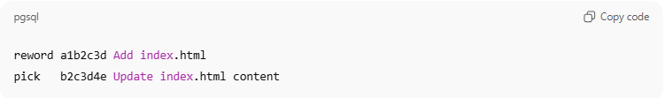
reword a1b2c3d Add index.html
pick b2c3d4e Update index.html content
- reword tells Git: “Stop and let me change only the commit message”
- No file changes needed
Save and close the editor.

3️⃣ Git opens the commit message editor
You’ll see the current commit message:
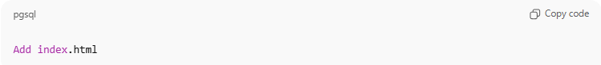
Add index.html
Now you edit the message. For example:
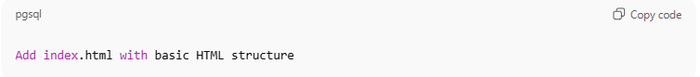
Add index.html with basic HTML structure
Save and close the editor.
✅ No need to stage files — only the message is being changed.

4️⃣ Git automatically continues the rebase
After you save the new message:
- Git will automatically replay b2c3d4e Update index.html content on top
- You don’t need to run git commit --amend — it’s already done
- Git rebase finishes unless there are conflicts

Notes
- After rewriting commits that have been pushed before, you will need to force push:
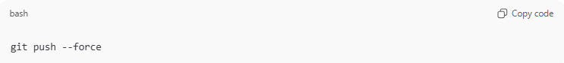
git push --force
- Overwrites remote branch completely
- Use carefully if others are working on the branch
- Can cause others to have to rebase their work

Key Points
# Source: AI Source: Provided by: [Data Path: Persons Table -> ID Column: 1, Name_En Column: Motasem Essam] -> From: [ChatGPT] on [2/19/2026]
- Only affects the commits you choose to edit.
- Older commits remain unchanged.
- The commit hashes of edited commits change, because Git creates new commits.
- If commits were already pushed, you may need a force push:
git push --force origin main
- Use rebase carefully to avoid rewriting shared history.

✅ In short:
Rebase = “Temporarily remove commits, edit a commit, then replay later commits on top”.
It lets you rewrite history for older commits, unlike --amend, which only edits the most recent commit.

Combine commits
# Source: AI Source: Provided by: [Data Path: Persons Table -> ID Column: 1, Name_En Column: Motasem Essam] -> From: [ChatGPT] on [2/19/2026]
You can combine commits in two ways: squash or fixup. This is usually done before editing commits in an interactive rebase.

Step 0: Start Interactive Rebase
git rebase -i HEAD~3
Editor shows:
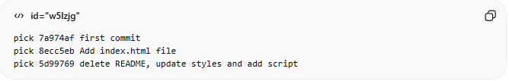
pick 7a974af first commit
pick 8ecc5eb Add index.html file
pick 5d99769 delete README, update styles and add script
This is the default view. From here, you can choose to squash, fixup, or edit commits.

Method 1: squash
# Source: AI Source: Provided by: [Data Path: Persons Table -> ID Column: 1, Name_En Column: Motasem Essam] -> From: [ChatGPT] on [2/19/2026]
- What it is: Combine this commit with the previous commit, keeping both commit messages.
- Use it for: Merging small commits into one while preserving messages.
Example:
Change the last line in the editor:
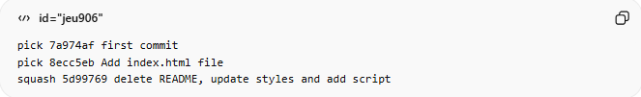
pick 7a974af first commit
pick 8ecc5eb Add index.html file
squash 5d99769 delete README, update styles and add script
- Git opens an editor showing both commit messages:
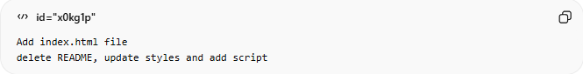
Add index.html file
delete README, update styles and add script
- Merge into a clean single message:
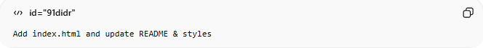
Add index.html and update README & styles

Method 2: fixup
# Source: AI Source: Provided by: [Data Path: Persons Table -> ID Column: 1, Name_En Column: Motasem Essam] -> From: [ChatGPT] on [2/19/2026]
- What it is: Combine this commit with the previous commit, discarding this commit’s message.
- Use it for: Minor corrections, like typos or small fixes, without cluttering commit history.
Example:
Editor:
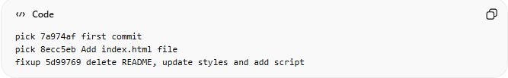
pick 7a974af first commit
pick 8ecc5eb Add index.html file
fixup 5d99769 delete README, update styles and add script
- Changes are merged into 8ecc5eb
- The commit message of 5d99769 is discarded

✅ Quick Reference Table
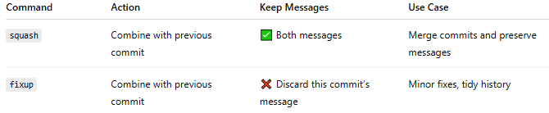
Command | Action | Keep Messages | Use Case
squash | Combine with previous commit | ✅ Both messages | Merge commits and preserve messages
fixup | Combine with previous commit | ❌ Discard this commit’s message | Minor fixes, tidy history

💡 Tip: Always make a backup branch before rebasing:
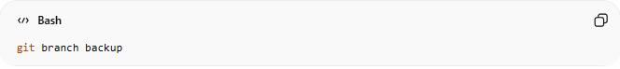
git branch backup

Delete Commits
# Source: AI Source: Provided by: [Data Path: Persons Table -> ID Column: 1, Name_En Column: Motasem Essam] -> From: [ChatGPT] on [2/19/2026]
If you have 3 commits in your Git history and want to delete the commit, here’s how to do it safely.
Assume your history looks like this:
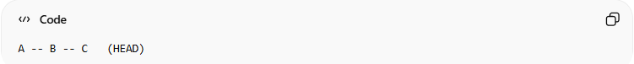
A -- B -- C (HEAD)
And you want to delete commit B.

✅ Method 1: Use Reset
# Source: AI Source: Provided by: [Data Path: Persons Table -> ID Column: 1, Name_En Column: Motasem Essam] -> From: [ChatGPT] on [2/19/2026]
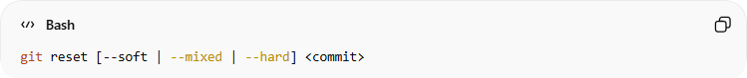
git reset [--soft | --mixed | --hard] <commit>
<commit> can be:
- ✅ Full commit hash
- ✅ Short commit hash
- ✅ Relative reference (HEAD~1, HEAD^)
- ✅ Reflog reference (HEAD@{1})
- ✅ Branch name (main, feature)
- ✅ Tag name
Git always resolves these to a commit hash internally.

✅ Option 1: Delete last commit and discard its changes
# Source: AI Source: Provided by: [Data Path: Persons Table -> ID Column: 1, Name_En Column: Motasem Essam] -> From: [ChatGPT] on [2/19/2026]
If you want to completely remove commit C and its changes:
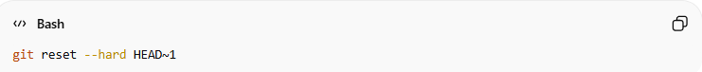
git reset --hard HEAD~1
What this does:
- HEAD~1 → one commit before current
- --hard → deletes the commit and removes its changes from your working directory
use git reflog.

✅ Option 2: Delete last commit but keep the changes (recommended if unsure)
# Source: AI Source: Provided by: [Data Path: Persons Table -> ID Column: 1, Name_En Column: Motasem Essam] -> From: [ChatGPT] on [2/19/2026]
If you want to remove the commit but keep the code changes:
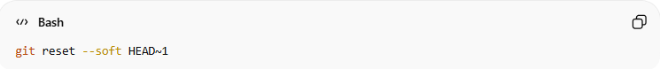
git reset --soft HEAD~1
This:
- Removes the commit
- Keeps all changes staged (ready to recommit)

✅ Option 3: Keep changes unstaged
# Source: AI Source: Provided by: [Data Path: Persons Table -> ID Column: 1, Name_En Column: Motasem Essam] -> From: [ChatGPT] on [2/19/2026]
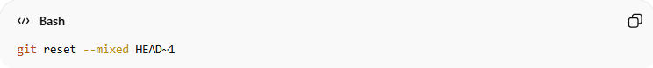
git reset --mixed HEAD~1
This:
- Removes the commit
- Keeps changes in your working directory (not staged)

🚨 If you already pushed the commit
If the commit was pushed to a remote:
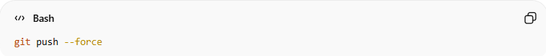
git push --force
⚠️ Only force-push if you're sure no one else depends on that commit.

Quick Summary
# Source: AI Source: Provided by: [Data Path: Persons Table -> ID Column: 1, Name_En Column: Motasem Essam] -> From: [ChatGPT] on [2/19/2026]
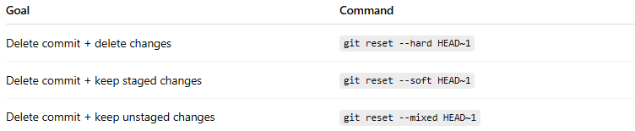
Goal | Command
Delete commit + delete changes | git reset --hard HEAD~1
Delete commit + keep staged changes | git reset --soft HEAD~1
Delete commit + keep unstaged changes | git reset --mixed HEAD~1

git reset with a commit hash
# Source: AI Source: Provided by: [Data Path: Persons Table -> ID Column: 1, Name_En Column: Motasem Essam] -> From: [ChatGPT] on [2/19/2026]
🔹 Basic Syntax
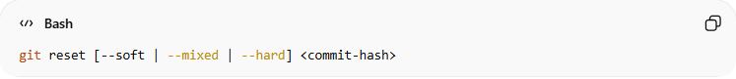
git reset [--soft | --mixed | --hard] <commit-hash>
Example:
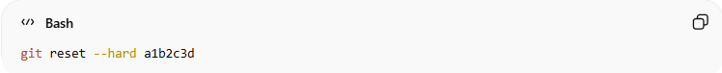
git reset --hard a1b2c3d
This moves HEAD to commit a1b2c3d.

🔎 What Each Option Does
Assume history:
A -- B -- C -- D (HEAD)
And you run:
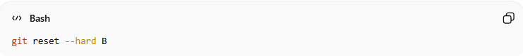
git reset --hard B
Now history becomes:
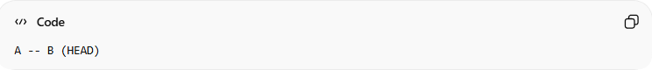
A -- B (HEAD)
Commits C and D are removed from the branch.
The difference between reset modes:
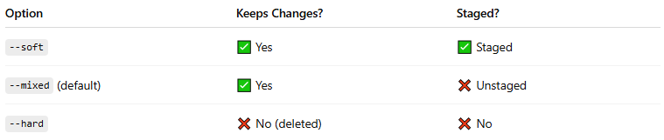
Option | Keeps Changes? | Staged?
--soft | ✅ Yes | ✅ Staged
--mixed (default) | ✅ Yes | ❌ Unstaged
--hard | ❌ No (deleted) | ❌ No

🔹 Using Short Hash
You don’t need the full hash.
Instead of:
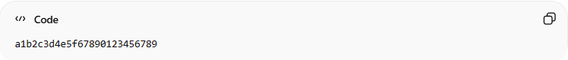
a1b2c3d4e5f67890123456789
You can use:
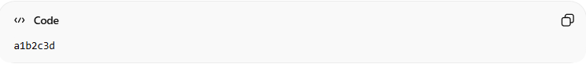
a1b2c3d
As long as it's unique.

⚠️ If You Already Pushed
If the commits were pushed to remote:
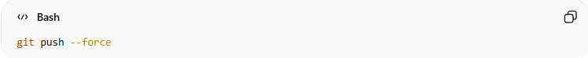
git push --force
Be careful — this rewrites history.

🔥 Example Recovery with Reflog Hash
From:
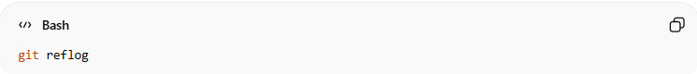
git reflog
You see:
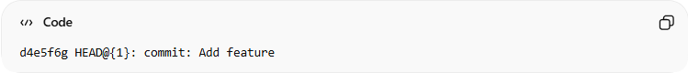
d4e5f6g HEAD@{1}: commit: Add feature
Restore it:
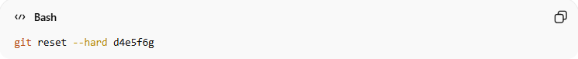
git reset --hard d4e5f6g

✅ Method 2: Use Interactive Rebase
# Source: AI Source: Provided by: [Data Path: Persons Table -> ID Column: 1, Name_En Column: Motasem Essam] -> From: [ChatGPT] on [2/19/2026]
Delete older commits:
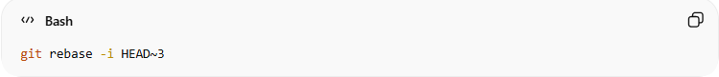
git rebase -i HEAD~3
Here’s what each part means:
- git rebase → Rewrites commit history.
- -i → Interactive mode (lets you edit commits).
- HEAD~3 → Refers to the commit 3 commits before the current one.
So you're rebasing everything after that commit (i.e., the last 3 commits).

This opens an editor showing something like:
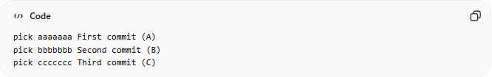
pick aaaaaaa First commit (A)
pick bbbbbbb Second commit (B)
pick ccccccc Third commit (C)
🔹 To delete the second commit:

Just delete the line with commit B
OR change pick to drop:
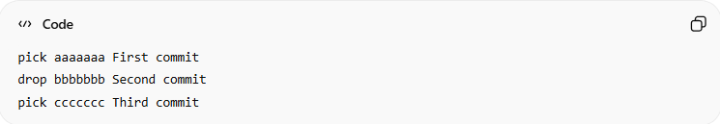
pick aaaaaaa First commit
drop bbbbbbb Second commit
pick ccccccc Third commit
Save and close the editor.
Git will replay commits without the second one.

⚠️ If You Already Pushed to Remote
After rebase, history changes. You must force push:
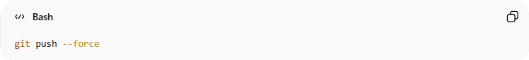
git push --force
⚠️ Be careful: this rewrites history and may affect teammates.

🧠 Alternative (If It's the Most Recent Commit)
If the second commit was the last one, you could use:
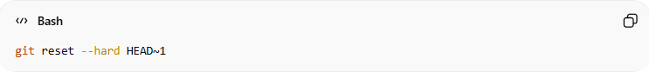
git reset --hard HEAD~1
But in your case (middle commit), interactive rebase is the correct way.

✅ Method 3: Use its hash
# Source: AI Source: Provided by: [Data Path: Persons Table -> ID Column: 1, Name_En Column: Motasem Essam] -> From: [ChatGPT] on [2/19/2026]
If you want to delete the second commit using its hash, you can do it with git rebase --onto.
Assume your history is:
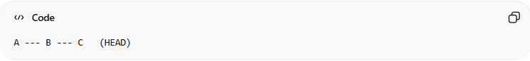
A --- B --- C (HEAD)
And you want to delete commit B.
Let’s say:
- A = 1111111
- B = 2222222 ❌ (the one you want to delete)
- C = 3333333

✅ Command Using Hash
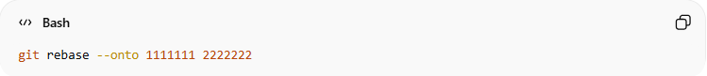
git rebase --onto 1111111 2222222
🔎 What this means:
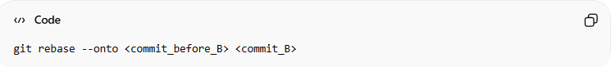
git rebase --onto <commit_before_B> <commit_B>
So Git will:
- Take commits after B (which is C)
- Replay them on top of A
- Effectively removing B
Result:
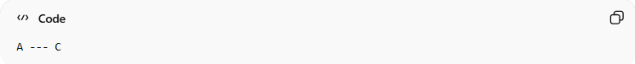
A --- C

🧠 How to Get the Hashes
Run:
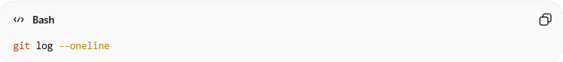
git log --oneline
Copy:
- The hash of the commit before the one you want to delete
- The hash of the commit you want to delete

⚠️ If Already Pushed
You must force push:
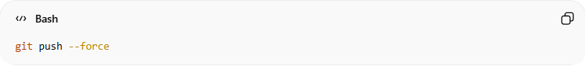
git push --force
Be careful if working with a team.

Using git reflog (Recover Lost Commits Safely)
# Source: AI Source: Provided by: [Data Path: Persons Table -> ID Column: 1, Name_En Column: Motasem Essam] -> From: [ChatGPT] on [2/19/2026]
Using git reflog (Recover Lost Commits Safely)
git reflog is your safety net. It records every movement of HEAD, even after a reset, rebase, or branch deletion.

🔎 1️⃣ View the Reflog
Run:
git reflog
Example output:
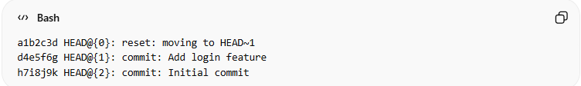
a1b2c3d HEAD@{0}: reset: moving to HEAD~1
d4e5f6g HEAD@{1}: commit: Add login feature
h7i8j9k HEAD@{2}: commit: Initial commit
What this means:
- HEAD@{0} → your current position
- HEAD@{1} → where HEAD was before the last action
- Each entry shows what happened (commit, reset, rebase, etc.)

♻️ 2️⃣ Recover a Deleted Commit
Let’s say you accidentally ran:
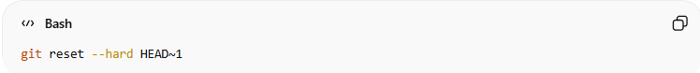
git reset --hard HEAD~1
You deleted the last commit 😬
Now:
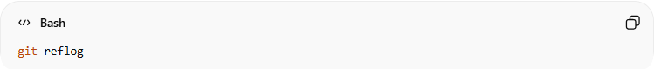
git reflog
Find the commit before the reset (example: HEAD@{1}).
To restore it:
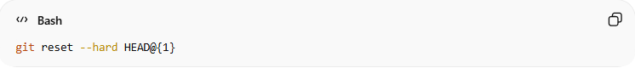
git reset --hard HEAD@{1}
✅ Your commit is back.

🎯 3️⃣ Recover Using Commit Hash
Instead of HEAD@{1}, you can use the hash:
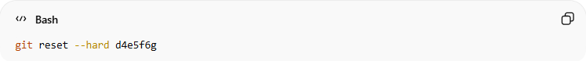
git reset --hard d4e5f6g
This moves HEAD directly to that commit.

🧪 4️⃣ Safer Recovery (Create a Branch Instead)
If you're unsure, create a branch first:
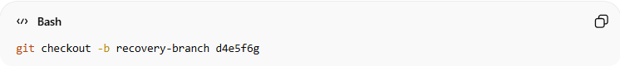
git checkout -b recovery-branch d4e5f6g
This:
- Keeps your current branch safe
- Restores the old commit on a new branch
Very recommended if you're nervous.

🧠 When is git reflog useful?
- After git reset --hard
- After deleting a branch
- After a bad rebase
- After force push mistakes
- When you say: “Where did my commit go?!”

⚠️ Important
- Reflog is local only
- Entries expire (usually after 30–90 days)
- Works even if commit is no longer in branch history

🔥 Quick Recovery Recipe
- git reflog
- Copy the hash or HEAD@{n}
- git reset --hard <hash>
Done.

Revert Commit

🔁 What is Revert in GitHub?
# Source: AI Source: Provided by: [Data Path: Persons Table -> ID Column: 1, Name_En Column: Motasem Essam] -> From: [ChatGPT] on [2/19/2026]
In GitHub, Revert means undoing the changes introduced by a specific commit — but in a safe way.
Instead of deleting history, GitHub creates a new commit that reverses the changes made by an earlier commit.
So:
- ❌ It does not remove the old commit
- ✅ It adds a new commit that cancels it out
This keeps your project history clean and traceable.

📌 When Should You Use Revert?
# Source: AI Source: Provided by: [Data Path: Persons Table -> ID Column: 1, Name_En Column: Motasem Essam] -> From: [ChatGPT] on [2/19/2026]
Use Revert when:
- A recent commit broke something
- You pushed a bug to production
- You want to undo a change without rewriting history
- You're working in a shared repository

💻 How to Use Revert in Git
# Source: AI Source: Provided by: [Data Path: Persons Table -> ID Column: 1, Name_En Column: Motasem Essam] -> From: [ChatGPT] on [2/19/2026]
If you're working locally:
git revert <commit-hash>
Example:
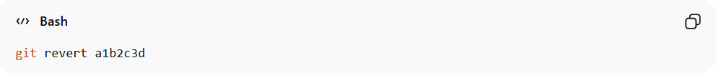
git revert a1b2c3d
Then push it:
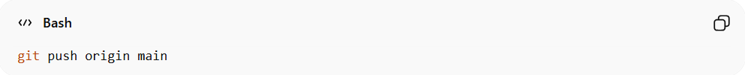
git push origin main
Git will:
- Create a new commit
- Reverse the changes from that commit

🔥 Revert vs Reset (Important Difference)
# Source: AI Source: Provided by: [Data Path: Persons Table -> ID Column: 1, Name_En Column: Motasem Essam] -> From: [ChatGPT] on [2/19/2026]
Revert | Reset
Safe for shared repos | Can rewrite history
Creates new commit | Deletes commits
Recommended for teams | Risky if already pushed
Use revert when working with others.

🧠 Simple Example
# Source: AI Source: Provided by: [Data Path: Persons Table -> ID Column: 1, Name_En Column: Motasem Essam] -> From: [ChatGPT] on [2/19/2026]
Imagine:
- Commit A → adds a feature
- You realize it's wrong
Using git revert A will:
- Create Commit B
- Commit B removes the feature
- History remains intact

Merge Commit

🔀 What Is a Merge Commit in Git?
# Source: AI Source: Provided by: [Data Path: Persons Table -> ID Column: 1, Name_En Column: Motasem Essam] -> From: [ChatGPT] on [2/19/2026]
A merge commit is a special commit created when you combine changes from one branch into another.
It happens when you use:
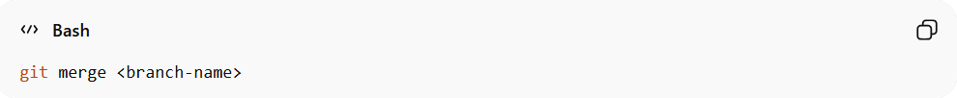
git merge <branch-name>

🧠 Why Is It Special?
# Source: AI Source: Provided by: [Data Path: Persons Table -> ID Column: 1, Name_En Column: Motasem Essam] -> From: [ChatGPT] on [2/19/2026]
Most commits have one parent (they continue a single line of history).
A merge commit has two parents:
- Parent 1 → the branch you merged into (e.g., main)
- Parent 2 → the branch you merged from (e.g., feature)
So it connects two histories together.

📊 Simple Example
# Source: AI Source: Provided by: [Data Path: Persons Table -> ID Column: 1, Name_En Column: Motasem Essam] -> From: [ChatGPT] on [2/19/2026]
Imagine this branch structure:
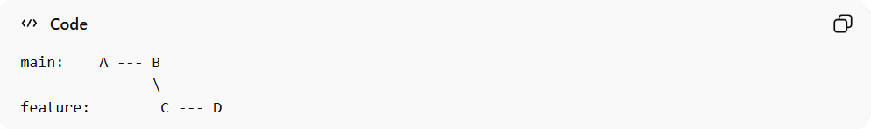
main: A --- B
\
feature: C --- D
When you merge feature into main, Git creates:
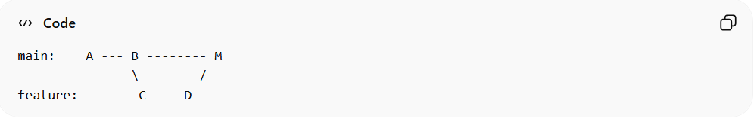
main: A --- B -------- M
\ /
feature: C --- D
M = Merge Commit
It contains:
- All changes from B
- All changes from D

🔥 When Does a Merge Commit Get Created?
# Source: AI Source: Provided by: [Data Path: Persons Table -> ID Column: 1, Name_En Column: Motasem Essam] -> From: [ChatGPT] on [2/19/2026]
A merge commit is created when:
- Both branches have new commits
- Git cannot just move the pointer forward (not a fast-forward)
If no new commits were added to main, Git may do a fast-forward merge (no merge commit created).

🛠 Example Command
# Source: AI Source: Provided by: [Data Path: Persons Table -> ID Column: 1, Name_En Column: Motasem Essam] -> From: [ChatGPT] on [2/19/2026]
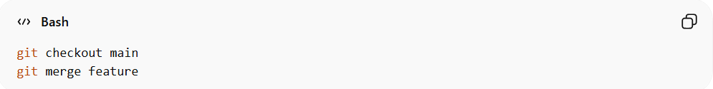
git checkout main
git merge feature
If needed, Git creates a merge commit automatically.

💡 Merge Commit vs Fast-Forward
# Source: AI Source: Provided by: [Data Path: Persons Table -> ID Column: 1, Name_En Column: Motasem Essam] -> From: [ChatGPT] on [2/19/2026]
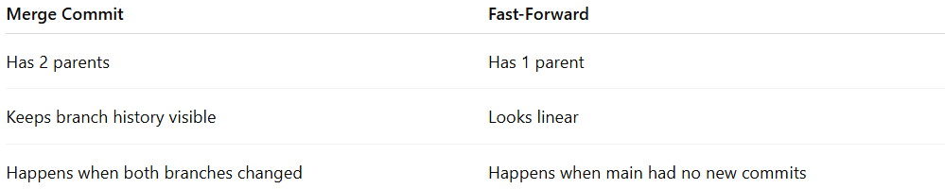
Merge Commit | Fast-Forward
Has 2 parents | Has 1 parent
Keeps branch history visible | Looks linear
Happens when both branches changed | Happens when main had no new commits

📌 On GitHub
# Source: AI Source: Provided by: [Data Path: Persons Table -> ID Column: 1, Name_En Column: Motasem Essam] -> From: [ChatGPT] on [2/19/2026]
When you:
- Create a Pull Request
- Click "Merge pull request"
GitHub usually creates a merge commit (unless you choose squash or rebase).

cherry-pick

What is a “cherry-pick”?
# Source: AI Source: Provided by: [Data Path: Persons Table -> ID Column: 1, Name_En Column: Motasem Essam] -> From: [ChatGPT] on [2/19/2026]
In Git, git cherry-pick is a command that allows you to take specific commits from one branch and apply them to another branch, without merging the whole branch.
- Normally, when you merge a branch, you bring in all its commits.
- With cherry-pick, you can select only the commits you want.
Syntax:
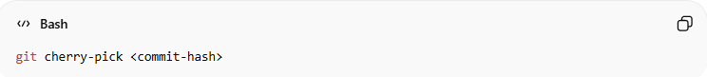
git cherry-pick <commit-hash>

What “relative commits” means
# Source: AI Source: Provided by: [Data Path: Persons Table -> ID Column: 1, Name_En Column: Motasem Essam] -> From: [ChatGPT] on [2/19/2026]
- Relative commits usually refer to commits specified relative to the current HEAD, instead of using their full SHA.
- You can use HEAD~n to refer to commits before the current one:
  - HEAD~1 → one commit before HEAD
  - HEAD~2 → two commits before HEAD, etc.
So if you want to cherry-pick the commit 3 steps behind your current HEAD, you could do:
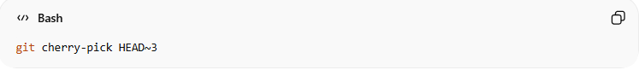
git cherry-pick HEAD~3

Examples
# Source: AI Source: Provided by: [Data Path: Persons Table -> ID Column: 1, Name_En Column: Motasem Essam] -> From: [ChatGPT] on [2/19/2026]
Cherry-pick a single relative commit
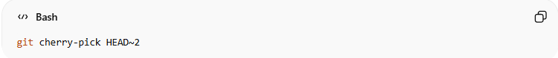
git cherry-pick HEAD~2
- Picks the commit two commits before the current HEAD and applies it to your current branch.
Cherry-pick a range of relative commits
You can pick multiple commits in a range:
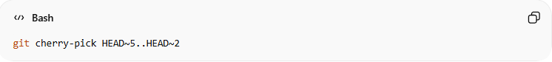
git cherry-pick HEAD~5..HEAD~2
- This picks commits starting from HEAD~5 up to (but not including) HEAD~2.
- Useful if you want a sequence of older commits without taking everything.

Key Notes
# Source: AI Source: Provided by: [Data Path: Persons Table -> ID Column: 1, Name_En Column: Motasem Essam] -> From: [ChatGPT] on [2/19/2026]
- Conflicts can happen just like with merges. You need to resolve them manually.
- Cherry-picking creates new commits on your current branch with the same changes. The commit hashes are different from the original ones.
- Use it to selectively move changes without merging entire branches.

Git Cherry-Pick: Full Explanation and Examples
# Source: AI Source: Provided by: [Data Path: Persons Table -> ID Column: 1, Name_En Column: Motasem Essam] -> From: [ChatGPT] on [2/19/2026]
1️⃣ When you create a new branch
- A new branch starts from the commit where you created it.
- All previous commits up to that point are included automatically.
- Any new commits made after the branch was created are not included.
Example:
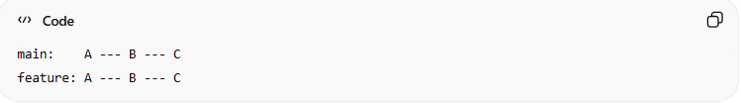
main: A --- B --- C
feature: A --- B --- C
The feature branch starts with all commits from main up to C.

2️⃣ If you make changes on another branch
- Suppose you add new commits D and E on main after the feature branch was created:
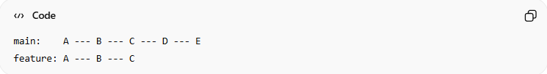
main: A --- B --- C --- D --- E
feature: A --- B --- C
- The feature branch does not automatically have D and E.
- If you want a specific commit (e.g., D) on feature, you use cherry-pick.
- Git will copy the changes from D and create a new commit D’ on the feature branch:
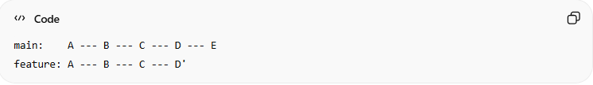
main: A --- B --- C --- D --- E
feature: A --- B --- C --- D'

3️⃣ Why not just merge?
- Merging would bring all commits from main (D and E) into feature.
- Sometimes you only want one specific commit, not everything.
- Cherry-pick lets you take just the commit you want, without merging the whole branch.

💡 Summary
# Source: AI Source: Provided by: [Data Path: Persons Table -> ID Column: 1, Name_En Column: Motasem Essam] -> From: [ChatGPT] on [2/19/2026]
- Cherry-pick = copy a single commit from one branch to another
- The original commit stays where it is
- A new commit is created on your current branch with the same changes and message
- Useful for taking changes made after your branch started or from another branch without merging everything

Fast-Forward

🚀 What Is a Fast-Forward in Git?
# Source: AI Source: Provided by: [Data Path: Persons Table -> ID Column: 1, Name_En Column: Motasem Essam] -> From: [ChatGPT] on [2/19/2026]
A fast-forward happens when Git can merge a branch by simply moving the branch pointer forward — without creating a merge commit.
👉 No new commit is created.
👉 History stays linear and clean.

🧠 When Does Fast-Forward Happen?
# Source: AI Source: Provided by: [Data Path: Persons Table -> ID Column: 1, Name_En Column: Motasem Essam] -> From: [ChatGPT] on [2/19/2026]
Fast-forward works only if the current branch has no new commits since the feature branch was created.
Example
Initial state:
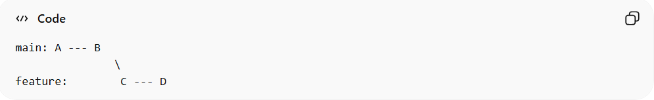
main: A --- B
\
feature: C --- D
If main didn’t change after feature was created, Git can just move main forward:
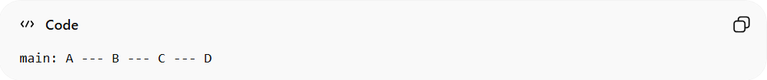
main: A --- B --- C --- D
No merge commit needed ✅
Git just "fast-forwards" the pointer.

🛠 Command Example
# Source: AI Source: Provided by: [Data Path: Persons Table -> ID Column: 1, Name_En Column: Motasem Essam] -> From: [ChatGPT] on [2/19/2026]
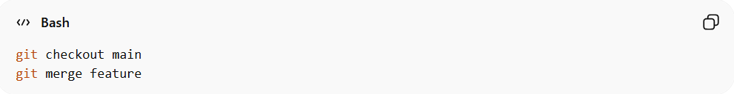
git checkout main
git merge feature
If possible, Git performs a fast-forward automatically.
You may see:
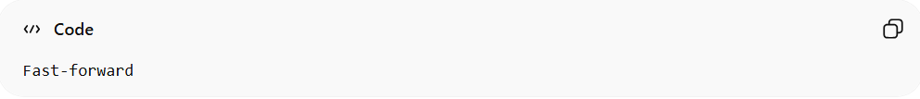
Fast-forward

🔥 Why Is It Called "Fast-Forward"?
# Source: AI Source: Provided by: [Data Path: Persons Table -> ID Column: 1, Name_En Column: Motasem Essam] -> From: [ChatGPT] on [2/19/2026]
Because Git doesn’t need to:
- Combine histories
- Create a special merge commit
- Resolve complex differences
It simply moves forward in time.

📊 Fast-Forward vs Merge Commit
# Source: AI Source: Provided by: [Data Path: Persons Table -> ID Column: 1, Name_En Column: Motasem Essam] -> From: [ChatGPT] on [2/19/2026]
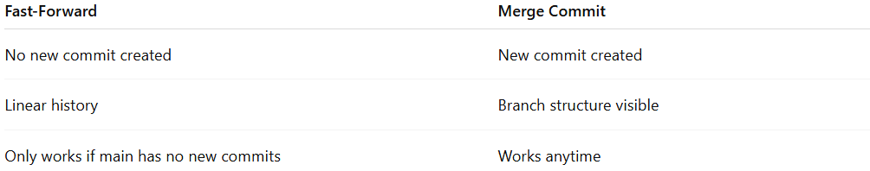
Fast-Forward | Merge Commit
No new commit created | New commit created
Linear history | Branch structure visible
Only works if main has no new commits | Works anytime

🧩 On GitHub
# Source: AI Source: Provided by: [Data Path: Persons Table -> ID Column: 1, Name_En Column: Motasem Essam] -> From: [ChatGPT] on [2/19/2026]
When merging a Pull Request:
- If no conflicts and no new commits on target branch → GitHub may fast-forward (depending on repo settings).
- If both branches changed → GitHub creates a merge commit.

Full Step-by-Step Lab: Fast-Forward

🔹 Step 1: Create a Test Repository
# Source: AI Source: Provided by: [Data Path: Persons Table -> ID Column: 1, Name_En Column: Motasem Essam] -> From: [ChatGPT] on [2/19/2026]
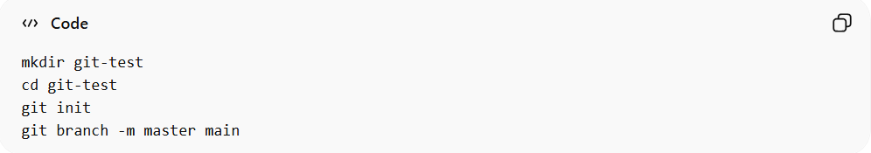
mkdir git-test
cd git-test
git init
git branch -m master main

🔹 Step 2: Initial Commit on main
# Source: AI Source: Provided by: [Data Path: Persons Table -> ID Column: 1, Name_En Column: Motasem Essam] -> From: [ChatGPT] on [2/19/2026]
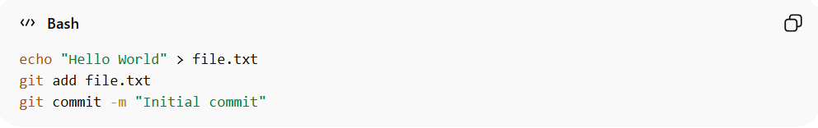
echo "Hello World" > file.txt
git add file.txt
git commit -m "Initial commit"

🔹 Step 3: Create a Feature Branch
# Source: AI Source: Provided by: [Data Path: Persons Table -> ID Column: 1, Name_En Column: Motasem Essam] -> From: [ChatGPT] on [2/19/2026]
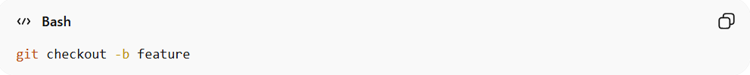
git checkout -b feature
Add a few commits:
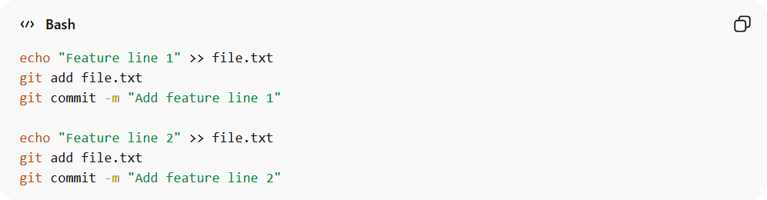
echo "Feature line 1" >> file.txt
git add file.txt
git commit -m "Add feature line 1"

echo "Feature line 2" >> file.txt
git add file.txt
git commit -m "Add feature line 2"
Branch structure now:
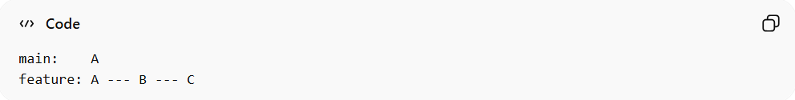
main: A
feature: A --- B --- C
- A = Initial commit
- B = Add feature line 1
- C = Add feature line 2

🔹 Step 4: Merge Feature into main (Normal Merge)
# Source: AI Source: Provided by: [Data Path: Persons Table -> ID Column: 1, Name_En Column: Motasem Essam] -> From: [ChatGPT] on [2/19/2026]
Switch to main:
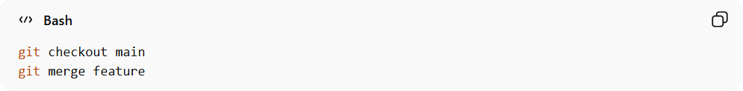
git checkout main
git merge feature
- If no new commits on main → Git may fast-forward
- To force a merge commit, use:
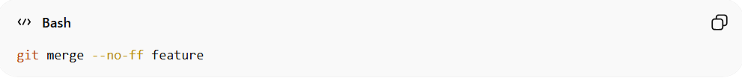
git merge --no-ff feature
- View history:
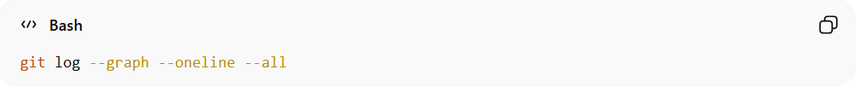
git log --graph --oneline --all

🔹 Step 5: Undo the Merge
# Source: AI Source: Provided by: [Data Path: Persons Table -> ID Column: 1, Name_En Column: Motasem Essam] -> From: [ChatGPT] on [2/19/2026]
If you merged your feature branch into main but want to undo it before pushing:
- Check the log to find the commit before the merge:
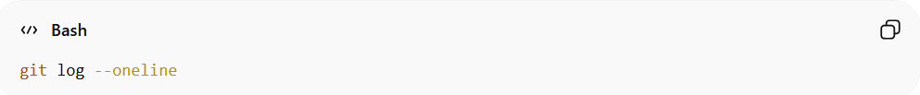
git log --oneline
Example output:
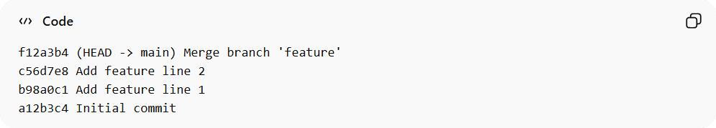
f12a3b4 (HEAD -> main) Merge branch 'feature'
c56d7e8 Add feature line 2
b98a0c1 Add feature line 1
a12b3c4 Initial commit
Here, a12b3c4 = commit before the merge.

- Reset main to the previous commit:
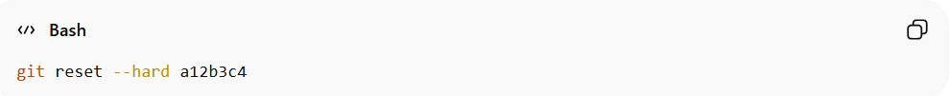
git reset --hard a12b3c4
- This removes the merge commit
- Branch is restored to its state before merging

- Verify:
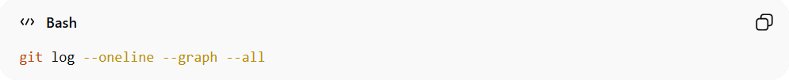
git log --oneline --graph --all
Your history should now look like:
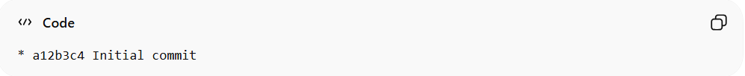
* a12b3c4 Initial commit
- Feature branch still exists with its commits (Add feature line 1, Add feature line 2)
- You can re-merge later if needed

How to force a merge commit (--no-ff)
# Source: AI Source: Provided by: [Data Path: Persons Table -> ID Column: 1, Name_En Column: Motasem Essam] -> From: [ChatGPT] on [2/19/2026]
Ah! You want to force Git to create a merge commit even when a fast-forward is possible. That’s exactly what --no-ff does. Let’s break it down.

🔹 What --no-ff Means
# Source: AI Source: Provided by: [Data Path: Persons Table -> ID Column: 1, Name_En Column: Motasem Essam] -> From: [ChatGPT] on [2/19/2026]
- ff = fast-forward
- --no-ff = no fast-forward → always create a merge commit
- Even if Git could just move the branch pointer, it will create a merge commit to preserve branch history.

💻 Command Line Example

1️⃣ Scenario
# Source: AI Source: Provided by: [Data Path: Persons Table -> ID Column: 1, Name_En Column: Motasem Essam] -> From: [ChatGPT] on [2/19/2026]
You have:
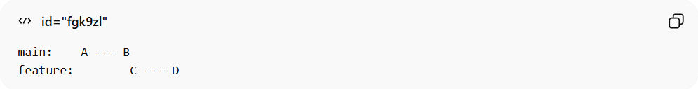
main: A --- B
feature: C --- D
main has no new commits, so normally Git would fast-forward:
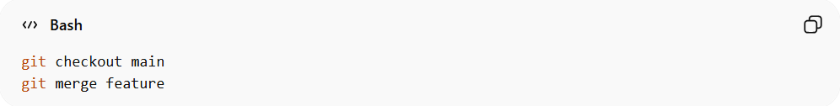
git checkout main
git merge feature
Results in fast-forward:
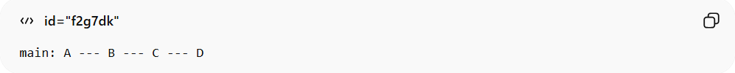
main: A --- B --- C --- D
No merge commit created.

2️⃣ Force a Merge Commit
# Source: AI Source: Provided by: [Data Path: Persons Table -> ID Column: 1, Name_En Column: Motasem Essam] -> From: [ChatGPT] on [2/19/2026]
Use --no-ff:
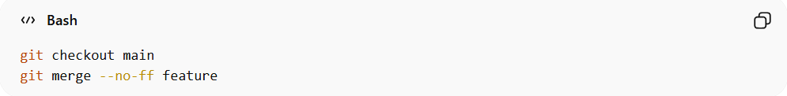
git checkout main
git merge --no-ff feature
Now Git creates a merge commit:
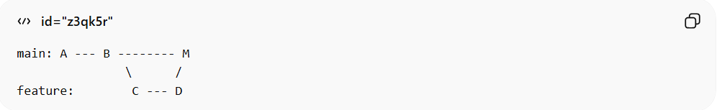
main: A --- B -------- M
\ /
feature: C --- D
- M = merge commit
- Keeps the branch history visible
- Safe for shared projects

3️⃣ Optional: Add a Commit Message
# Source: AI Source: Provided by: [Data Path: Persons Table -> ID Column: 1, Name_En Column: Motasem Essam] -> From: [ChatGPT] on [2/19/2026]
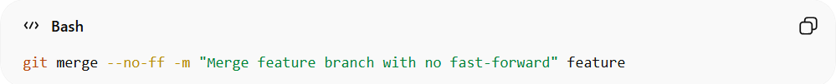
git merge --no-ff -m "Merge feature branch with no fast-forward" feature

🔹 Why Use --no-ff?
# Source: AI Source: Provided by: [Data Path: Persons Table -> ID Column: 1, Name_En Column: Motasem Essam] -> From: [ChatGPT] on [2/19/2026]
- ✅ Keeps branch history visible
- ✅ Easier to track when features were merged
- ✅ Useful for teams and release branches

🟢 How to Squash and Merge

✅ On GitHub Website
# Source: AI Source: Provided by: [Data Path: Persons Table -> ID Column: 1, Name_En Column: Motasem Essam] -> From: [ChatGPT] on [2/19/2026]
- Open your Pull Request
- Click the green “Merge” button dropdown
- Choose “Squash and merge”
- Edit the commit message (optional)
- Click Confirm squash and merge
✔ All commits in that branch become one single commit
✔ Cleaner history

📌 What Happens?
# Source: AI Source: Provided by: [Data Path: Persons Table -> ID Column: 1, Name_En Column: Motasem Essam] -> From: [ChatGPT] on [2/19/2026]
If your branch had:
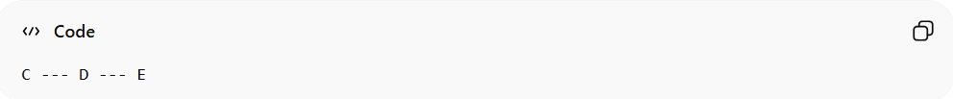
C --- D --- E
After squash merge:
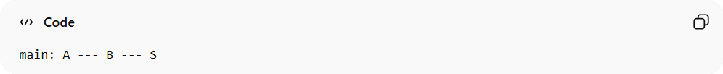
main: A --- B --- S
S = one combined commit

💻 Squash via Command Line
# Source: AI Source: Provided by: [Data Path: Persons Table -> ID Column: 1, Name_En Column: Motasem Essam] -> From: [ChatGPT] on [2/19/2026]
If you want to squash locally:
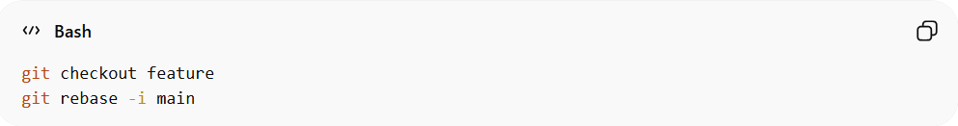
git checkout feature
git rebase -i main
An editor opens.
Change:
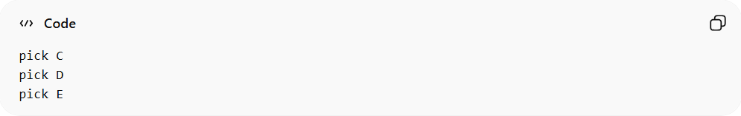
pick C
pick D
pick E
To:
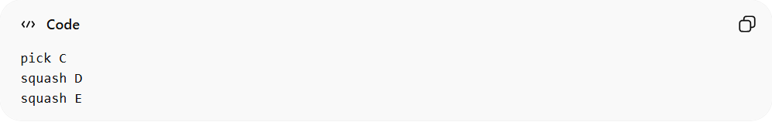
pick C
squash D
squash E
Save → Git combines them into one commit.
Then:
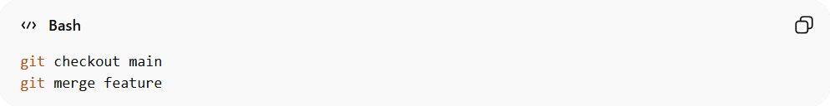
git checkout main
git merge feature

Undo a Squash Merge
# Source: AI Source: Provided by: [Data Path: Persons Table -> ID Column: 1, Name_En Column: Motasem Essam] -> From: [ChatGPT] on [2/19/2026]
Undo a Squash Merge
Squash merges combine all commits into one commit.
If Not Pushed Yet
- Reset the branch to the commit before squash:
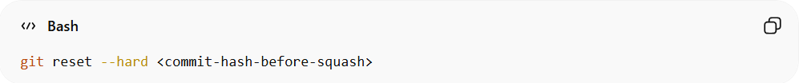
git reset --hard <commit-hash-before-squash>
- Now your branch is back with all original commits.

Full Step-by-Step Lab: Squash and Merge

1️⃣ Setup Repository
# Source: AI Source: Provided by: [Data Path: Persons Table -> ID Column: 1, Name_En Column: Motasem Essam] -> From: [ChatGPT] on [2/19/2026]
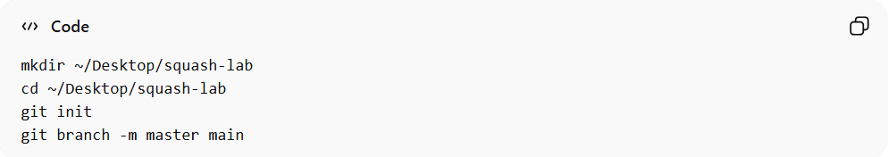
mkdir ~/Desktop/squash-lab
cd ~/Desktop/squash-lab
git init
git branch -m master main

2️⃣ Create Initial Commits on main
# Source: AI Source: Provided by: [Data Path: Persons Table -> ID Column: 1, Name_En Column: Motasem Essam] -> From: [ChatGPT] on [2/19/2026]
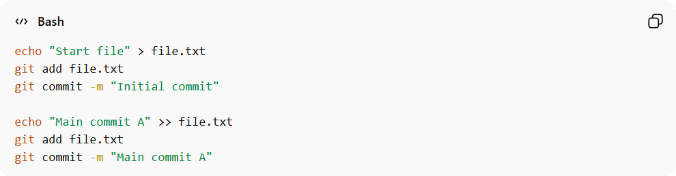
echo "Start file" > file.txt
git add file.txt
git commit -m "Initial commit"

echo "Main commit A" >> file.txt
git add file.txt
git commit -m "Main commit A"
main history:
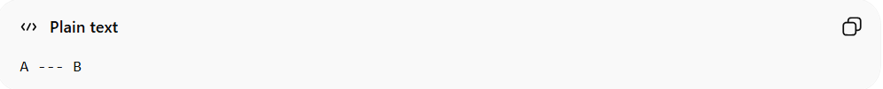
A --- B

3️⃣ Create Feature Branch with Multiple Commits
# Source: AI Source: Provided by: [Data Path: Persons Table -> ID Column: 1, Name_En Column: Motasem Essam] -> From: [ChatGPT] on [2/19/2026]
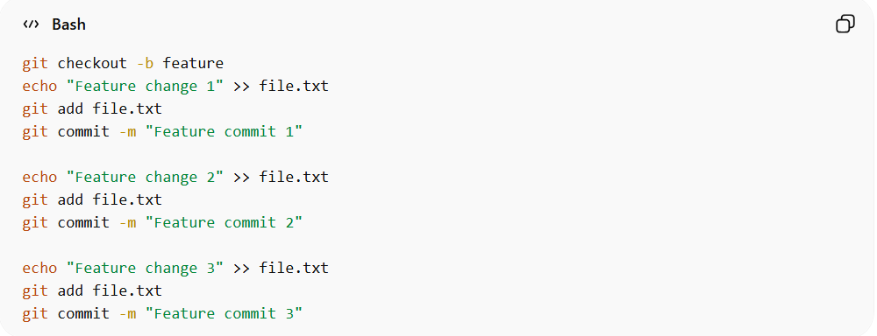
git checkout -b feature
echo "Feature change 1" >> file.txt
git add file.txt
git commit -m "Feature commit 1"

echo "Feature change 2" >> file.txt
git add file.txt
git commit -m "Feature commit 2"

echo "Feature change 3" >> file.txt
git add file.txt
git commit -m "Feature commit 3"
feature history:
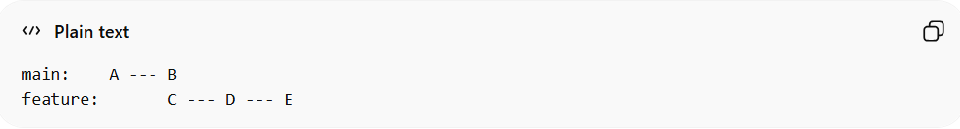
main: A --- B
feature: C --- D --- E

4️⃣ Squash Commits on Feature Branch
# Source: AI Source: Provided by: [Data Path: Persons Table -> ID Column: 1, Name_En Column: Motasem Essam] -> From: [ChatGPT] on [2/19/2026]
- Start interactive rebase onto main:
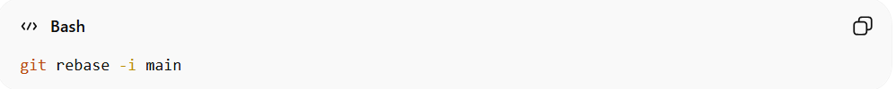
git rebase -i main
- Git opens the editor and shows something like:
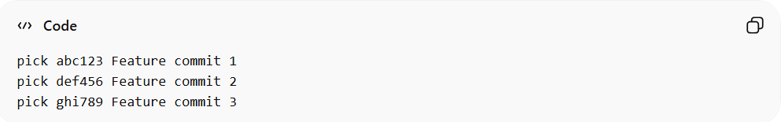
pick abc123 Feature commit 1
pick def456 Feature commit 2
pick ghi789 Feature commit 3
- Change it to squash all except the first:
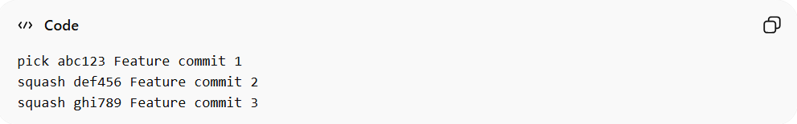
pick abc123 Feature commit 1
squash def456 Feature commit 2
squash ghi789 Feature commit 3
- Save and close the editor. Git will open another editor to combine commit messages. For example, keep:
Feature commit 1, 2, 3
- Save and close again.
✅ Now your feature branch has one single commit:
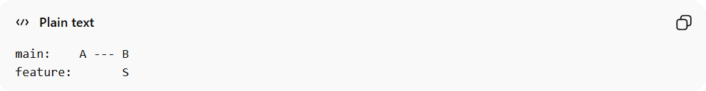
main: A --- B
feature: S
S = squashed commit of C+D+E

5️⃣ Merge Squashed Feature into Main
# Source: AI Source: Provided by: [Data Path: Persons Table -> ID Column: 1, Name_En Column: Motasem Essam] -> From: [ChatGPT] on [2/19/2026]
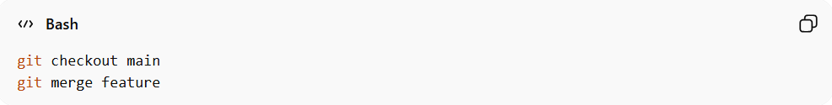
git checkout main
git merge feature
- Since main didn’t change after branching, Git usually fast-forwards
- If you want to force a merge commit:
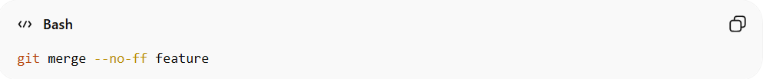
git merge --no-ff feature
Final history with forced merge:
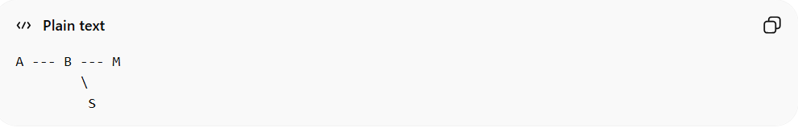
A --- B --- M
\
S
- M = merge commit
- S = squashed feature commit

6️⃣ Undo a Squash Merge (Optional, Not Pushed)
# Source: AI Source: Provided by: [Data Path: Persons Table -> ID Column: 1, Name_En Column: Motasem Essam] -> From: [ChatGPT] on [2/19/2026]
If you want to restore the original commits:
- Check git log:
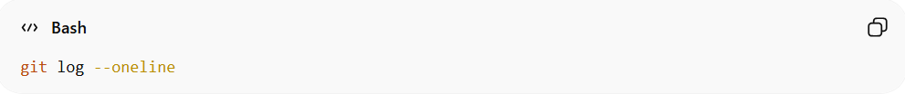
git log --oneline
- Find the commit before the squash merge (hash: <commit-before-squash>)
- Reset main branch:
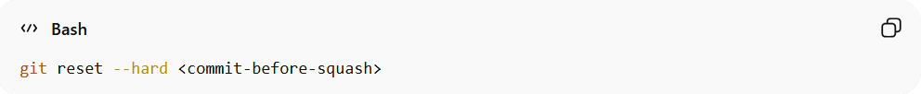
git reset --hard <commit-before-squash>
- This restores main to its previous state
- Feature branch still has the original commits if you didn’t squash locally
- If you used reflog, you can also recover the commits

🔵 How to Rebase and Merge
# Source: AI Source: Provided by: [Data Path: Persons Table -> ID Column: 1, Name_En Column: Motasem Essam] -> From: [ChatGPT] on [2/19/2026]
This keeps all commits but makes history linear.

✅ On GitHub Website
# Source: AI Source: Provided by: [Data Path: Persons Table -> ID Column: 1, Name_En Column: Motasem Essam] -> From: [ChatGPT] on [2/19/2026]
- Open Pull Request
- Click the merge dropdown
- Select “Rebase and merge”
- Confirm
✔ No merge commit created
✔ Keeps commits separate
✔ History becomes linear

📌 What Happens?
# Source: AI Source: Provided by: [Data Path: Persons Table -> ID Column: 1, Name_En Column: Motasem Essam] -> From: [ChatGPT] on [2/19/2026]
Before:
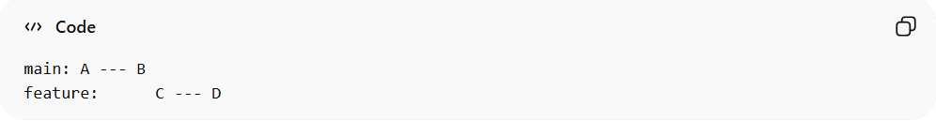
main: A --- B
feature: C --- D
After rebase & merge:
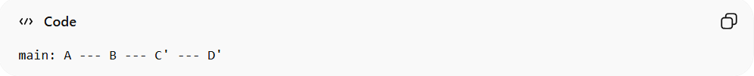
main: A --- B --- C' --- D'
No merge commit.

💻 Rebase via Command Line
# Source: AI Source: Provided by: [Data Path: Persons Table -> ID Column: 1, Name_En Column: Motasem Essam] -> From: [ChatGPT] on [2/19/2026]
git checkout feature
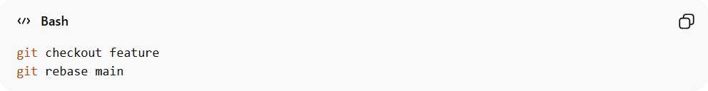
git rebase main
If no conflicts:
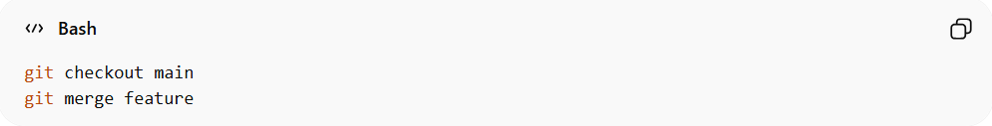
git checkout main
git merge feature
This becomes a fast-forward merge.

Undo a Rebase
# Source: AI Source: Provided by: [Data Path: Persons Table -> ID Column: 1, Name_En Column: Motasem Essam] -> From: [ChatGPT] on [2/19/2026]
When you rebase, Git rewrites commits, so the original commits still exist in Git’s reflog for a while.
Steps:
- Check reflog (history of all actions)
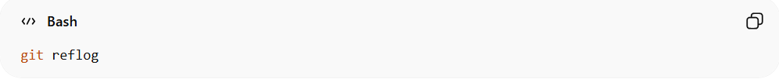
git reflog
You’ll see something like:
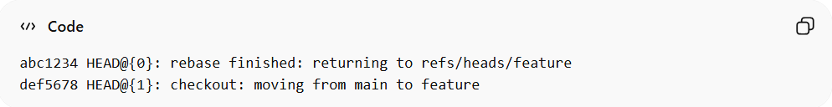
abc1234 HEAD@{0}: rebase finished: returning to refs/heads/feature
def5678 HEAD@{1}: checkout: moving from main to feature
- Reset to the original commit
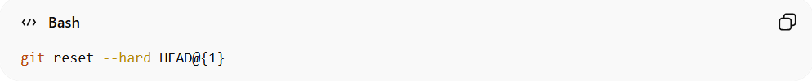
git reset --hard HEAD@{1}
- HEAD@{1} = the state before the rebase
- This restores your branch exactly as it was
- If already pushed
- You may need to force push if the remote has the rebased commits:
git push –force

If Already Pushed
- You can still reset locally, but to update remote:
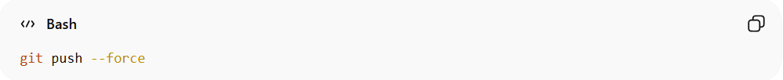
git push --force
⚠ Warning: Force pushing can overwrite others’ work if they pulled the branch.

What Happens When Conflicts Occur During Rebase
# Source: AI Source: Provided by: [Data Path: Persons Table -> ID Column: 1, Name_En Column: Motasem Essam] -> From: [ChatGPT] on [2/19/2026]
When you run:
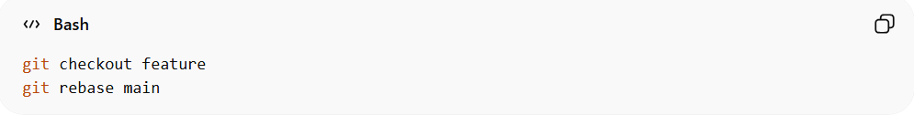
git checkout feature
git rebase main
Git replays each commit from your branch onto main, one by one.
If Git cannot apply a commit cleanly because the same lines were changed in main, you get a rebase conflict:
CONFLICT (content): Merge conflict in file.txt
At this point:
- Git pauses the rebase
- Your branch is not fully rebased yet
- Git tells you which files have conflicts

🛠 Steps to Resolve Conflicts During Rebase
# Source: AI Source: Provided by: [Data Path: Persons Table -> ID Column: 1, Name_En Column: Motasem Essam] -> From: [ChatGPT] on [2/19/2026]
- Check status
git status
Git shows which files are conflicted.
- Edit the files to fix conflicts
- Keep the correct lines
- Remove the conflict markers (<<<<, ====, >>>>)
- Mark as resolved
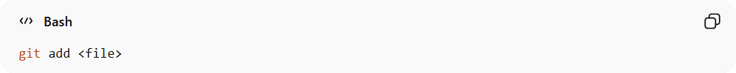
git add <file>
- Continue the rebase
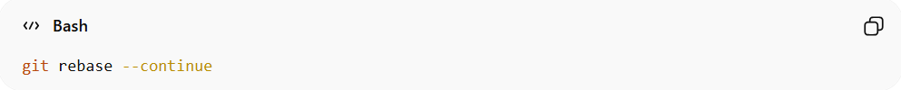
git rebase --continue
Git will move to the next commit in the rebase sequence.
- If you want to abort the rebase
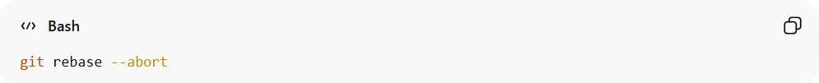
git rebase --abort
This restores your branch to its original state before the rebase.

⚠ Key Points About Rebase Conflicts
# Source: AI Source: Provided by: [Data Path: Persons Table -> ID Column: 1, Name_En Column: Motasem Essam] -> From: [ChatGPT] on [2/19/2026]
- Conflicts are handled one commit at a time, not all at once
- After resolving conflicts, each commit is re-applied
- Rebase rewrites commits → commit hashes change
- If already pushed to a remote, you may need:
git push --force
because history has been rewritten.

💡 Tip
# Source: AI Source: Provided by: [Data Path: Persons Table -> ID Column: 1, Name_En Column: Motasem Essam] -> From: [ChatGPT] on [2/19/2026]
- For shared branches, avoid rebasing commits that others are using
- For private feature branches, rebasing is safe and keeps history clean

Full Step-by-Step Lab: Rebase & Merge with Conflict

1️⃣ Setup Repository
# Source: AI Source: Provided by: [Data Path: Persons Table -> ID Column: 1, Name_En Column: Motasem Essam] -> From: [ChatGPT] on [2/19/2026]
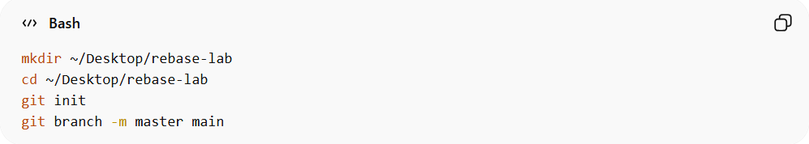
mkdir ~/Desktop/rebase-lab
cd ~/Desktop/rebase-lab
git init
git branch -m master main

2️⃣ Create Initial Commits on main
# Source: AI Source: Provided by: [Data Path: Persons Table -> ID Column: 1, Name_En Column: Motasem Essam] -> From: [ChatGPT] on [2/19/2026]
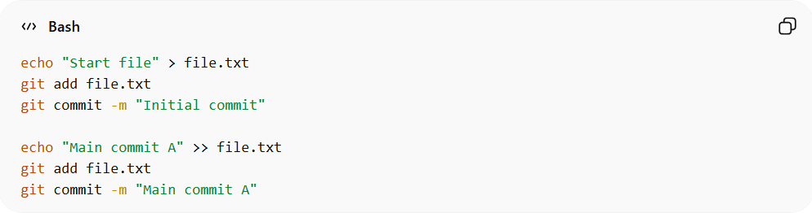
echo "Start file" > file.txt
git add file.txt
git commit -m "Initial commit"

echo "Main commit A" >> file.txt
git add file.txt
git commit -m "Main commit A"
main history:
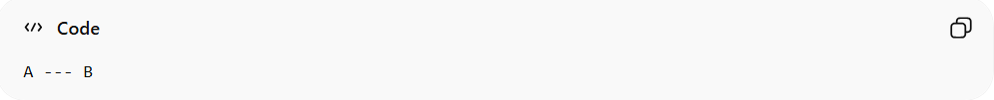
A --- B

3️⃣ Create Feature Branch
# Source: AI Source: Provided by: [Data Path: Persons Table -> ID Column: 1, Name_En Column: Motasem Essam] -> From: [ChatGPT] on [2/19/2026]
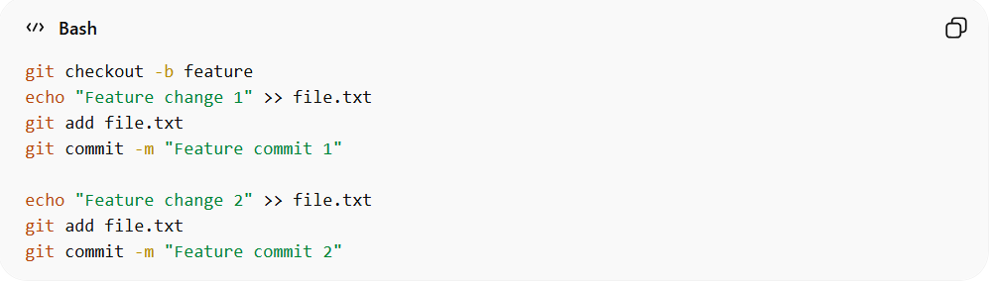
git checkout -b feature
echo "Feature change 1" >> file.txt
git add file.txt
git commit -m "Feature commit 1"

echo "Feature change 2" >> file.txt
git add file.txt
git commit -m "Feature commit 2"
feature history:
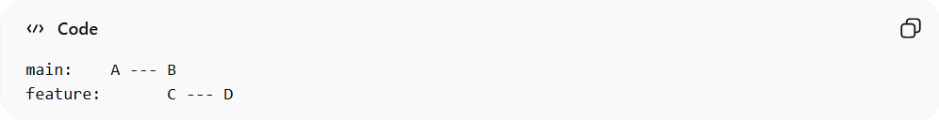
main: A --- B
feature: C --- D

4️⃣ Add a New Commit on Main (to force rebase)
# Source: AI Source: Provided by: [Data Path: Persons Table -> ID Column: 1, Name_En Column: Motasem Essam] -> From: [ChatGPT] on [2/19/2026]
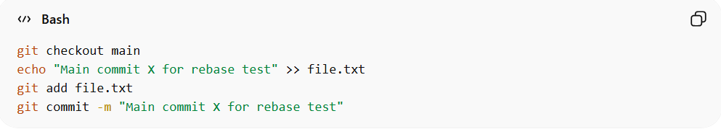
git checkout main
echo "Main commit X for rebase test" >> file.txt
git add file.txt
git commit -m "Main commit X for rebase test"
main now has:
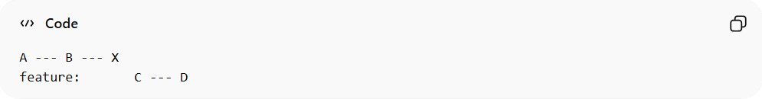
A --- B --- X
feature: C --- D

5️⃣ Rebase Feature onto Main
# Source: AI Source: Provided by: [Data Path: Persons Table -> ID Column: 1, Name_En Column: Motasem Essam] -> From: [ChatGPT] on [2/19/2026]
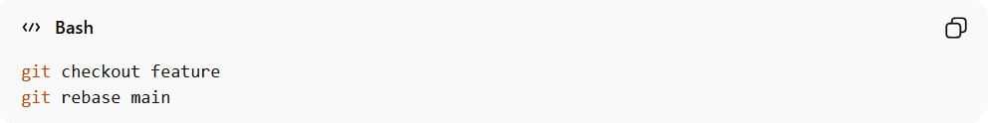
git checkout feature
git rebase main
- Git will replay C and D on top of X
- If there is no conflict, rebase completes
- If a conflict appears, Git pauses
Git will show: 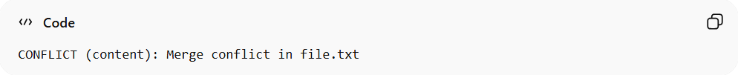
CONFLICT (content): Merge conflict in file.txt

6️⃣ Resolve the Conflict
# Source: AI Source: Provided by: [Data Path: Persons Table -> ID Column: 1, Name_En Column: Motasem Essam] -> From: [ChatGPT] on [2/19/2026]
- Open file.txt. You will see conflict markers:
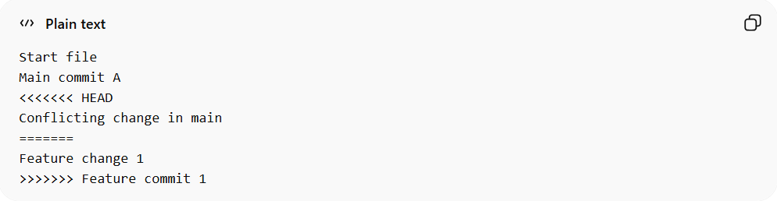
Start file
Main commit A
<<<<<<< HEAD
Conflicting change in main
=======
Feature change 1
>>>>>>> Feature commit 1
- Decide what to keep — we will keep both changes:
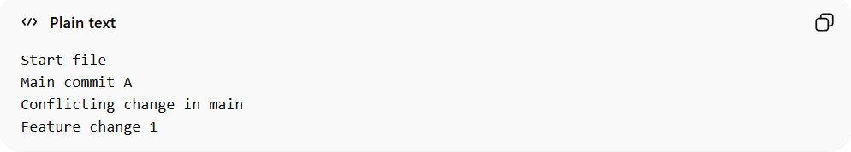
Start file
Main commit A
Conflicting change in main
Feature change 1
- Save the file
- Mark as resolved:
git add file.txt
- Continue rebase:
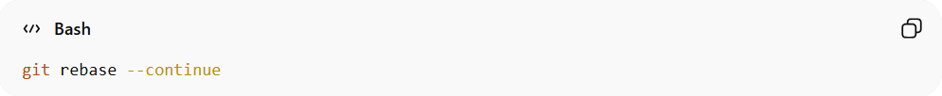
git rebase --continue
Repeat if more conflicts occur.

7️⃣ Merge Feature Back into Main
# Source: AI Source: Provided by: [Data Path: Persons Table -> ID Column: 1, Name_En Column: Motasem Essam] -> From: [ChatGPT] on [2/19/2026]
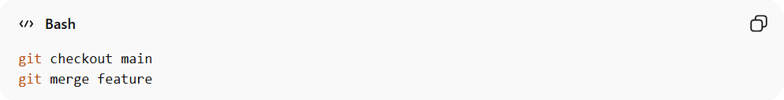
git checkout main
git merge feature
- Since feature is rebased, this will be a fast-forward merge
- Final history:
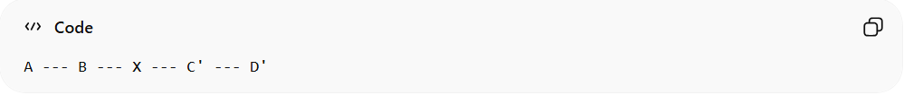
A --- B --- X --- C' --- D'
- C' = feature commit 1 (resolved)
- D' = feature commit 2
✔ Linear history, no merge commit.

8️⃣ Undo a Finished Rebase (Optional)
# Source: AI Source: Provided by: [Data Path: Persons Table -> ID Column: 1, Name_En Column: Motasem Essam] -> From: [ChatGPT] on [2/19/2026]
If you want to undo the rebase:
- Check reflog:
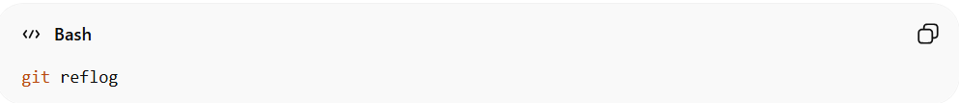
git reflog
You’ll see output like this:
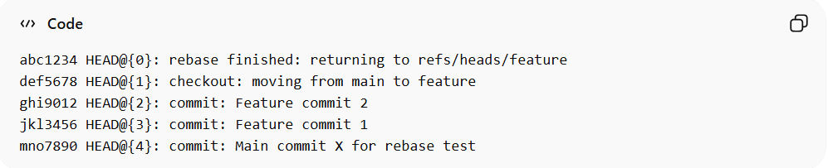
- Reset to state before rebase:
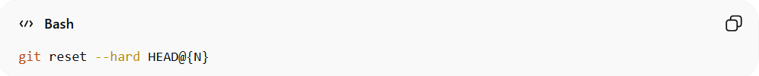
git reset --hard HEAD@{N}
- Replace {N} with the entry just before the rebase

- Check branch history:
git log --oneline --graph –all
- main should point to the commit before the rebase
- feature still has all original commits
- No rebased commits appear on main

Optional: Check reflog to confirm HEAD:
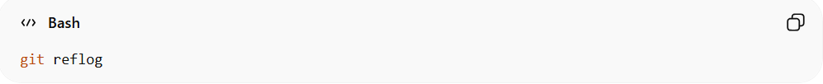
git reflog
- HEAD@{0} should now point to the commit before the rebase

Optional: Check feature branch:
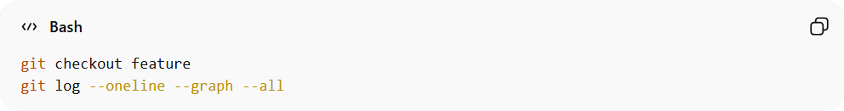
git checkout feature
git log --oneline --graph --all
- All original feature commits remain intact

Rebase vs 🚀 Fast-Forward

🚀 Fast-Forward
# Source: AI Source: Provided by: [Data Path: Persons Table -> ID Column: 1, Name_En Column: Motasem Essam] -> From: [ChatGPT] on [2/19/2026]
A fast-forward is a type of merge.
It happens when the target branch (like main) has no new commits, so Git can simply move the pointer forward.
Example
Before:
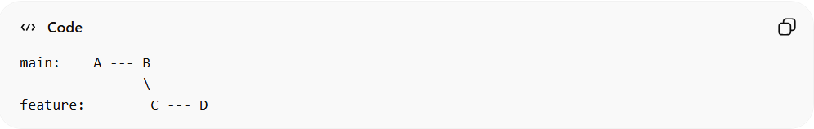
main: A --- B
\
feature: C --- D
If main did not change, merging results in:
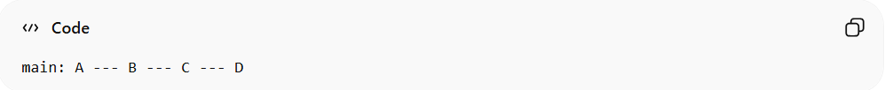
main: A --- B --- C --- D
✔ No new commit created
✔ No history rewritten
✔ Happens automatically when possible

🔁 Rebase
# Source: AI Source: Provided by: [Data Path: Persons Table -> ID Column: 1, Name_En Column: Motasem Essam] -> From: [ChatGPT] on [2/19/2026]
Rebase moves your branch commits on top of another branch by rewriting history.
It changes commit hashes.
Example
Before:
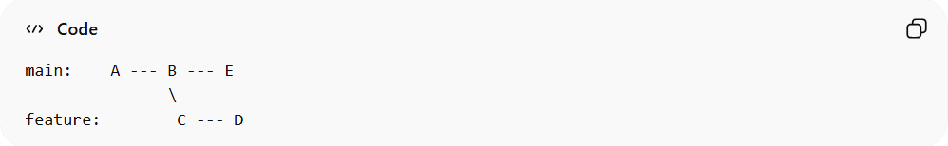
main: A --- B --- E
\
feature: C --- D
If you run:
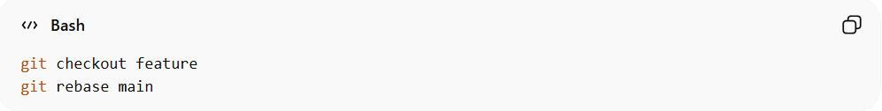
git checkout feature
git rebase main
After rebase:
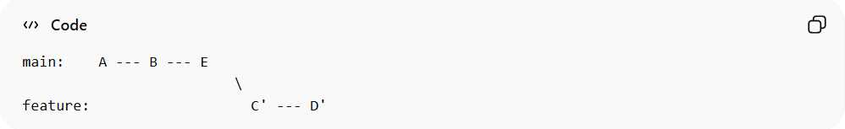
main: A --- B --- E
\
feature: C' --- D'
Now when you merge, it becomes a fast-forward:
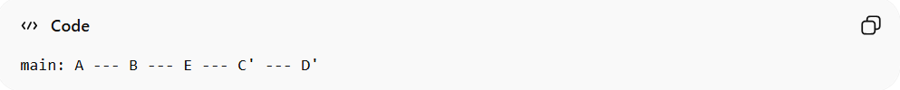
main: A --- B --- E --- C' --- D'
✔ No merge commit
⚠ Rewrites commit history
✔ Makes history linear

🔥 Key Difference
# Source: AI Source: Provided by: [Data Path: Persons Table -> ID Column: 1, Name_En Column: Motasem Essam] -> From: [ChatGPT] on [2/19/2026]
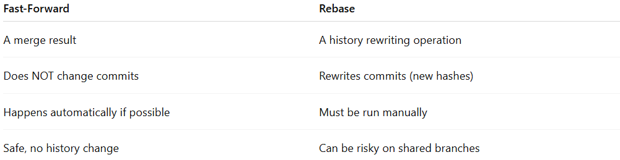
Fast-Forward | Rebase
A merge result | A history rewriting operation
Does NOT change commits | Rewrites commits (new hashes)
Happens automatically if possible | Must be run manually
Safe, no history change | Can be risky on shared branches

🧠 Simple Explanation
# Source: AI Source: Provided by: [Data Path: Persons Table -> ID Column: 1, Name_En Column: Motasem Essam] -> From: [ChatGPT] on [2/19/2026]
- Fast-forward = “Move the branch pointer forward.”
- Rebase = “Pick up my commits and replay them somewhere else.”

📌 On GitHub
# Source: AI Source: Provided by: [Data Path: Persons Table -> ID Column: 1, Name_En Column: Motasem Essam] -> From: [ChatGPT] on [2/19/2026]
- “Rebase and merge” uses rebase first
- Then finishes with a fast-forward merge
- No merge commit is created

🔥 Quick Comparison
# Source: AI Source: Provided by: [Data Path: Persons Table -> ID Column: 1, Name_En Column: Motasem Essam] -> From: [ChatGPT] on [2/19/2026]
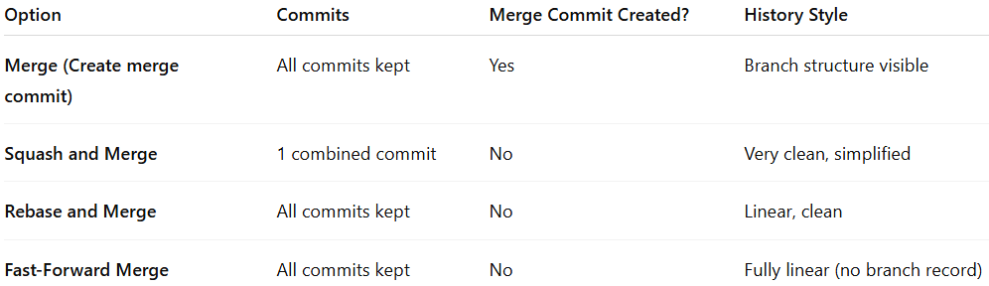
Option | Commits | Merge Commit Created? | History Style
Merge (Create merge commit) | All commits kept | Yes | Branch structure visible
Squash and Merge | 1 combined commit | No | Very clean, simplified
Rebase and Merge | All commits kept | No | Linear, clean
Fast-Forward Merge | All commits kept | No | Fully linear (no branch record)

Merge Commit vs cherry-pick

🔹 1️⃣ Merge Commit
# Source: AI Source: Provided by: [Data Path: Persons Table -> ID Column: 1, Name_En Column: Motasem Essam] -> From: [ChatGPT] on [2/19/2026]
Definition:
A merge commit combines all changes from one branch into another. It keeps the branch history intact and usually has two parents.
Example
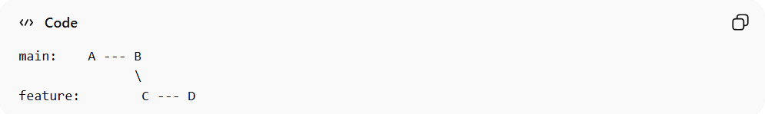
Before merge:
main: A --- B
\
feature: C --- D
After git merge feature:
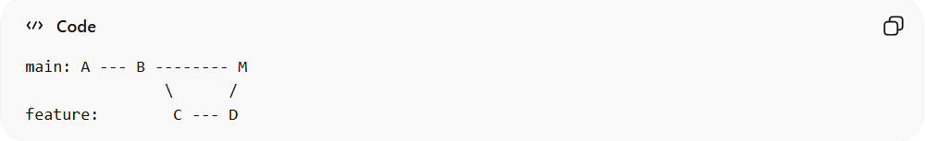
main: A --- B -------- M
\ /
feature: C --- D
- M = merge commit
- Includes all commits C and D
- Maintains the branch structure
✅ Use case: When you want to integrate a full feature or branch and preserve history.

🔹 2️⃣ Cherry-Pick
# Source: AI Source: Provided by: [Data Path: Persons Table -> ID Column: 1, Name_En Column: Motasem Essam] -> From: [ChatGPT] on [2/19/2026]
Definition:
git cherry-pick applies a single commit (or selected commits) from one branch onto another, without merging the whole branch.
Example
You only want commit D from the feature branch:
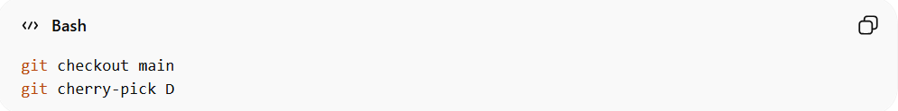
git checkout main
git cherry-pick D
Result:
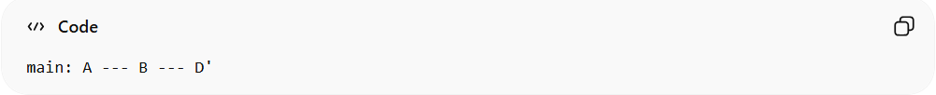
main: A --- B --- D'
- Only commit D is added
- Commit hash changes (D')
- No branch history is preserved
✅ Use case: When you want specific changes without merging a whole branch.

🔹 Key Differences
# Source: AI Source: Provided by: [Data Path: Persons Table -> ID Column: 1, Name_En Column: Motasem Essam] -> From: [ChatGPT] on [2/19/2026]
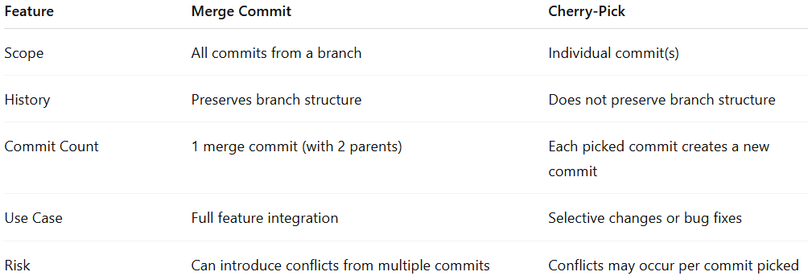
Feature | Merge Commit | Cherry-Pick
Scope | All commits from a branch | Individual commit(s)
History | Preserves branch structure | Does not preserve branch structure
Commit Count | 1 merge commit (with 2 parents) | Each picked commit creates a new commit
Use Case | Full feature integration | Selective changes or bug fixes
Risk | Can introduce conflicts from multiple commits | Conflicts may occur per commit picked

🔹 💡 Quick Analogy
- Merge commit = “Bring in the whole folder of changes.”
- Cherry-pick = “Take just one file from another branch and apply it here.”

🧠 When to Use What?
# Source: AI Source: Provided by: [Data Path: Persons Table -> ID Column: 1, Name_En Column: Motasem Essam] -> From: [ChatGPT] on [2/19/2026]
- Squash → Small feature branches, messy commits
- Rebase → Clean, professional history
- Merge commit → When you want full branch tracking

What most companies prefer in real projects
# Source: AI Source: Provided by: [Data Path: Persons Table -> ID Column: 1, Name_En Column: Motasem Essam] -> From: [ChatGPT] on [2/19/2026]
In real-world software projects, companies choose merge strategies based on team size, workflow, and the need for clean history vs traceability. Here’s a detailed breakdown:

🔹 1️⃣ Merge Commit (Default Merge)
# Source: AI Source: Provided by: [Data Path: Persons Table -> ID Column: 1, Name_En Column: Motasem Essam] -> From: [ChatGPT] on [2/19/2026]
- What it does: Keeps all commits and creates a merge commit to connect branches.
- Why companies use it:
  - Shows the full branch structure
  - Easy to see when features were integrated
  - Safe for shared repositories (no rewriting history)
- Best for:
  - Big teams
  - Long-lived feature or release branches
  - Projects where traceability of merges matters (like enterprise or open-source)
✅ Example: GitHub pull request → “Create a merge commit”

🔹 2️⃣ Squash and Merge
# Source: AI Source: Provided by: [Data Path: Persons Table -> ID Column: 1, Name_En Column: Motasem Essam] -> From: [ChatGPT] on [2/19/2026]
- What it does: Combines all feature branch commits into one commit before merging.
- Why companies use it:
  - Keeps the main branch clean and concise
  - Avoids messy WIP (“work in progress”) commits
- Best for:
  - Small features
  - Short-lived branches
  - Projects where a clean history is more important than full commit trace
✅ Example: A minor bugfix branch with 5 small commits becomes 1 commit on main.

🔹 3️⃣ Rebase and Merge
# Source: AI Source: Provided by: [Data Path: Persons Table -> ID Column: 1, Name_En Column: Motasem Essam] -> From: [ChatGPT] on [2/19/2026]
- What it does: Replays feature branch commits on top of the main branch → creates a linear history
- Why companies use it:
  - Very clean, readable commit history
  - No unnecessary merge commits
- Best for:
  - Small teams or solo developers
  - Teams that enforce strict linear history
- Caution:
  - Rewrites commit hashes → risky for shared branches
  - Usually allowed only on private feature branches
✅ Example: GitHub pull request → “Rebase and merge”

🔹 4️⃣ Fast-Forward Merges
# Source: AI Source: Provided by: [Data Path: Persons Table -> ID Column: 1, Name_En Column: Motasem Essam] -> From: [ChatGPT] on [2/19/2026]
- What it does: Moves branch pointer forward; no merge commit
- Why companies use it:
  - Keeps history completely linear
  - No merge commits cluttering history
- Best for:
  - Small, frequent updates
  - When the main branch is the only place that moves (like hotfix branches)

🔹 📊 Summary Table: What Companies Prefer
# Source: AI Source: Provided by: [Data Path: Persons Table -> ID Column: 1, Name_En Column: Motasem Essam] -> From: [ChatGPT] on [2/19/2026]
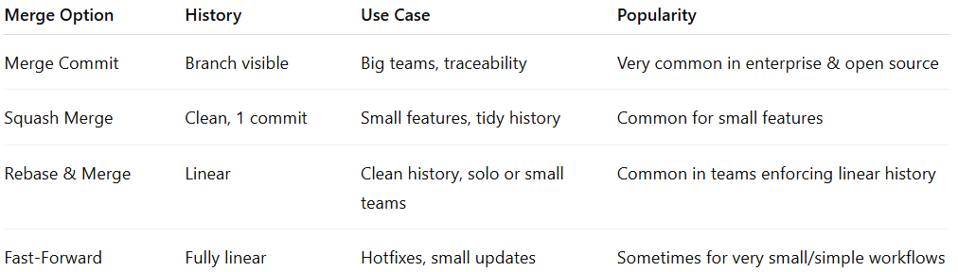
Merge Option | History | Use Case | Popularity
Merge Commit | Branch visible | Big teams, traceability | Very common in enterprise & open source
Squash Merge | Clean, 1 commit | Small features, tidy history | Common for small features
Rebase & Merge | Linear | Clean history, solo or small teams | Common in teams enforcing linear history
Fast-Forward | Fully linear | Hotfixes, small updates | Sometimes for very small/simple workflows

💡 Real-World Trend
# Source: AI Source: Provided by: [Data Path: Persons Table -> ID Column: 1, Name_En Column: Motasem Essam] -> From: [ChatGPT] on [2/19/2026]
- Open-source projects → often use merge commits to show branch history.
- Tech startups → prefer squash or rebase for cleaner main branches.
- Large enterprises → mix merge commits for big features + squash for minor fixes.

Bisect commit
# Source: AI Source: Provided by: [Data Path: Persons Table -> ID Column: 1, Name_En Column: Motasem Essam] -> From: [ChatGPT] on [2/19/2026]
git bisect is a debugging tool in Git that helps you find the exact commit that introduced a bug by using a binary search through your commit history.
Instead of checking commits one by one, Git automatically narrows down the problematic commit by repeatedly asking you whether a commit is good (no bug) or bad (bug present).

⚙️ How It Works (Concept)
# Source: AI Source: Provided by: [Data Path: Persons Table -> ID Column: 1, Name_En Column: Motasem Essam] -> From: [ChatGPT] on [2/19/2026]
If you have:
- 100 commits
- A bug exists now
- But it worked earlier
git bisect will:
- Pick a commit in the middle
- Ask you if it is good or bad
- Narrow the search to half the commits
- Repeat until it finds the first bad commit
This makes it very fast.
Example:
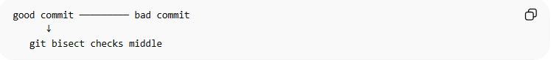
good commit ───────── bad commit
↓
git bisect checks middle

🧪 Basic Workflow
# Source: AI Source: Provided by: [Data Path: Persons Table -> ID Column: 1, Name_En Column: Motasem Essam] -> From: [ChatGPT] on [2/19/2026]
1️⃣ Start bisect
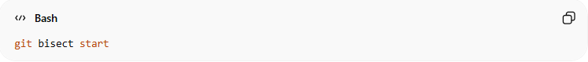
git bisect start
2️⃣ Mark the current commit as bad
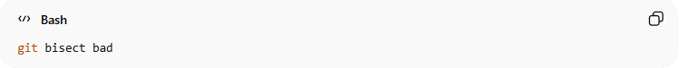
git bisect bad
3️⃣ Mark a known good commit
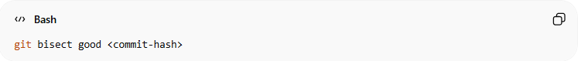
git bisect good <commit-hash>
Git will now checkout a commit in the middle.
4️⃣ Test the code
Run your program/tests and decide:
If the bug exists:
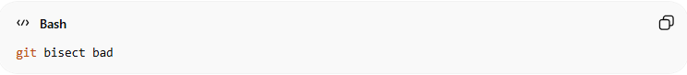
git bisect bad
If it works:
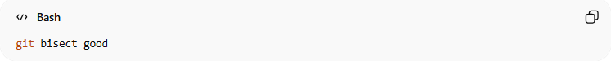
git bisect good
Git repeats this until it finds the first bad commit.
5️⃣ Finish
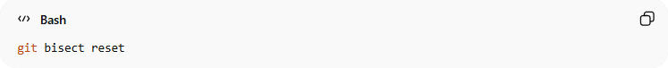
git bisect reset
This returns you to your original branch.

📌 Example
# Source: AI Source: Provided by: [Data Path: Persons Table -> ID Column: 1, Name_En Column: Motasem Essam] -> From: [ChatGPT] on [2/19/2026]
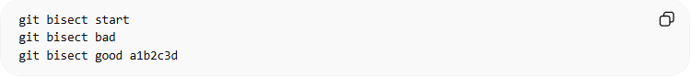
git bisect start
git bisect bad
git bisect good a1b2c3d
Git might respond:
Bisecting: 6 revisions left to test
You test → mark good/bad → Git continues until it outputs:
<commit-hash> is the first bad commit

🚀 Why Developers Use It
# Source: AI Source: Provided by: [Data Path: Persons Table -> ID Column: 1, Name_En Column: Motasem Essam] -> From: [ChatGPT] on [2/19/2026]
git bisect is great for:
- 🐞 Finding when a bug was introduced
- ⚡ Debugging large commit histories
- 🤖 Automating tests while searching
Instead of checking 100 commits, you only test about:
log2(100) ≈ 7 commits

Full Example
# Source: AI Source: Provided by: [Data Path: Persons Table -> ID Column: 1, Name_En Column: Motasem Essam] -> From: [ChatGPT] on [2/19/2026]
Here is a complete practical example you can run yourself to understand git bisect in Git.
We will intentionally add a bug, then use bisect to find the commit that introduced it.

1️⃣ Create a Test Repository
# Source: AI Source: Provided by: [Data Path: Persons Table -> ID Column: 1, Name_En Column: Motasem Essam] -> From: [ChatGPT] on [2/19/2026]
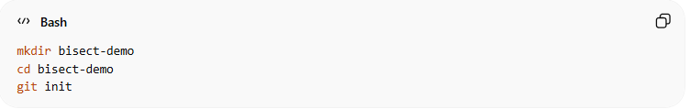
mkdir bisect-demo
cd bisect-demo
git init

2️⃣ Create a Working Program
# Source: AI Source: Provided by: [Data Path: Persons Table -> ID Column: 1, Name_En Column: Motasem Essam] -> From: [ChatGPT] on [2/19/2026]
Create app.py
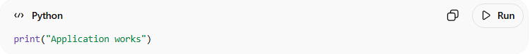
print("Application works")
Commit it:
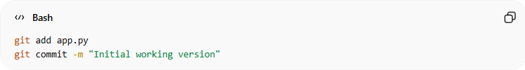
git add app.py
git commit -m "Initial working version"

3️⃣ Add More Good Commits
# Source: AI Source: Provided by: [Data Path: Persons Table -> ID Column: 1, Name_En Column: Motasem Essam] -> From: [ChatGPT] on [2/19/2026]
Edit app.py
print("Application works v2")
Commit:
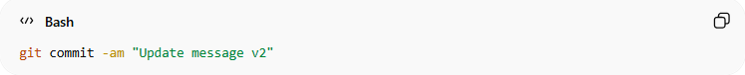
git commit -am "Update message v2"
Edit again:
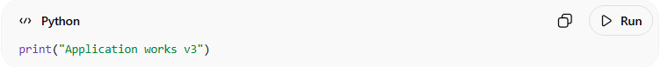
print("Application works v3")
Commit:
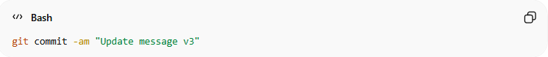
git commit -am "Update message v3"

4️⃣ Introduce a Bug
# Source: AI Source: Provided by: [Data Path: Persons Table -> ID Column: 1, Name_En Column: Motasem Essam] -> From: [ChatGPT] on [2/19/2026]
Now break the program:
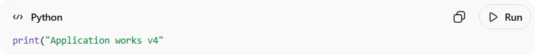
print("Application works v4"
(Missing closing bracket → syntax error)
Commit the bug:
git commit -am "Bug introduced"

5️⃣ Add Another Commit After Bug
# Source: AI Source: Provided by: [Data Path: Persons Table -> ID Column: 1, Name_En Column: Motasem Essam] -> From: [ChatGPT] on [2/19/2026]
Edit:
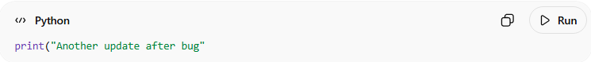
print("Another update after bug"
Commit:
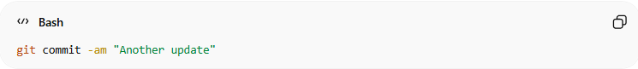
git commit -am "Another update"
Now history looks like:
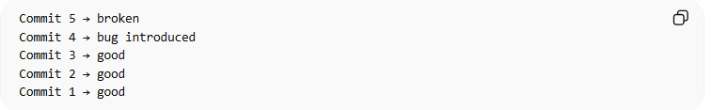
Commit 5 → broken
Commit 4 → bug introduced
Commit 3 → good
Commit 2 → good
Commit 1 → good

6️⃣ Start Git Bisect
# Source: AI Source: Provided by: [Data Path: Persons Table -> ID Column: 1, Name_En Column: Motasem Essam] -> From: [ChatGPT] on [2/19/2026]
Tell Git current version is bad
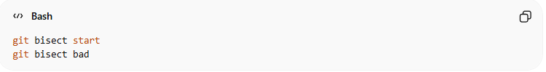
git bisect start
git bisect bad
Tell Git a known good commit
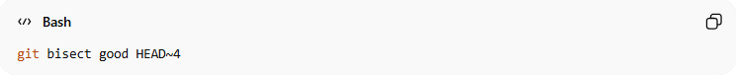
git bisect good HEAD~4

What HEAD~4 Means
- HEAD → the current commit you are on
- HEAD~1 → 1 commit before HEAD
- HEAD~2 → 2 commits before HEAD
- HEAD~3 → 3 commits before HEAD
- HEAD~4 → 4 commits before HEAD

Git will automatically checkout a middle commit.
Example output:
Bisecting: 2 revisions left to test

7️⃣ Test the Code
# Source: AI Source: Provided by: [Data Path: Persons Table -> ID Column: 1, Name_En Column: Motasem Essam] -> From: [ChatGPT] on [2/19/2026]
Run the program:
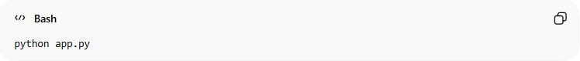
python app.py
If it works:
git bisect good
If it fails:
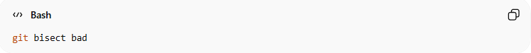
git bisect bad
Git will move to another commit.
Repeat until Git finds:
<commit-hash> is the first bad commit
Example:
abc1234 Bug introduced
Now you know exactly where the bug started.

8️⃣ Exit Bisect
# Source: AI Source: Provided by: [Data Path: Persons Table -> ID Column: 1, Name_En Column: Motasem Essam] -> From: [ChatGPT] on [2/19/2026]
Return to your branch:
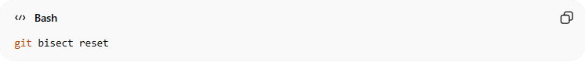
git bisect reset

🎯 Result
# Source: AI Source: Provided by: [Data Path: Persons Table -> ID Column: 1, Name_En Column: Motasem Essam] -> From: [ChatGPT] on [2/19/2026]
You successfully used git bisect to:
- search commit history
- test commits
- locate the first bad commit

💡 Pro tip (real developer workflow):
# Source: AI Source: Provided by: [Data Path: Persons Table -> ID Column: 1, Name_En Column: Motasem Essam] -> From: [ChatGPT] on [2/19/2026]
You can automate testing with:
git bisect run python app.py
Git will automatically test each commit.

Verify
# Source: AI Source: Provided by: [Data Path: Persons Table -> ID Column: 1, Name_En Column: Motasem Essam] -> From: [ChatGPT] on [2/19/2026]
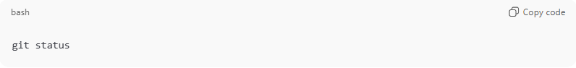
git status
- With --soft, you’ll see the files staged for commit.
- With --mixed, the files appear modified but not staged.

⚡ Summary
# Source: AI Source: Provided by: [Data Path: Persons Table -> ID Column: 1, Name_En Column: Motasem Essam] -> From: [ChatGPT] on [2/19/2026]
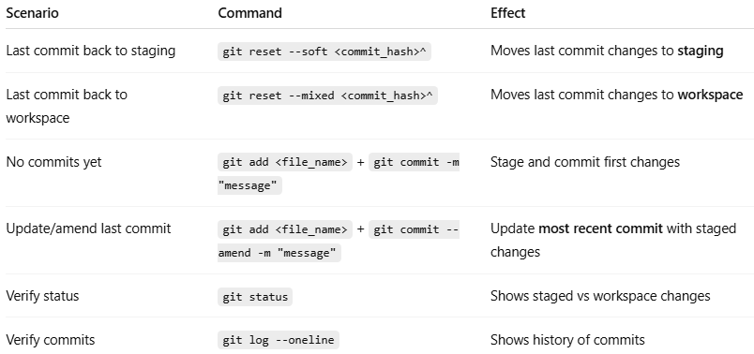
Scenario | Command | Effect
Last commit back to staging | git reset --soft <commit_hash>^ | Moves last commit changes to staging
Last commit back to workspace | git reset --mixed <commit_hash>^ | Moves last commit changes to workspace
No commits yet | git add <file_name> + git commit -m "message" | Stage and commit first changes
Update/amend last commit | git add <file_name> + git commit --amend -m "message" | Update most recent commit with staged changes
Verify status | git status | Shows staged vs workspace changes
Verify commits | git log --oneline | Shows history of commits

💡 Tips:
- Use git commit --amend for the first commit or last commit updates.
- Use HEAD~1 if you prefer not to type the hash when moving the last commit back to staging.
- Always check git status before and after to ensure your changes are staged or unstaged correctly.

Example

Check commit history
# Source: ScreenShots Source: Provided by: [Persons Table -> ID Column: 1, Name_En Column: Motasem Essam] -> Tool: [Lightshot Program] -> From [Operating System: Windows] on [2/19/2026]
After add first commit and push remote
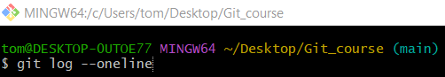
git log --oneline
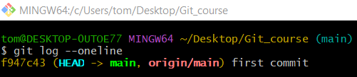

After add second commit but didn’t push to remote yet

git log --oneline
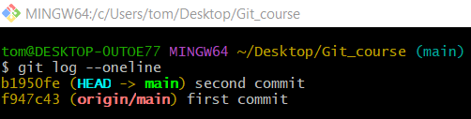

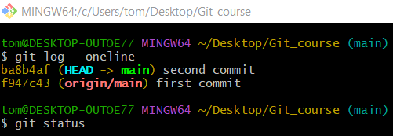
git status
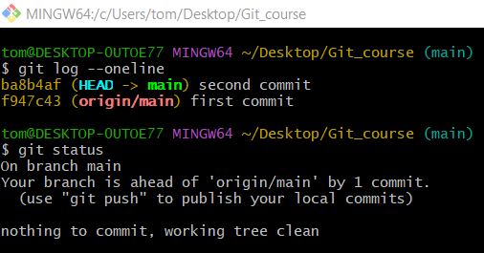

Update commits

Method 1: Update the most recent commit

Option 1: Amend and change the commit message
# Source: ScreenShots Source: Provided by: [Persons Table -> ID Column: 1, Name_En Column: Motasem Essam] -> Tool: [Lightshot Program] -> From [Operating System: Windows] on [2/19/2026]
I have two commits but didn’t push to remote yet
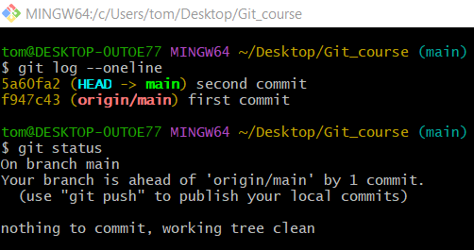
then create new file and check git status and stage it
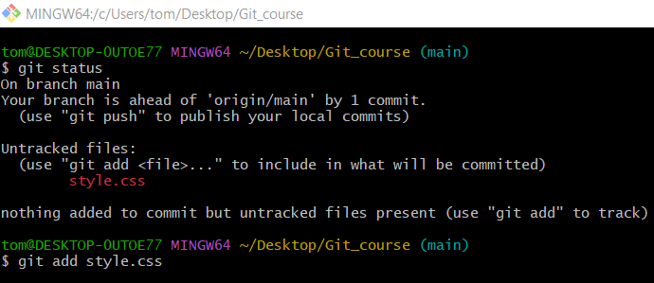

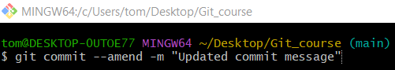
git commit --amend -m "Updated commit message"
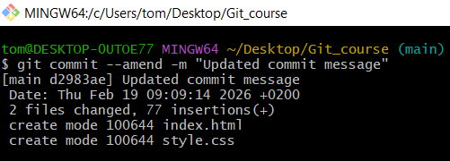
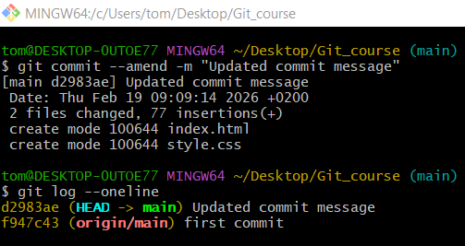

Option 2: Amend without changing the commit message
# Source: ScreenShots Source: Provided by: [Persons Table -> ID Column: 1, Name_En Column: Motasem Essam] -> Tool: [Lightshot Program] -> From [Operating System: Windows] on [2/19/2026]
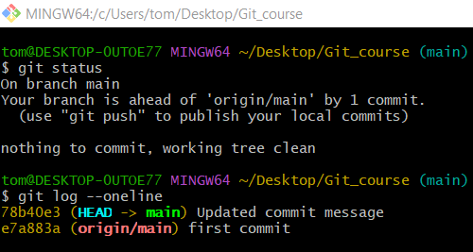
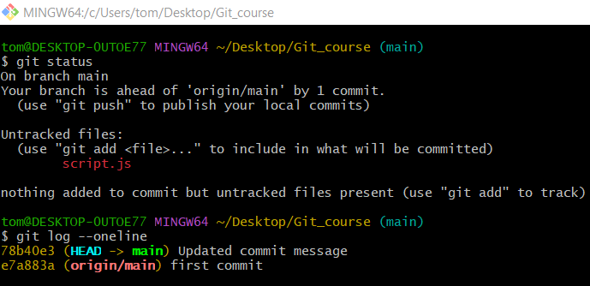
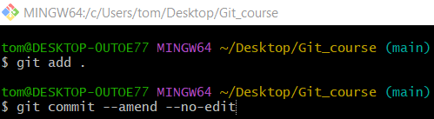
git commit --amend --no-edit
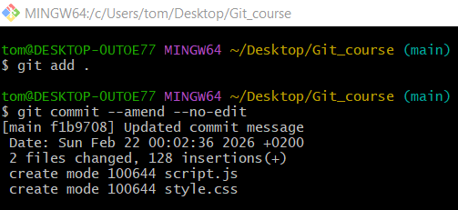
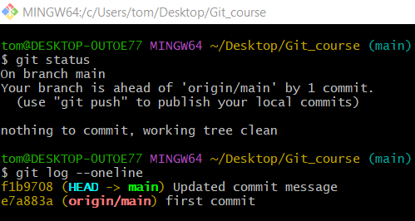

Method 2: Update Older Commits

Option 1: Modify files and/or message
# Source: ScreenShots Source: Provided by: [Persons Table -> ID Column: 1, Name_En Column: Motasem Essam] -> Tool: [Lightshot Program] -> From [Operating System: Windows] on [2/19/2026]
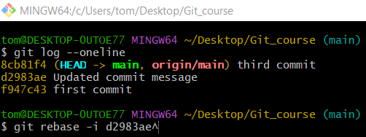
git rebase -i d2983ae^
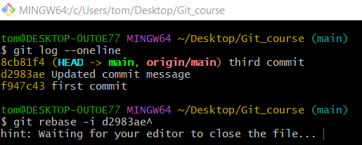
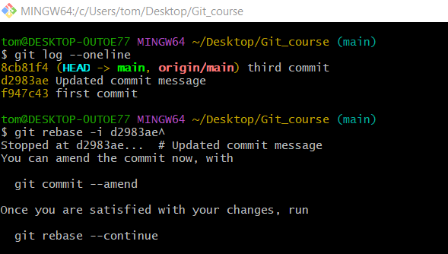
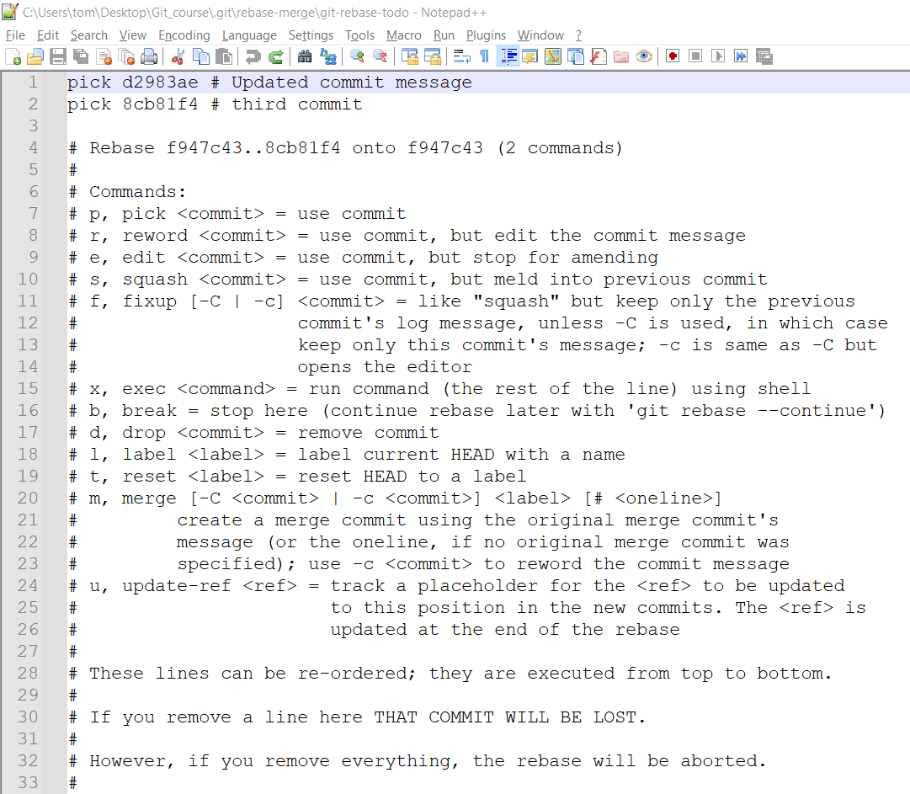
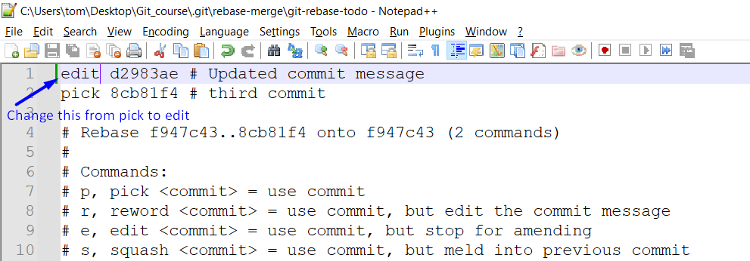
Save and close editor. Git pauses at the commit.

modify style CSS file name and content
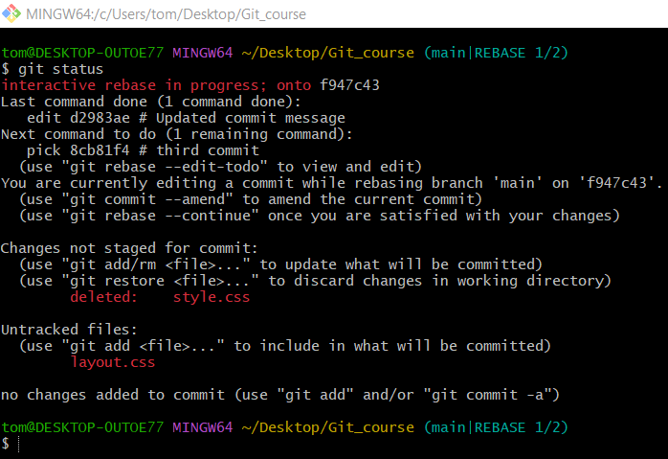
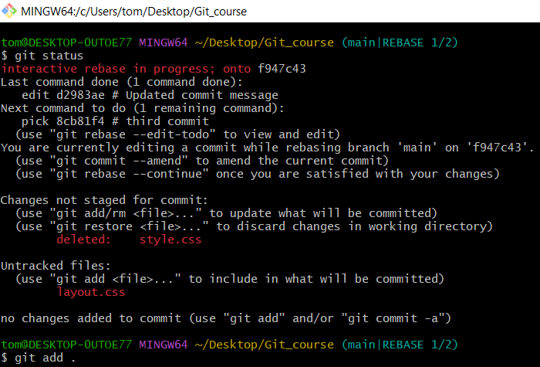
Git add .
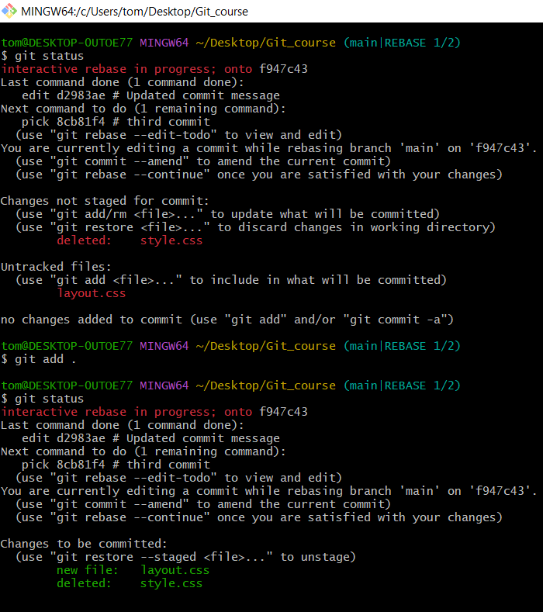
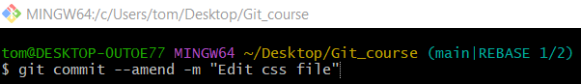
git commit --amend -m "Edit css file"
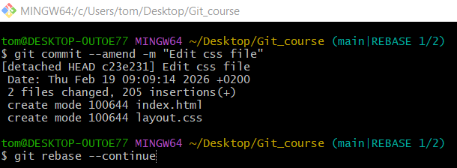
git rebase --continue
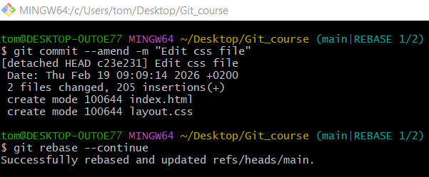

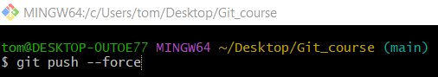
git push --force
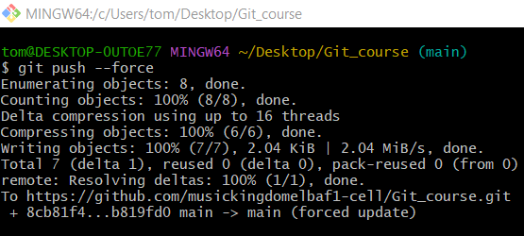
# Source: ScreenShots Source: Provided by: [Persons Table -> ID Column: 1, Name_En Column: Motasem Essam] -> Tool: [Lightshot Program] -> From [Site: https://github.com] on [2/19/2026]
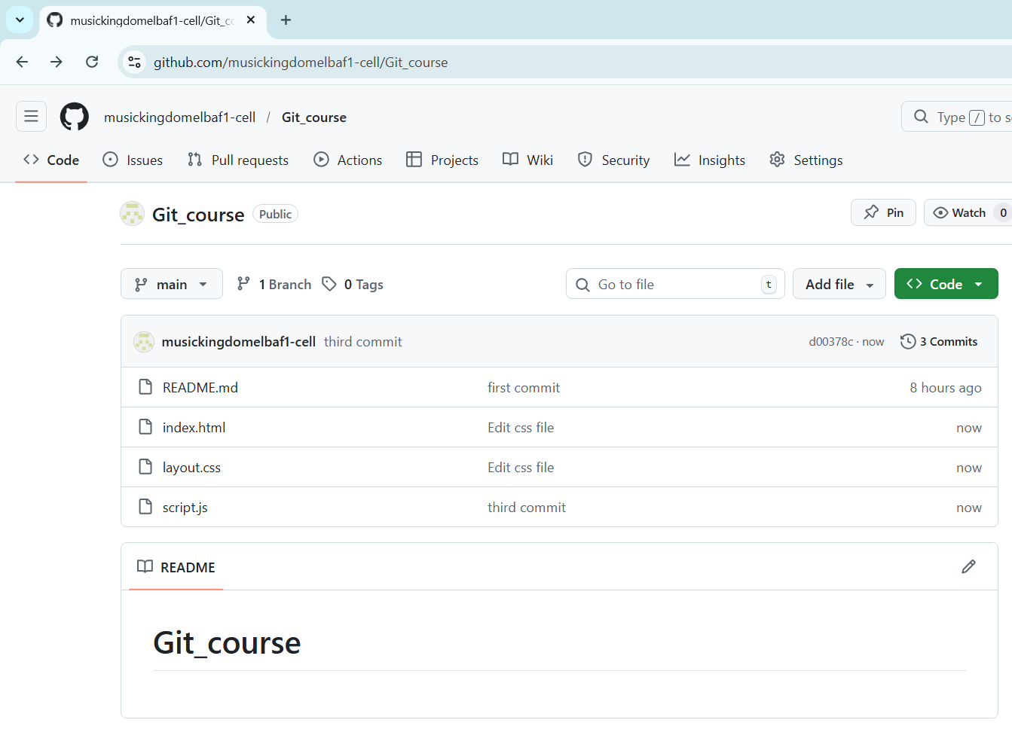

Option 2: Change only commit message
# Source: ScreenShots Source: Provided by: [Persons Table -> ID Column: 1, Name_En Column: Motasem Essam] -> Tool: [Lightshot Program] -> From [Operating System: Windows] on [2/19/2026]
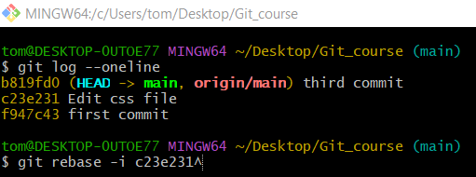
git rebase -i c23e231^
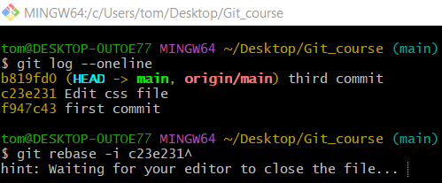
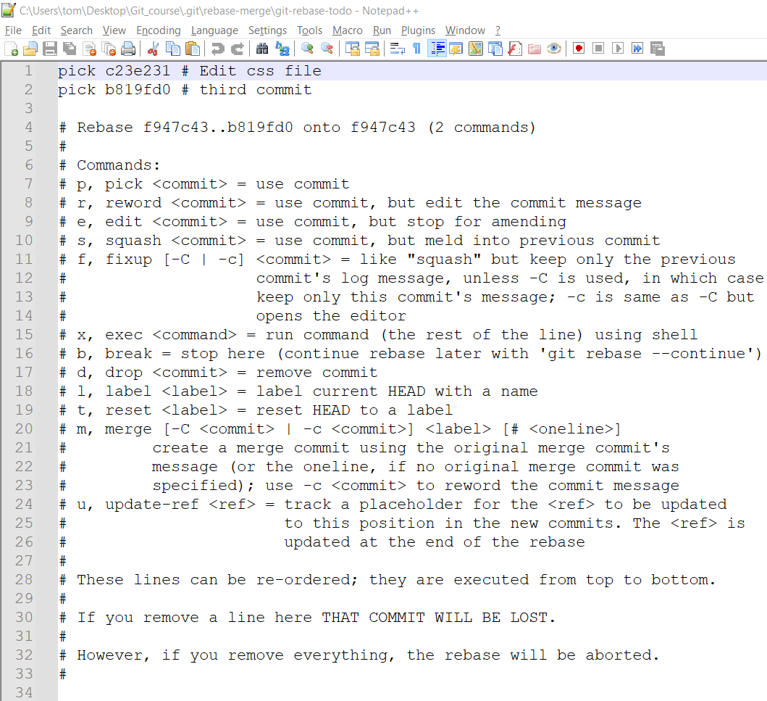
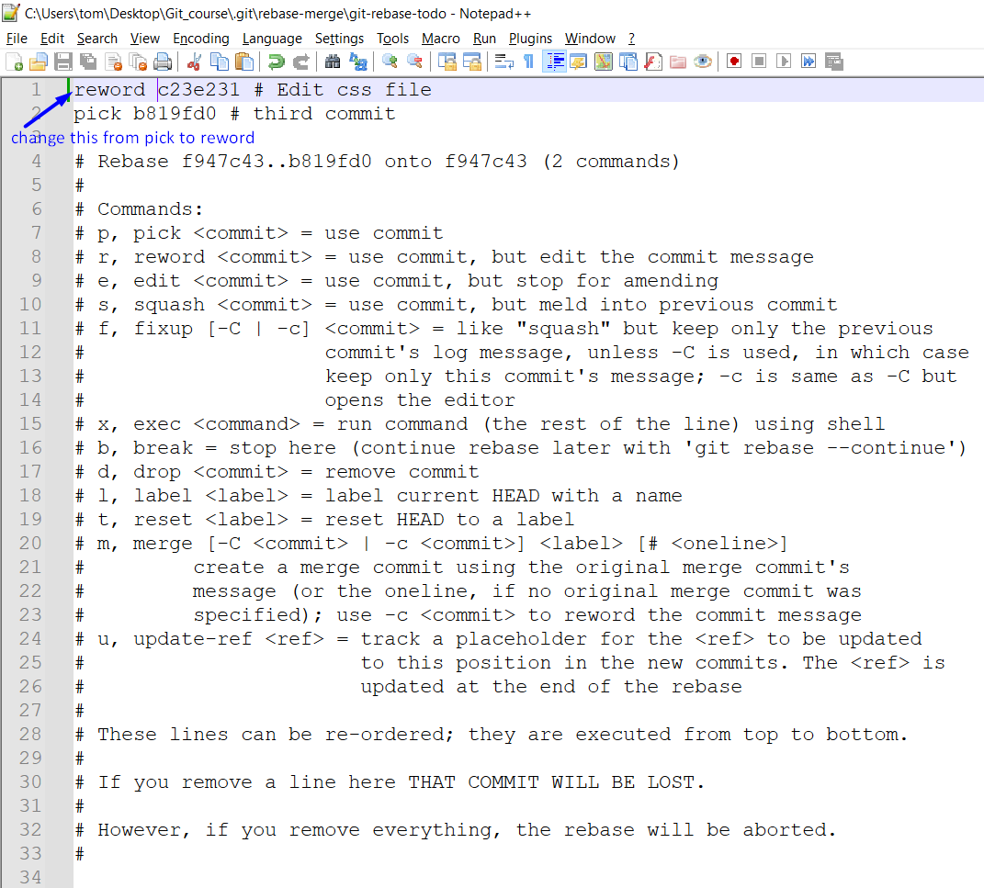
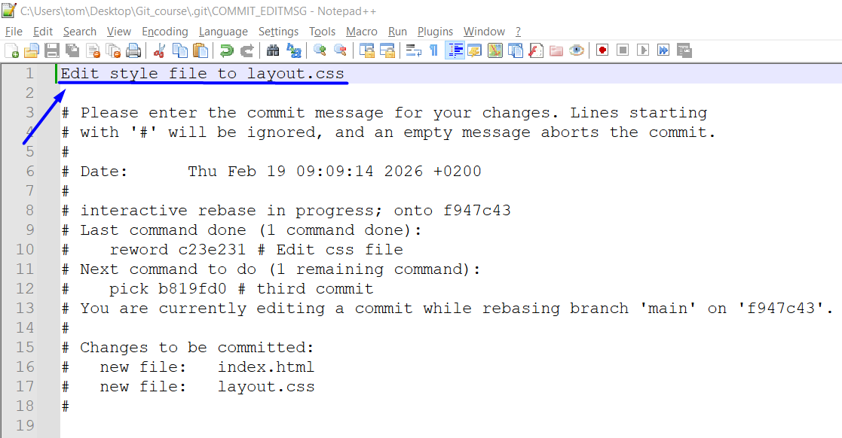
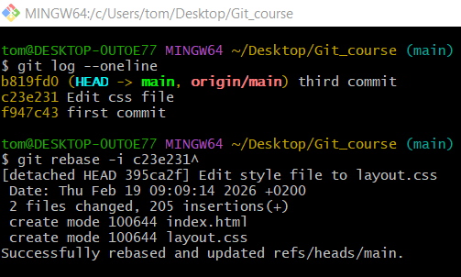

git push --force
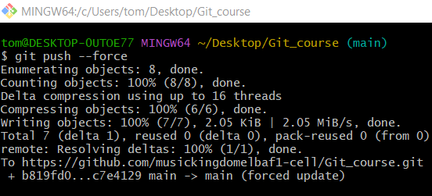
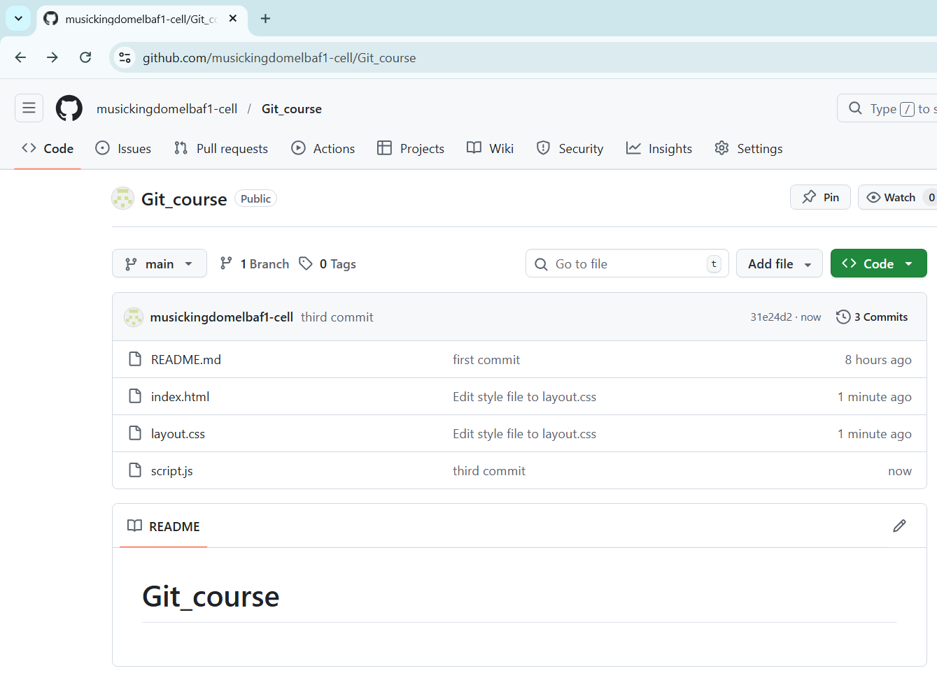

Combine commits

Method 1: squash
# Source: ScreenShots Source: Provided by: [Persons Table -> ID Column: 1, Name_En Column: Motasem Essam] -> Tool: [Lightshot Program] -> From [Site: https://github.com] on [2/19/2026]
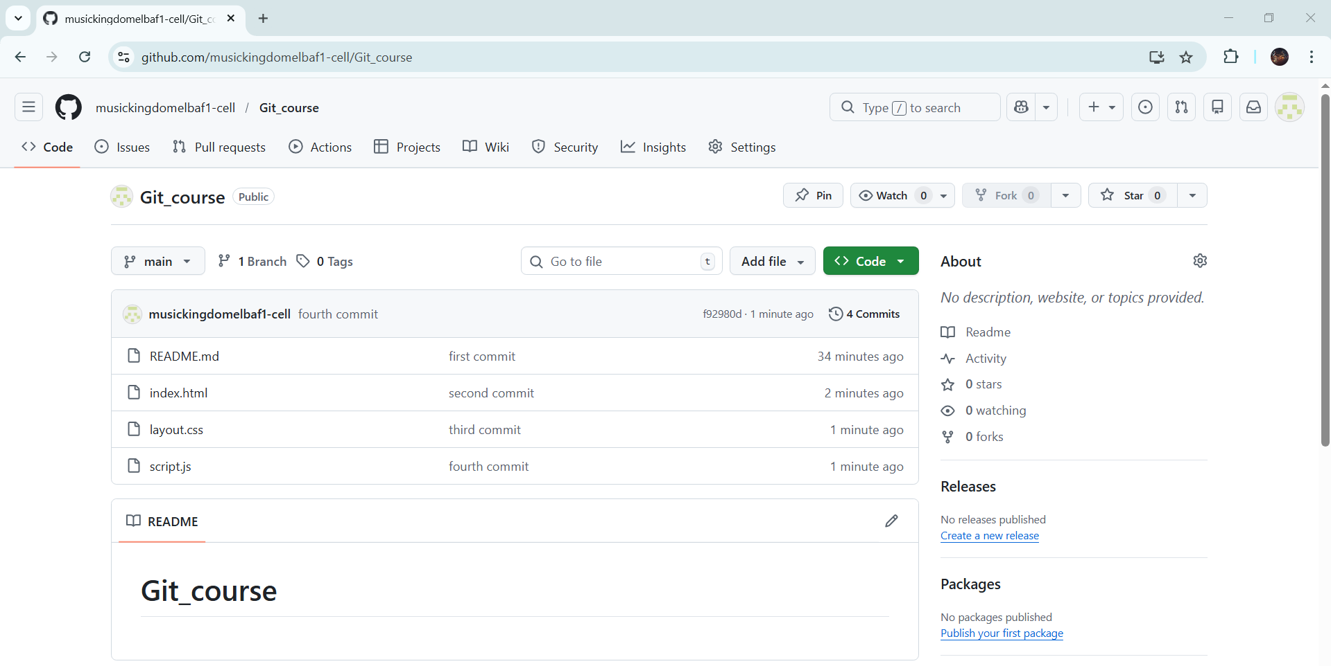
# Source: ScreenShots Source: Provided by: [Persons Table -> ID Column: 1, Name_En Column: Motasem Essam] -> Tool: [Lightshot Program] -> From [Operating System: Windows] on [2/19/2026]
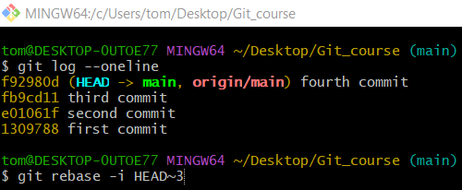
git rebase -i HEAD~3

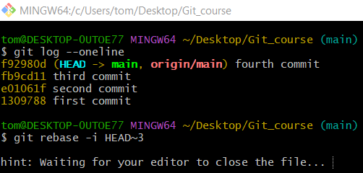
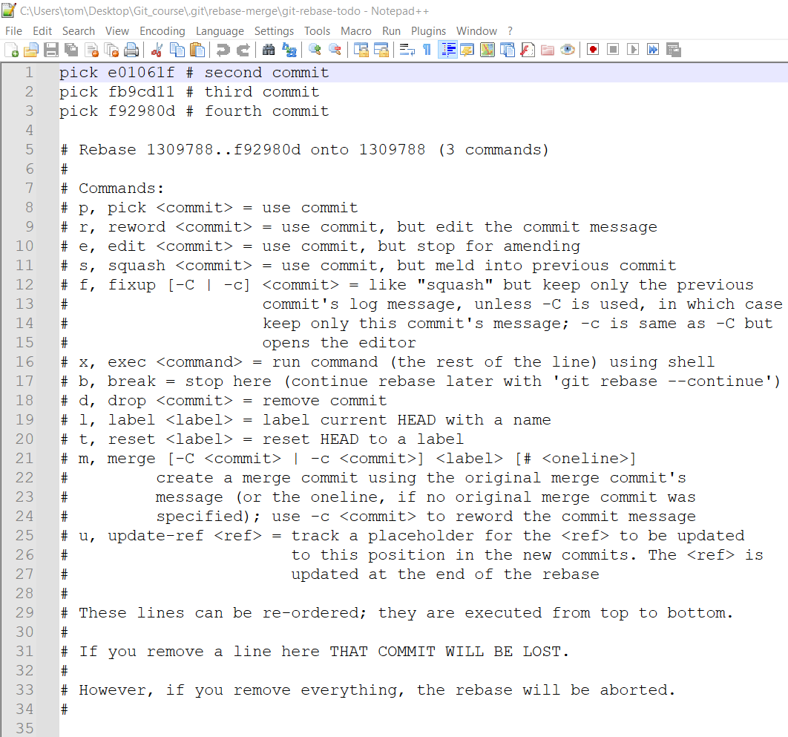
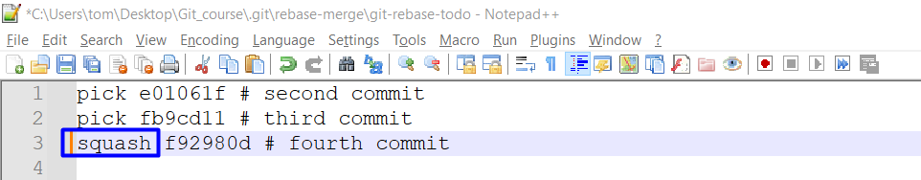
squash
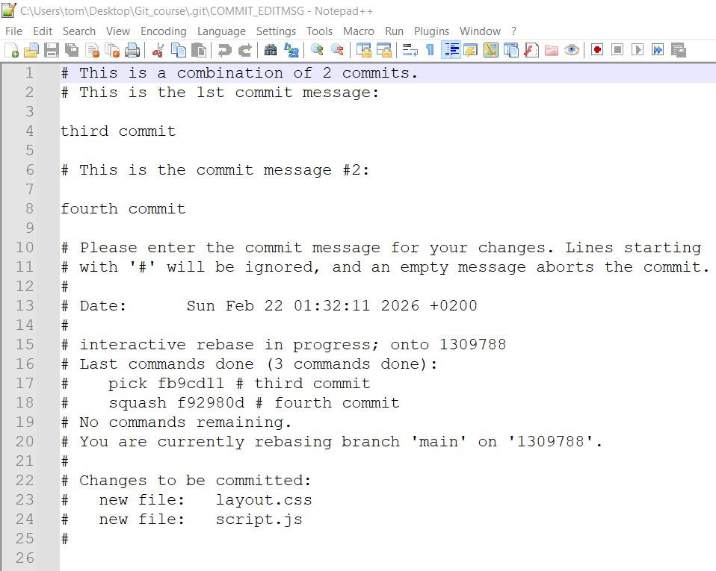

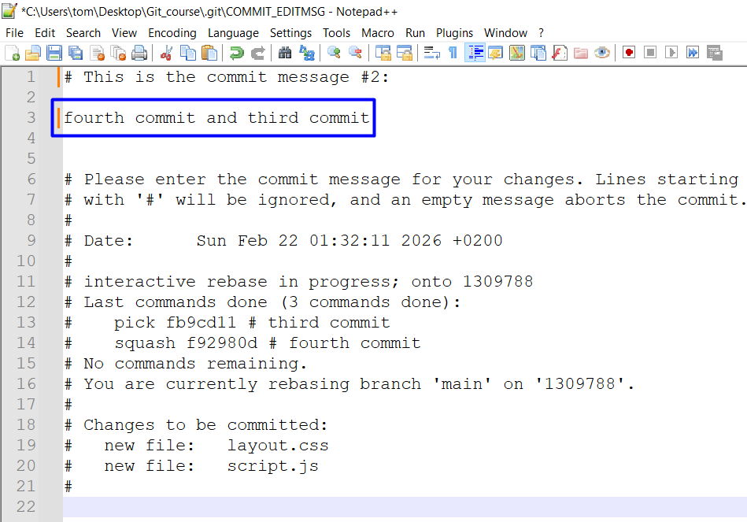
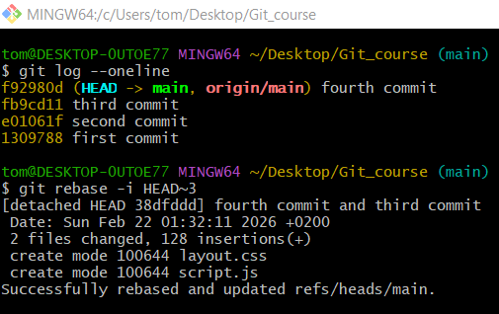

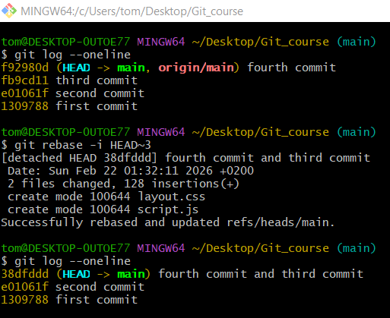

Method 2: fixup
# Source: ScreenShots Source: Provided by: [Persons Table -> ID Column: 1, Name_En Column: Motasem Essam] -> Tool: [Lightshot Program] -> From [Operating System: Windows] on [2/19/2026]
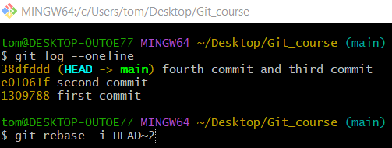
git rebase -i HEAD~2
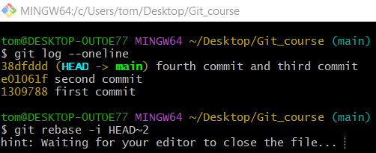
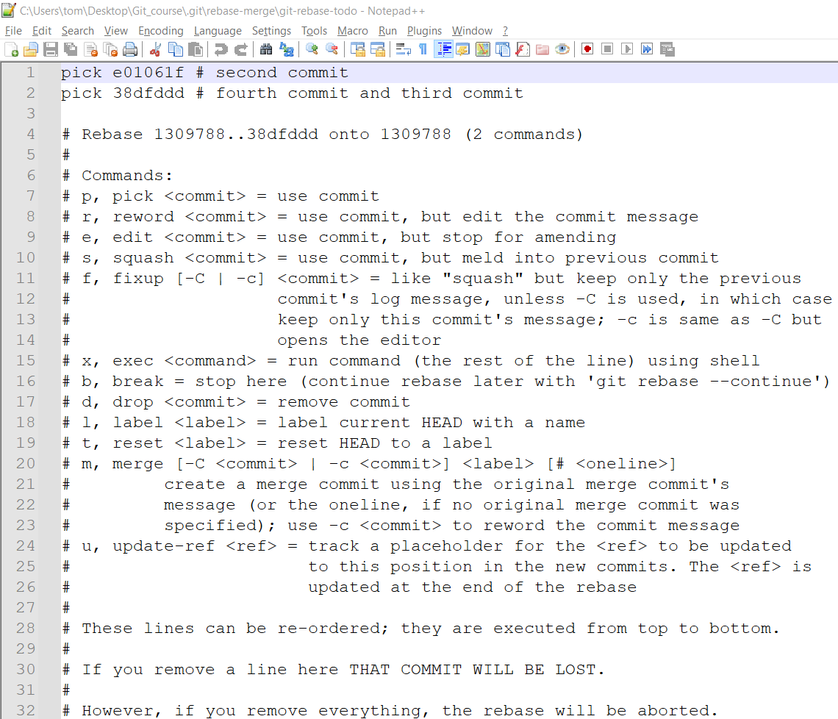
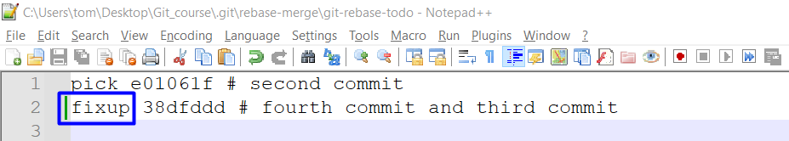
fixup
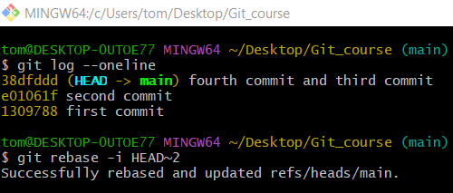
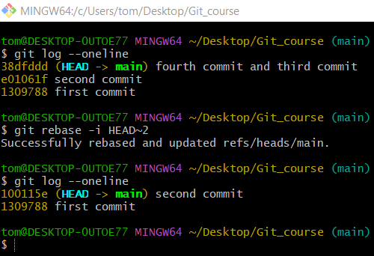
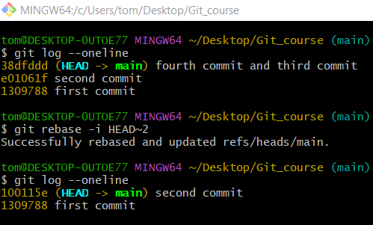
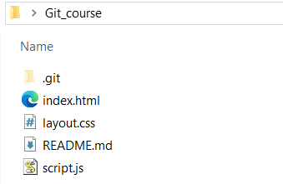

Delete Commits

✅ Method 1: Use Reset

✅ Option 1: Delete last commit and discard its changes
# Source: ScreenShots Source: Provided by: [Persons Table -> ID Column: 1, Name_En Column: Motasem Essam] -> Tool: [Lightshot Program] -> From [Operating System: Windows] on [2/19/2026]
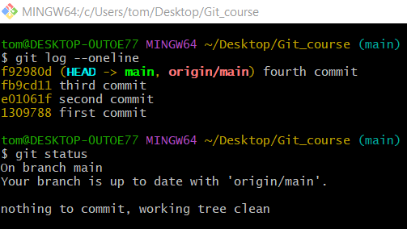
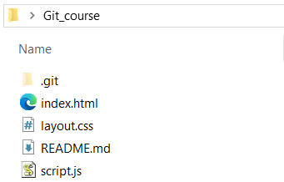
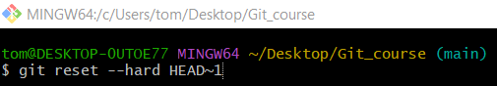
git reset --hard HEAD~1
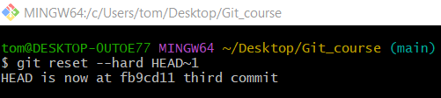
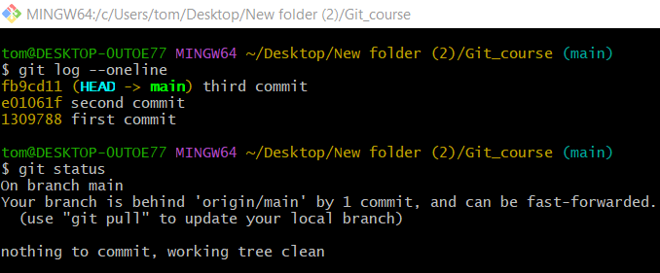
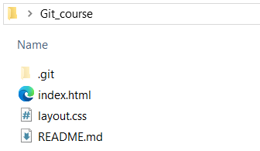

✅ Option 2: Delete last commit but keep the changes (recommended if unsure)
# Source: ScreenShots Source: Provided by: [Persons Table -> ID Column: 1, Name_En Column: Motasem Essam] -> Tool: [Lightshot Program] -> From [Site: https://github.com] on [2/19/2026]

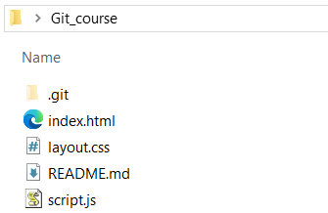
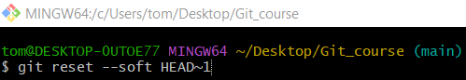
git reset --soft HEAD~1
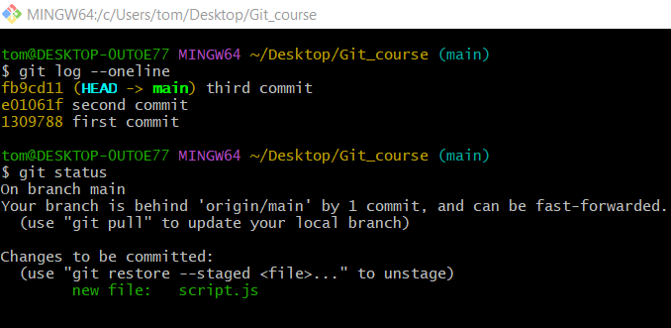
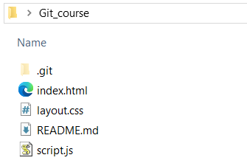

✅ Option 3: Keep changes unstaged
# Source: ScreenShots Source: Provided by: [Persons Table -> ID Column: 1, Name_En Column: Motasem Essam] -> Tool: [Lightshot Program] -> From [Site: https://github.com] on [2/19/2026]

/

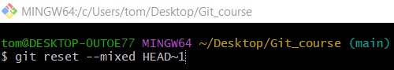
git reset --mixed HEAD~1
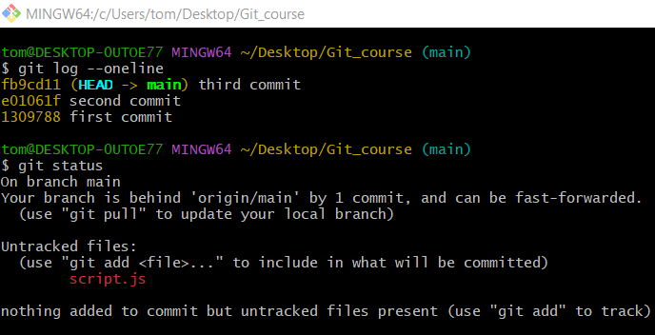


git reset with a commit hash
# Source: ScreenShots Source: Provided by: [Persons Table -> ID Column: 1, Name_En Column: Motasem Essam] -> Tool: [Lightshot Program] -> From [Site: https://github.com] on [2/19/2026]


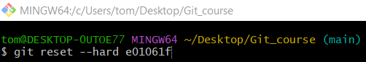
git reset --hard e01061f
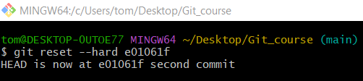
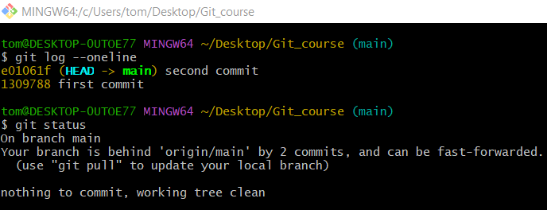
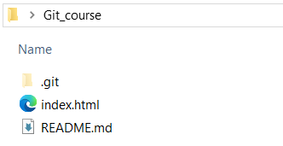

✅ Method 2: Use Interactive Rebase
# Source: ScreenShots Source: Provided by: [Persons Table -> ID Column: 1, Name_En Column: Motasem Essam] -> Tool: [Lightshot Program] -> From [Site: https://github.com] on [2/19/2026]


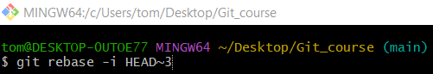
git rebase -i HEAD~3
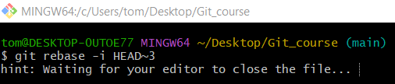

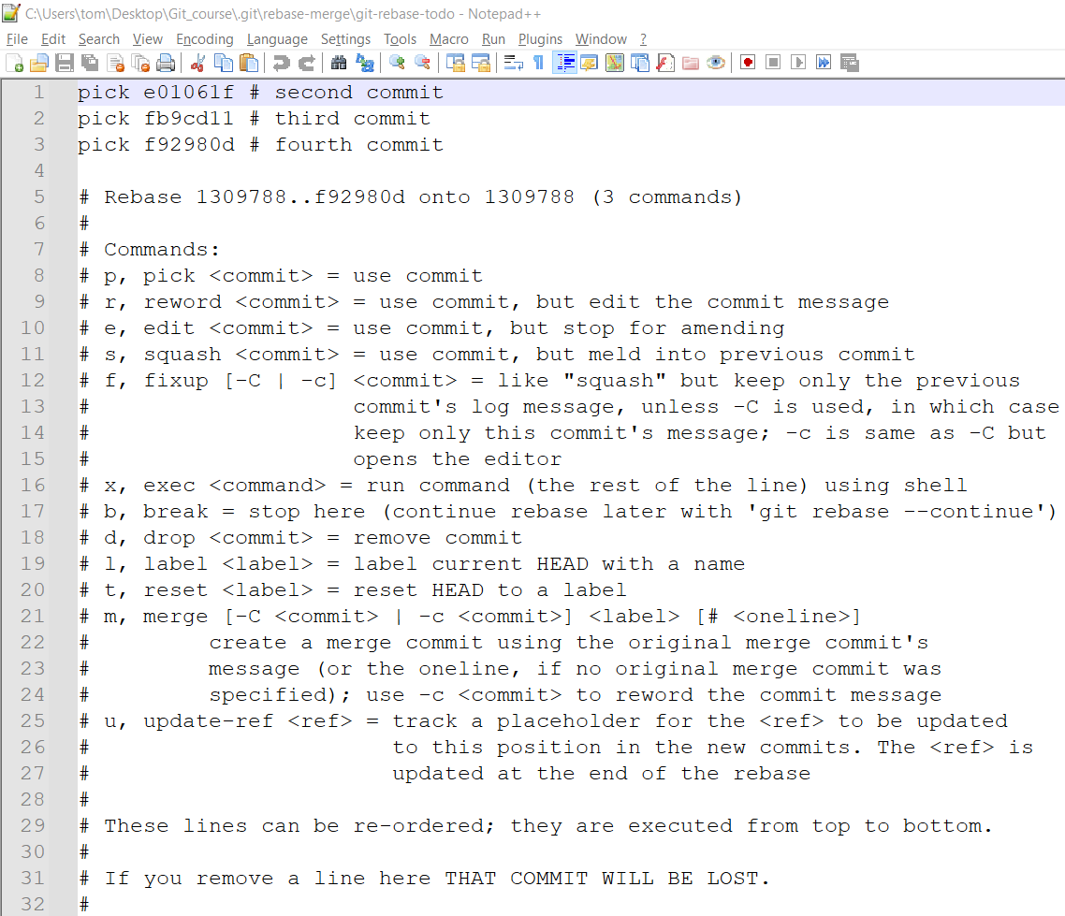
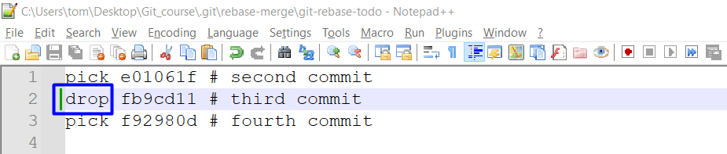
drop
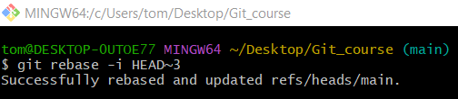
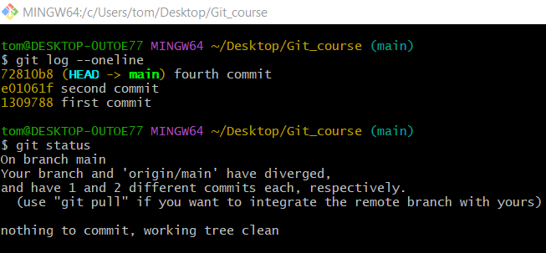
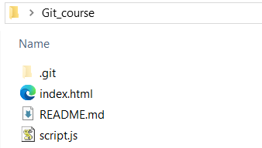

✅ Method 3: Use its hash
# Source: ScreenShots Source: Provided by: [Persons Table -> ID Column: 1, Name_En Column: Motasem Essam] -> Tool: [Lightshot Program] -> From [Site: https://github.com] on [2/19/2026]


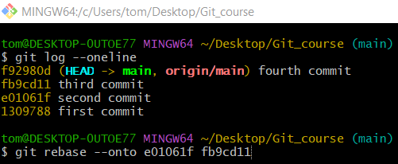
git rebase --onto e01061f fb9cd11
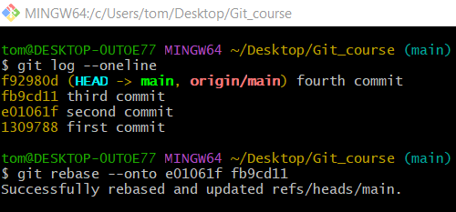
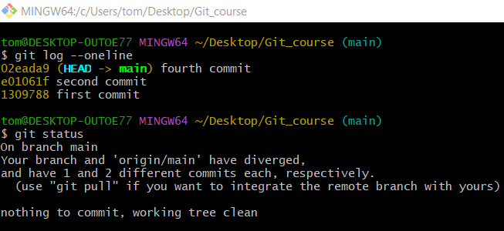


Using git reflog
# Source: ScreenShots Source: Provided by: [Persons Table -> ID Column: 1, Name_En Column: Motasem Essam] -> Tool: [Lightshot Program] -> From [Site: https://github.com] on [2/19/2026]
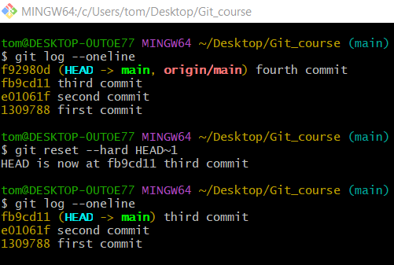
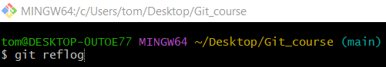
git reflog
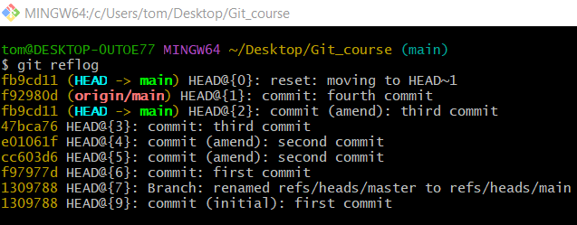
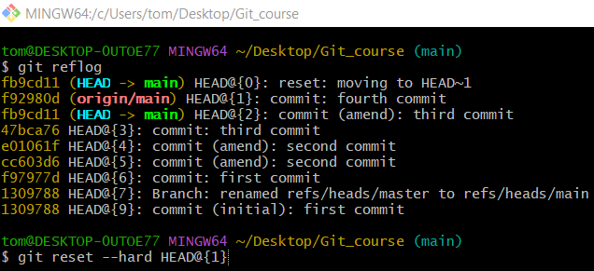
git reset --hard HEAD@{1}
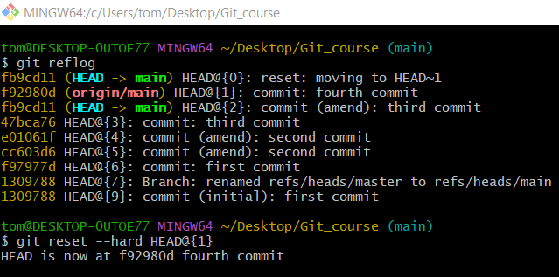
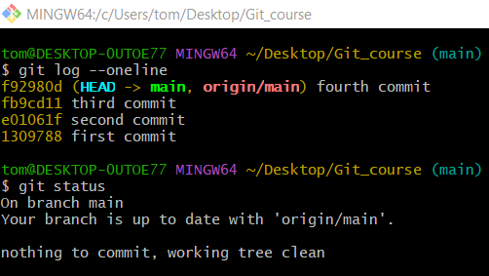

Rollback Commit in Phpstrom
# Source: ScreenShots Source: Provided by: [Persons Table -> ID Column: 1, Name_En Column: Motasem Essam] -> Tool: [Lightshot Program] -> From [Site: https://github.com] on [2/19/2026]
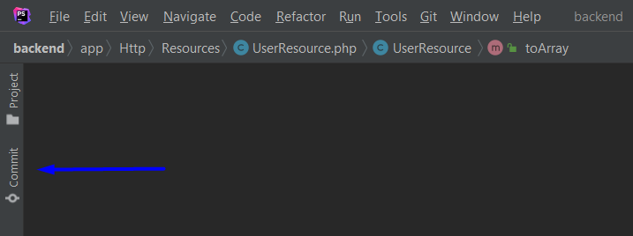
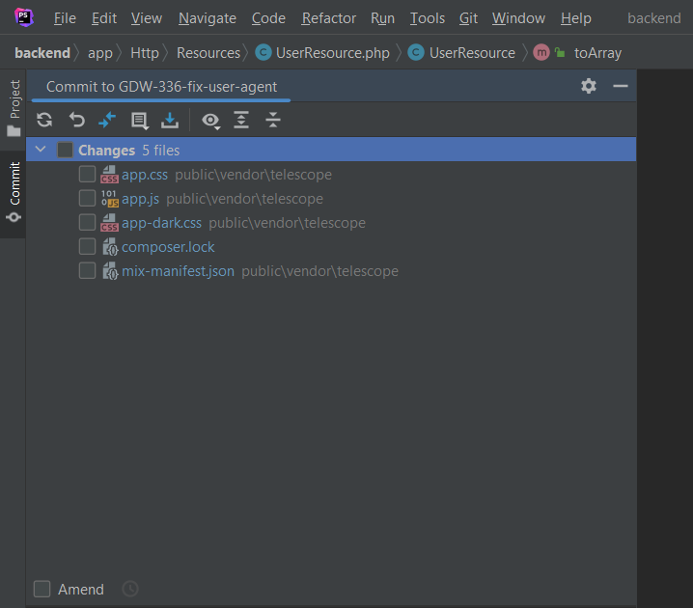
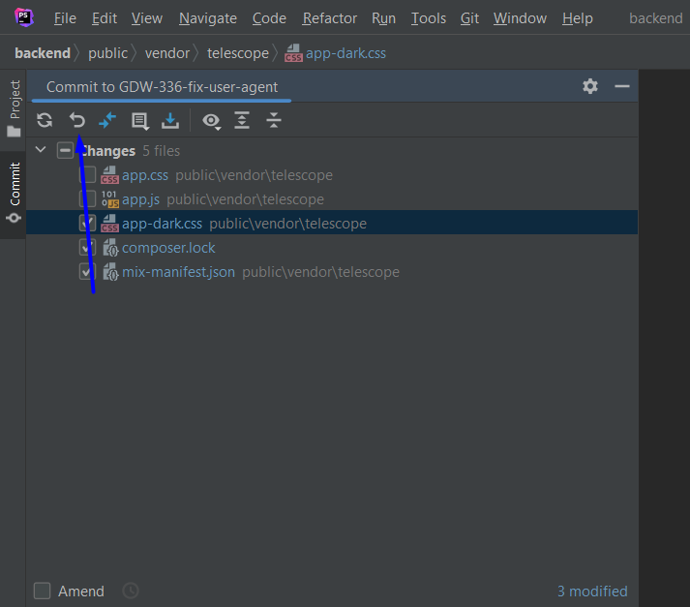

Revert Commit
# Source: ScreenShots Source: Provided by: [Persons Table -> ID Column: 1, Name_En Column: Motasem Essam] -> Tool: [Lightshot Program] -> From [Operating System: Windows] on [2/19/2026]
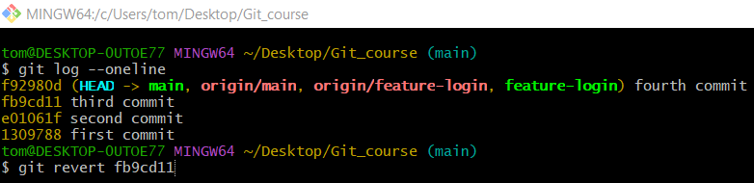
git revert fb9cd11
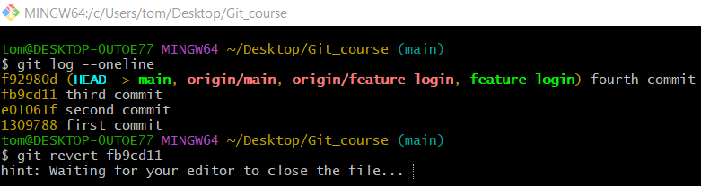
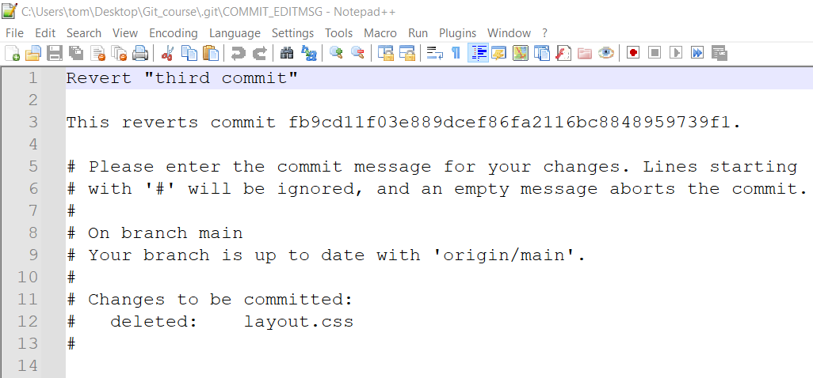
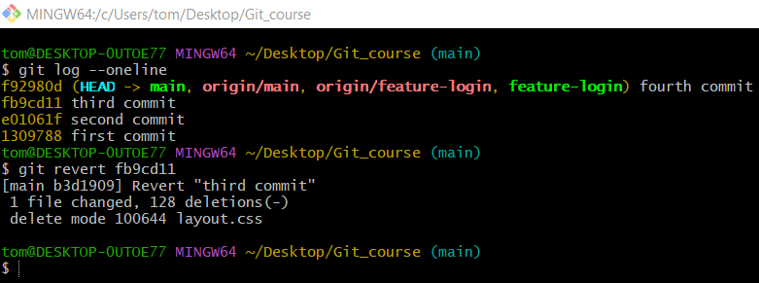
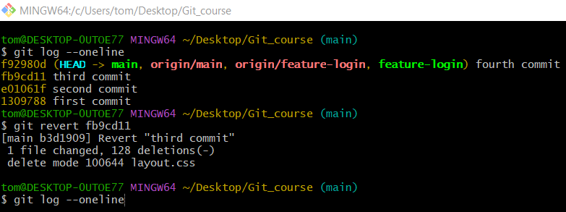
git log --oneline
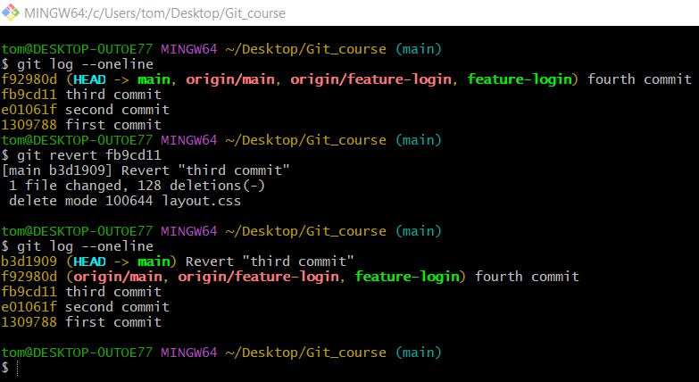
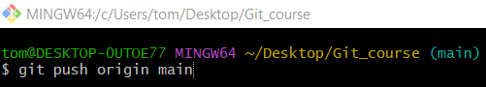
git push origin main
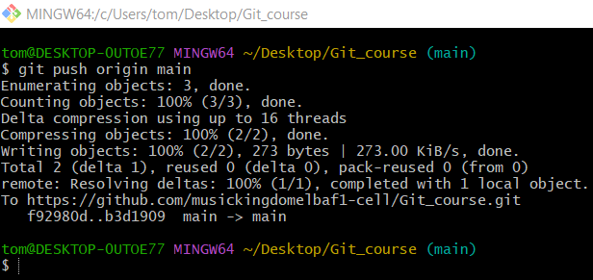

Merge Commit

cherry-pick
# Source: ScreenShots Source: Provided by: [Persons Table -> ID Column: 1, Name_En Column: Motasem Essam] -> Tool: [Lightshot Program] -> From [Operating System: Windows] on [2/19/2026]
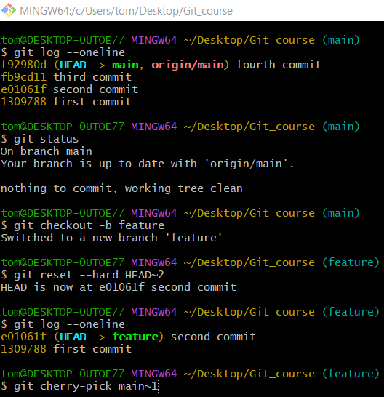
git cherry-pick main~1
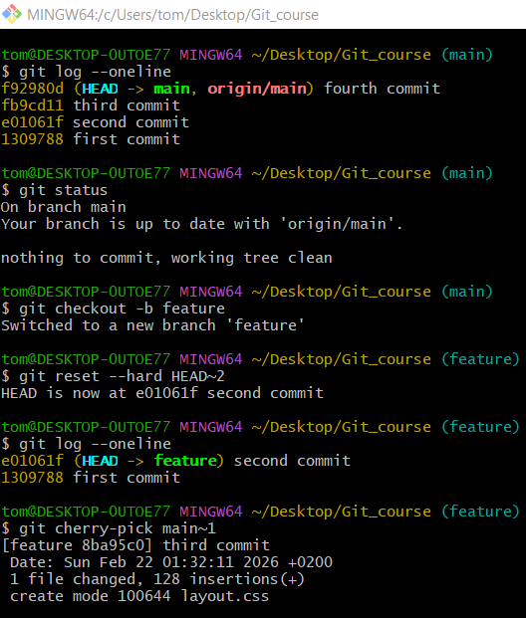
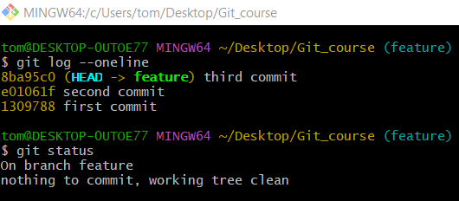

Fast-forward

Full Step-by-Step Lab: Fast-Forward

🔹 Step 1: Create a Test Repository
# Source: ScreenShots Source: Provided by: [Persons Table -> ID Column: 1, Name_En Column: Motasem Essam] -> Tool: [Lightshot Program] -> From [Operating System: Windows] on [2/19/2026]
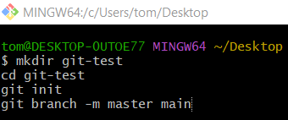
mkdir git-test
cd git-test
git init
git branch -m master main
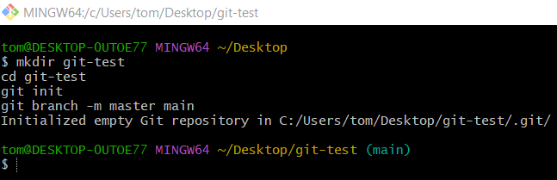

🔹 Step 2: Initial Commit on main
# Source: ScreenShots Source: Provided by: [Persons Table -> ID Column: 1, Name_En Column: Motasem Essam] -> Tool: [Lightshot Program] -> From [Operating System: Windows] on [2/19/2026]
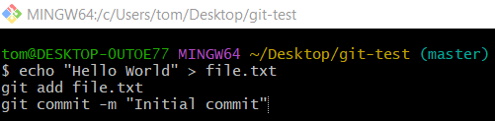
echo "Hello World" > file.txt
git add file.txt
git commit -m "Initial commit"
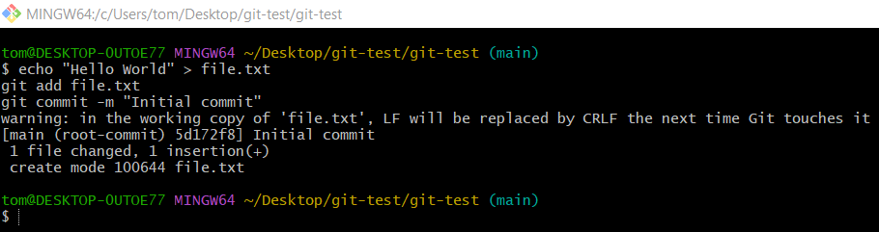

🔹 Step 3: Create a Feature Branch
# Source: ScreenShots Source: Provided by: [Persons Table -> ID Column: 1, Name_En Column: Motasem Essam] -> Tool: [Lightshot Program] -> From [Operating System: Windows] on [2/19/2026]
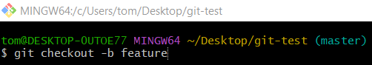
git checkout -b feature
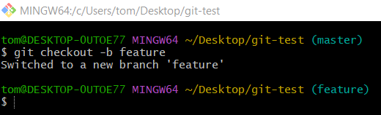
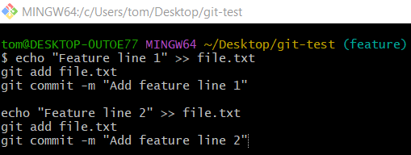
echo "Feature line 1" >> file.txt
git add file.txt
git commit -m "Add feature line 1"

echo "Feature line 2" >> file.txt
git add file.txt
git commit -m "Add feature line 2"
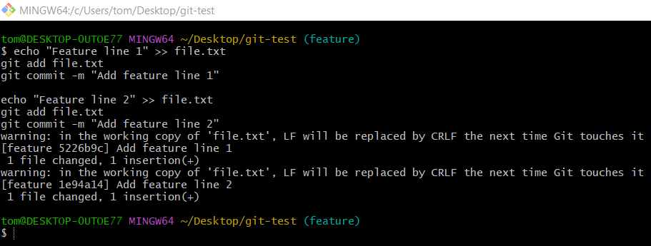

🔹 Step 4: Merge Feature into main (Normal Merge)
# Source: ScreenShots Source: Provided by: [Persons Table -> ID Column: 1, Name_En Column: Motasem Essam] -> Tool: [Lightshot Program] -> From [Operating System: Windows] on [2/19/2026]
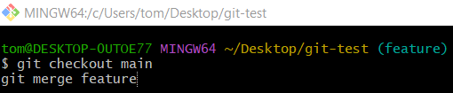
git checkout main
git merge feature
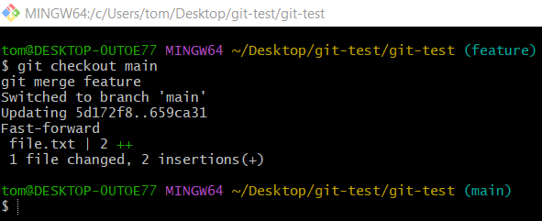

🔹 Step 5: Undo the Merge
# Source: ScreenShots Source: Provided by: [Persons Table -> ID Column: 1, Name_En Column: Motasem Essam] -> Tool: [Lightshot Program] -> From [Operating System: Windows] on [2/19/2026]
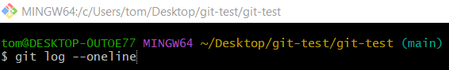
git log --oneline
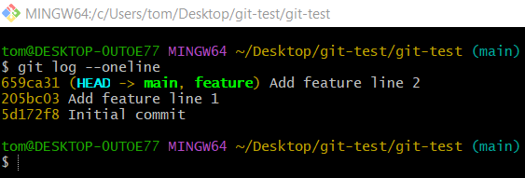
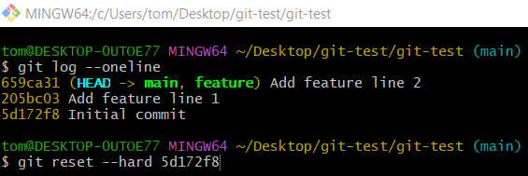
git reset --hard 5d172f8
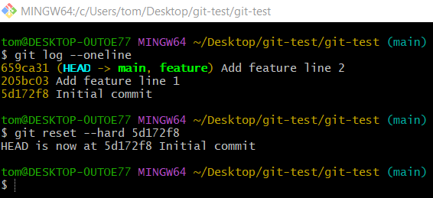
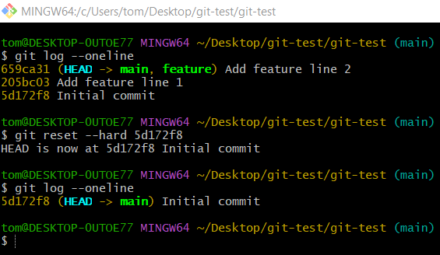

Squash and Merge

Full Step-by-Step Lab: Squash and Merge

1️⃣ Setup Repository
# Source: ScreenShots Source: Provided by: [Persons Table -> ID Column: 1, Name_En Column: Motasem Essam] -> Tool: [Lightshot Program] -> From [Operating System: Windows] on [2/19/2026]
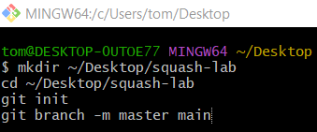
mkdir ~/Desktop/squash-lab
cd ~/Desktop/squash-lab
git init
git branch -m master main
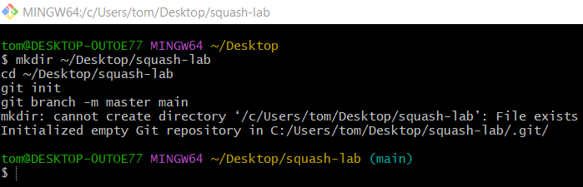

2️⃣ Create Initial Commits on main
# Source: ScreenShots Source: Provided by: [Persons Table -> ID Column: 1, Name_En Column: Motasem Essam] -> Tool: [Lightshot Program] -> From [Operating System: Windows] on [2/19/2026]
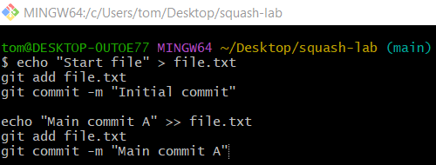
echo "Start file" > file.txt
git add file.txt
git commit -m "Initial commit"

echo "Main commit A" >> file.txt
git add file.txt
git commit -m "Main commit A"
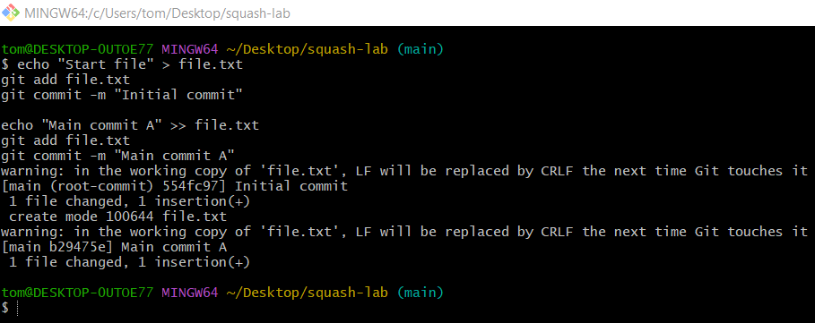

3️⃣ Squash Commits on Feature Branch
# Source: ScreenShots Source: Provided by: [Persons Table -> ID Column: 1, Name_En Column: Motasem Essam] -> Tool: [Lightshot Program] -> From [Operating System: Windows] on [2/19/2026]
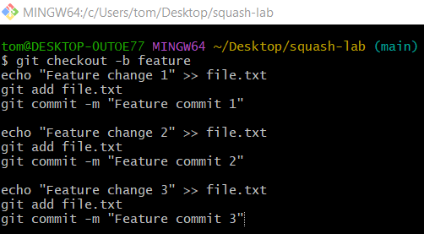
git checkout -b feature
echo "Feature change 1" >> file.txt
git add file.txt
git commit -m "Feature commit 1"

echo "Feature change 2" >> file.txt
git add file.txt
git commit -m "Feature commit 2"

echo "Feature change 3" >> file.txt
git add file.txt
git commit -m "Feature commit 3"

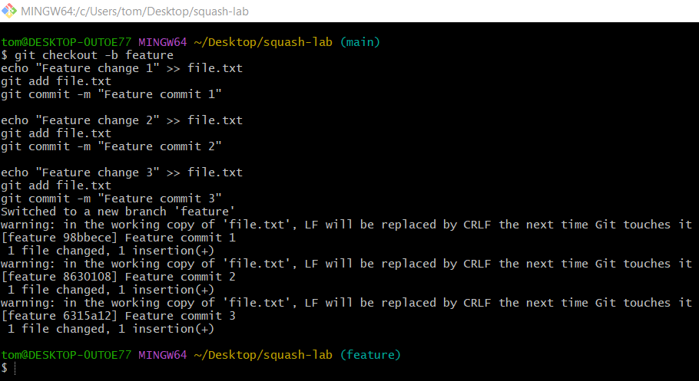

4️⃣ Squash Commits on Feature Branch
# Source: ScreenShots Source: Provided by: [Persons Table -> ID Column: 1, Name_En Column: Motasem Essam] -> Tool: [Lightshot Program] -> From [Operating System: Windows] on [2/19/2026]
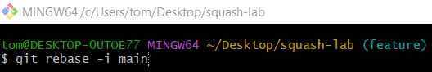
git rebase -i main
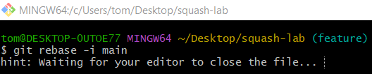
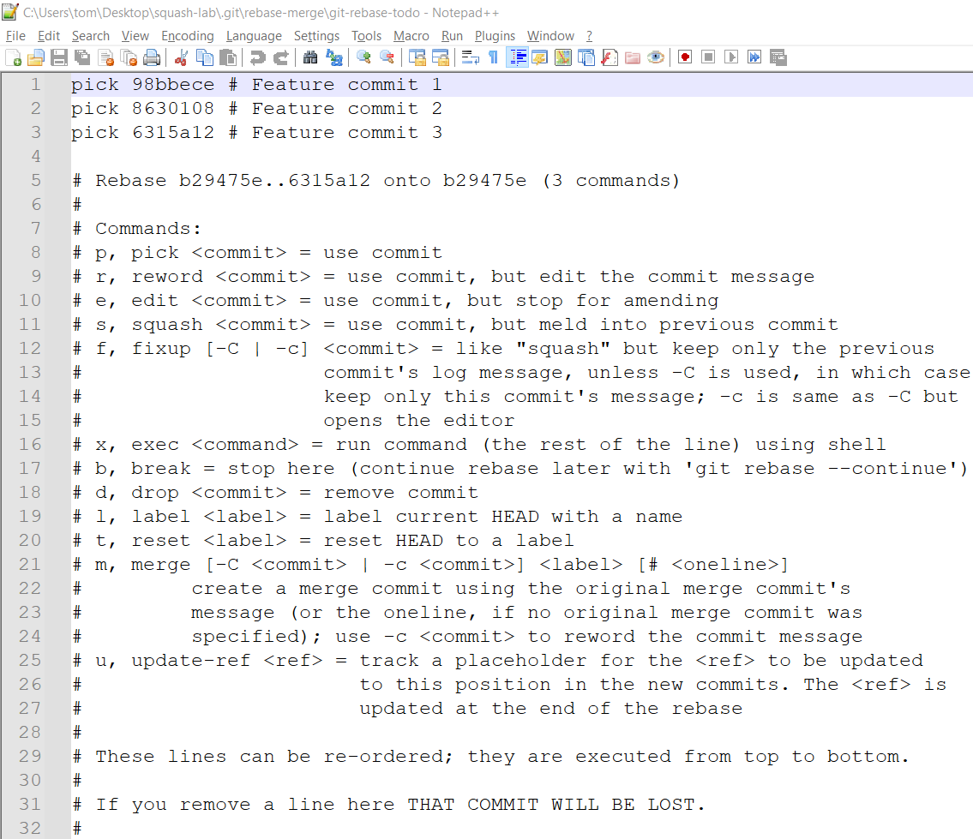
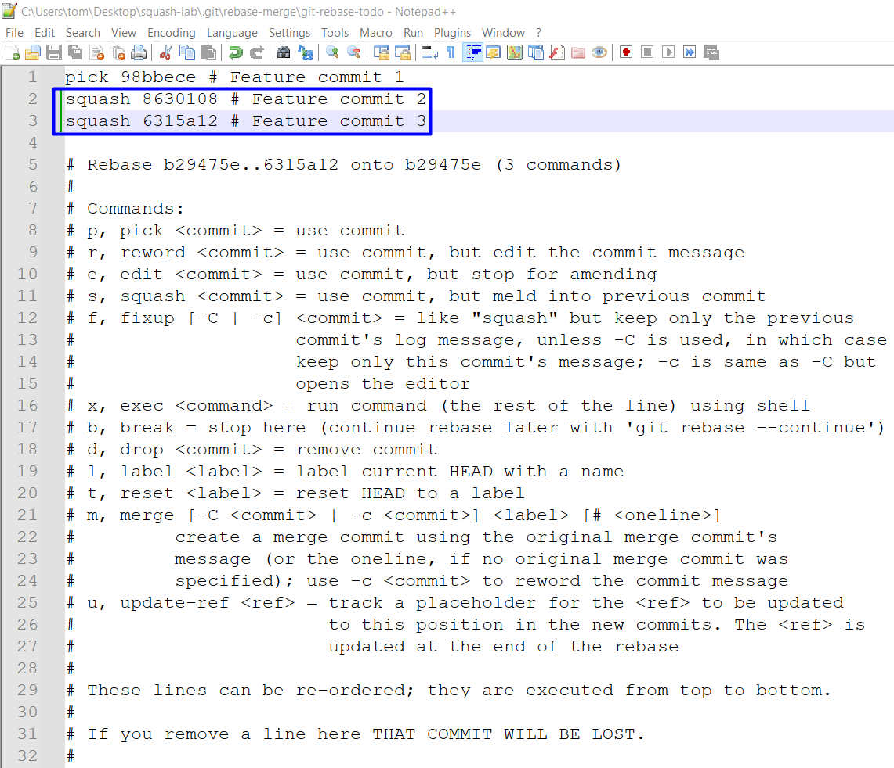
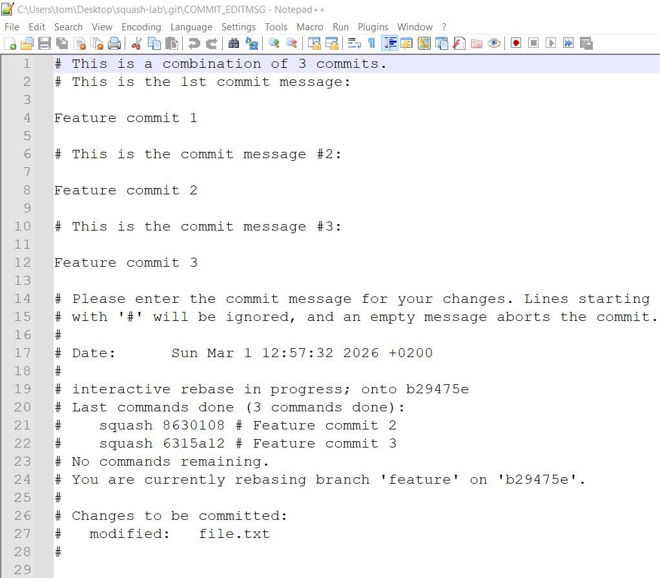
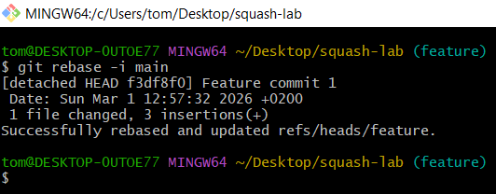

5️⃣ Merge Squashed Feature into Main
# Source: ScreenShots Source: Provided by: [Persons Table -> ID Column: 1, Name_En Column: Motasem Essam] -> Tool: [Lightshot Program] -> From [Operating System: Windows] on [2/19/2026]
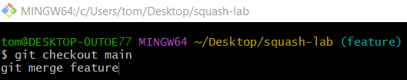
git checkout main
git merge feature
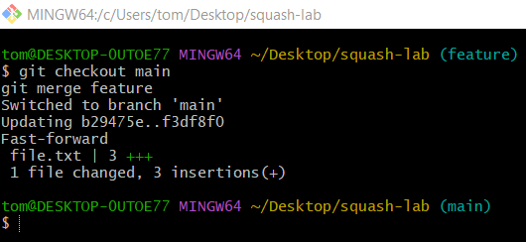

6️⃣ Undo a Squash Merge
# Source: ScreenShots Source: Provided by: [Persons Table -> ID Column: 1, Name_En Column: Motasem Essam] -> Tool: [Lightshot Program] -> From [Operating System: Windows] on [2/19/2026]
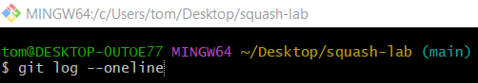
git log --oneline
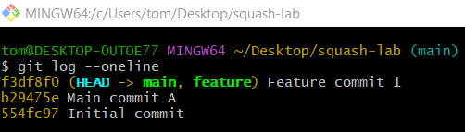
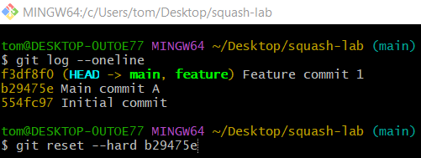
git reset --hard b29475e
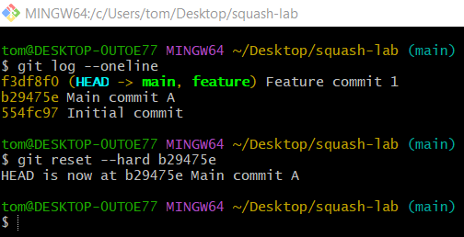
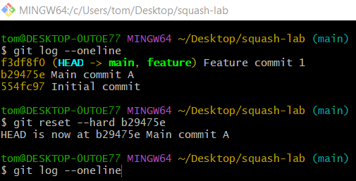
git log --oneline
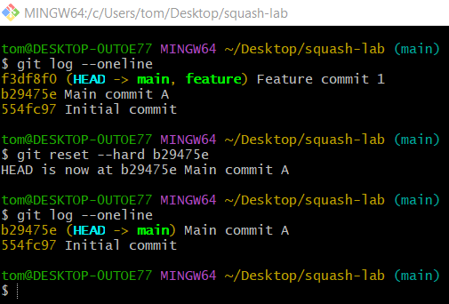

Rebase and Merge

Full Step-by-Step Lab: Rebase & Merge with Conflict

1️⃣ Setup Repository
# Source: ScreenShots Source: Provided by: [Persons Table -> ID Column: 1, Name_En Column: Motasem Essam] -> Tool: [Lightshot Program] -> From [Operating System: Windows] on [2/19/2026]
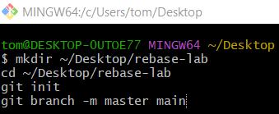
mkdir ~/Desktop/rebase-lab
cd ~/Desktop/rebase-lab
git init
git branch -m master main
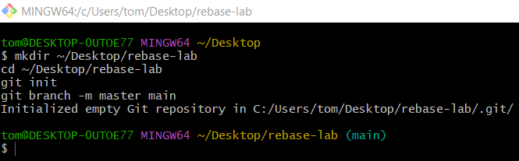

2️⃣ Create Initial Commits on main
# Source: ScreenShots Source: Provided by: [Persons Table -> ID Column: 1, Name_En Column: Motasem Essam] -> Tool: [Lightshot Program] -> From [Operating System: Windows] on [2/19/2026]
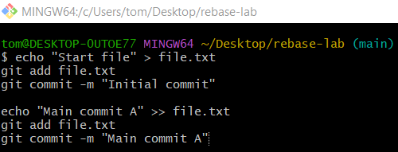
echo "Start file" > file.txt
git add file.txt
git commit -m "Initial commit"

echo "Main commit A" >> file.txt
git add file.txt
git commit -m "Main commit A"
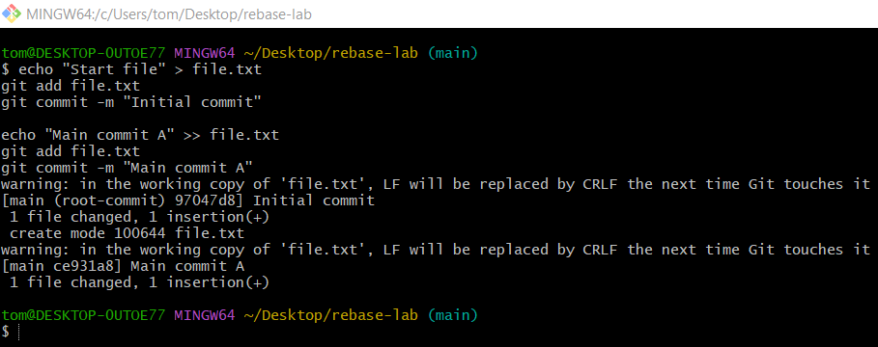

3️⃣ Create Feature Branch
# Source: ScreenShots Source: Provided by: [Persons Table -> ID Column: 1, Name_En Column: Motasem Essam] -> Tool: [Lightshot Program] -> From [Operating System: Windows] on [2/19/2026]
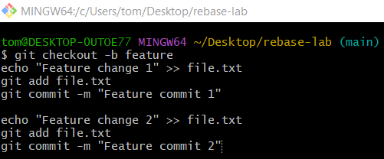
git checkout -b feature
echo "Feature change 1" >> file.txt
git add file.txt
git commit -m "Feature commit 1"

echo "Feature change 2" >> file.txt
git add file.txt
git commit -m "Feature commit 2"
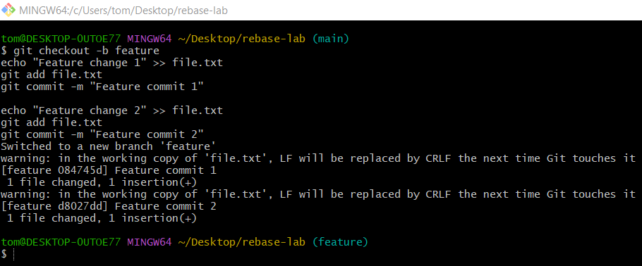

4️⃣ Add a New Commit on Main (to force rebase)
# Source: ScreenShots Source: Provided by: [Persons Table -> ID Column: 1, Name_En Column: Motasem Essam] -> Tool: [Lightshot Program] -> From [Operating System: Windows] on [2/19/2026]
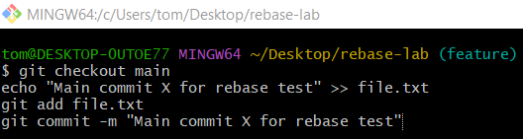
git checkout main
echo "Main commit X for rebase test" >> file.txt
git add file.txt
git commit -m "Main commit X for rebase test"
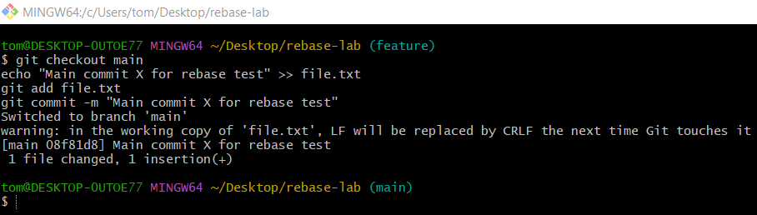

5️⃣ Rebase Feature onto Main
# Source: ScreenShots Source: Provided by: [Persons Table -> ID Column: 1, Name_En Column: Motasem Essam] -> Tool: [Lightshot Program] -> From [Operating System: Windows] on [2/19/2026]
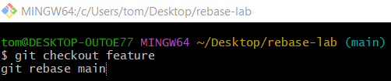
git checkout feature
git rebase main
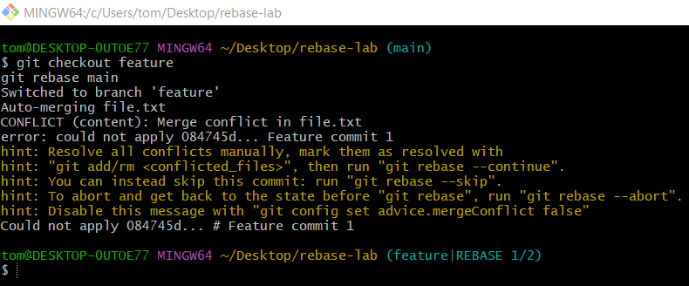

6️⃣ Resolve the Conflict
# Source: ScreenShots Source: Provided by: [Persons Table -> ID Column: 1, Name_En Column: Motasem Essam] -> Tool: [Lightshot Program] -> From [Operating System: Windows] on [2/19/2026]
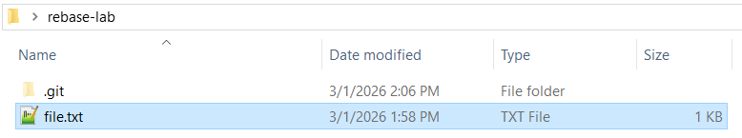
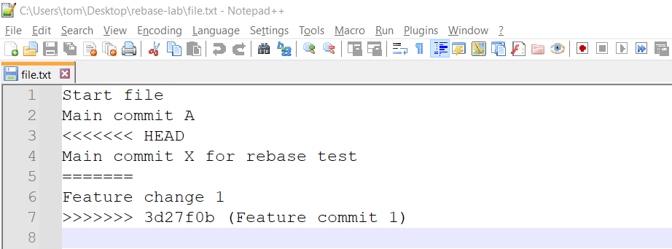
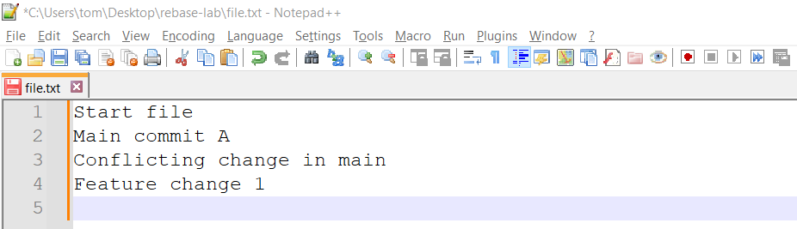
Start file
Main commit A
Conflicting change in main
Feature change 1
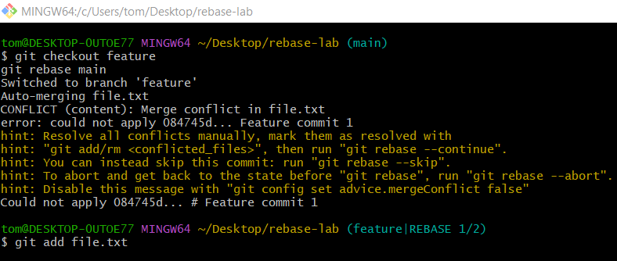
git add file.txt
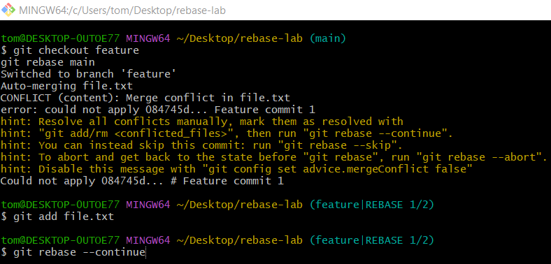
git rebase --continue
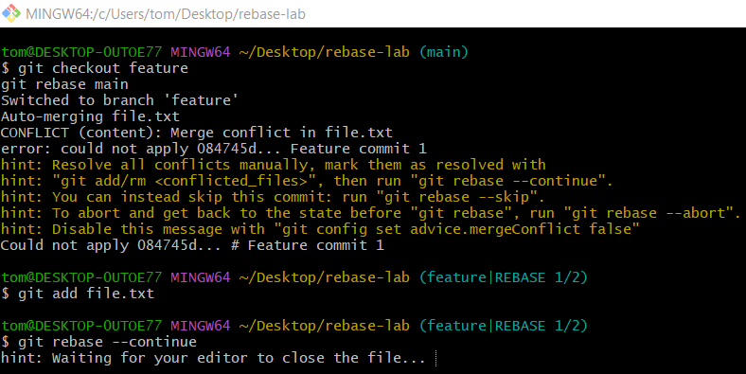
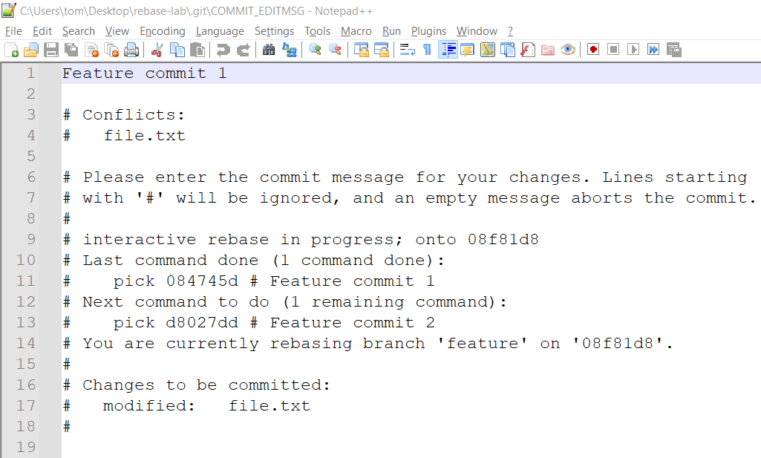
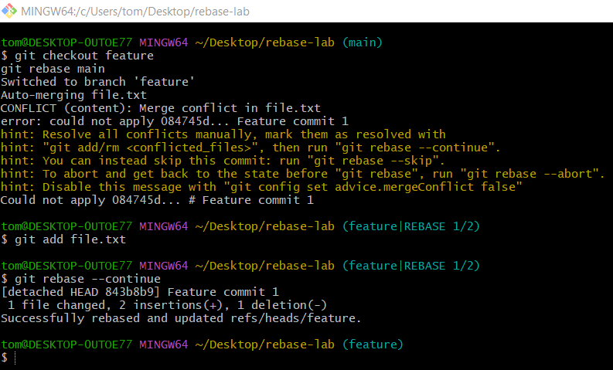

7️⃣ Merge Feature Back into Main
# Source: ScreenShots Source: Provided by: [Persons Table -> ID Column: 1, Name_En Column: Motasem Essam] -> Tool: [Lightshot Program] -> From [Operating System: Windows] on [2/19/2026]
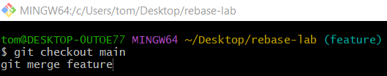
git checkout main
git merge feature
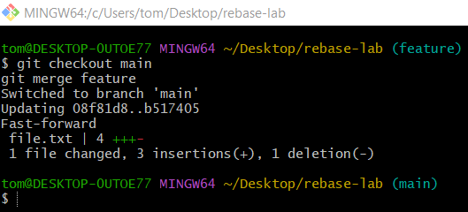

8️⃣ Undo a Finished Rebase (Optional)
# Source: ScreenShots Source: Provided by: [Persons Table -> ID Column: 1, Name_En Column: Motasem Essam] -> Tool: [Lightshot Program] -> From [Operating System: Windows] on [2/19/2026]
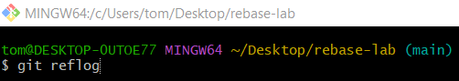
git reflog
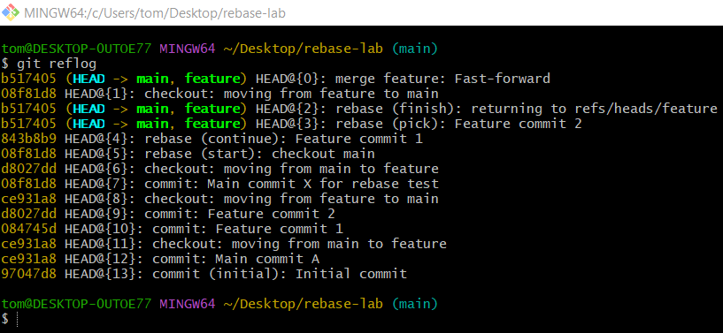
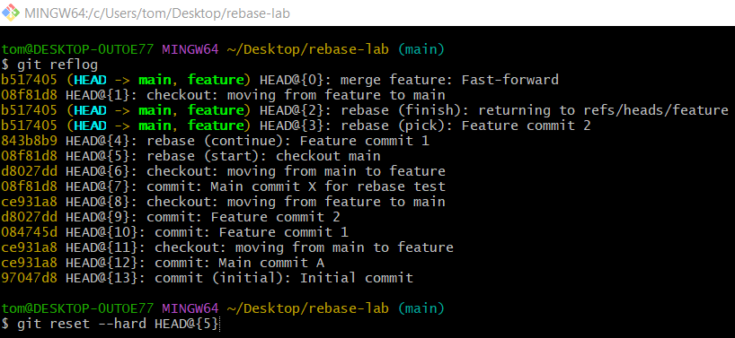
git reset --hard HEAD@{5}
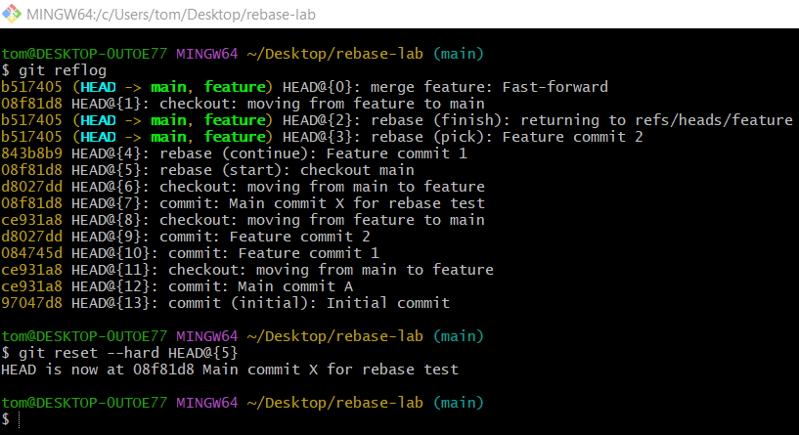

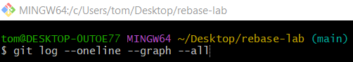
git log --oneline --graph --all
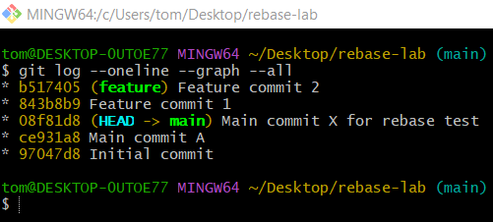

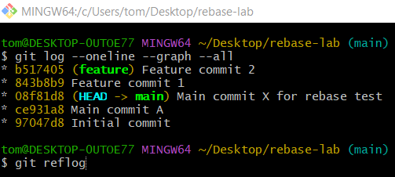
git reflog
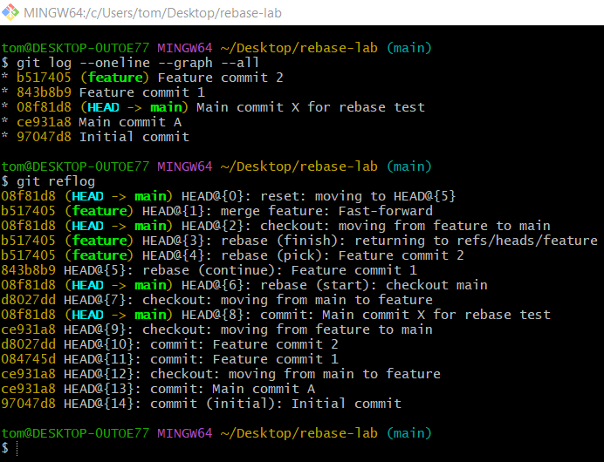
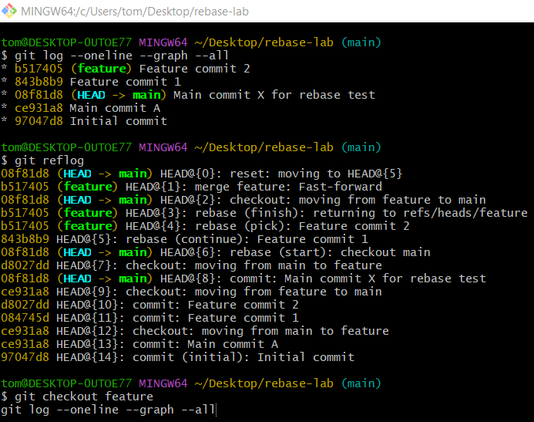
git checkout feature
git log --oneline --graph --all
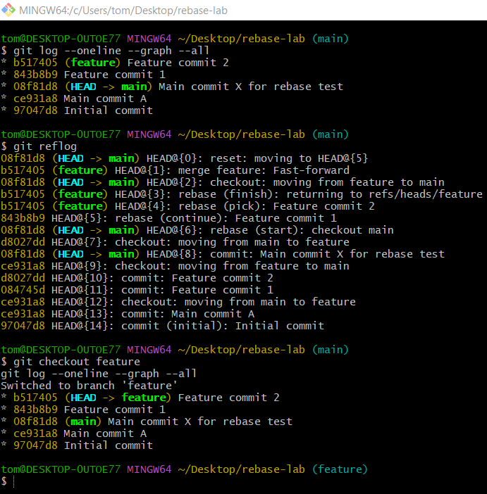

Bisect commit

1️⃣ Create a Test Repository
# Source: ScreenShots Source: Provided by: [Persons Table -> ID Column: 1, Name_En Column: Motasem Essam] -> Tool: [Lightshot Program] -> From [Operating System: Windows] on [2/19/2026]
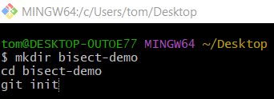
mkdir bisect-demo
cd bisect-demo
git init
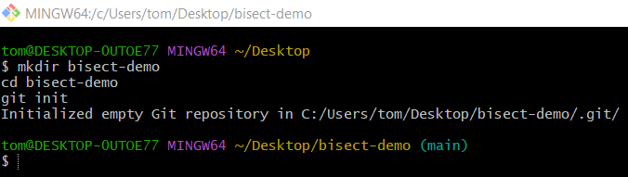

2️⃣ Create a Working Program
# Source: ScreenShots Source: Provided by: [Persons Table -> ID Column: 1, Name_En Column: Motasem Essam] -> Tool: [Lightshot Program] -> From [Operating System: Windows] on [2/19/2026]
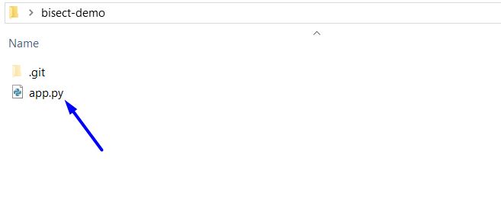
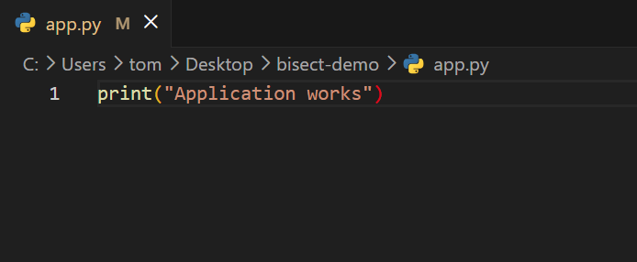
print("Application works")
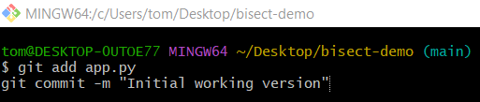
git add app.py
git commit -m "Initial working version"
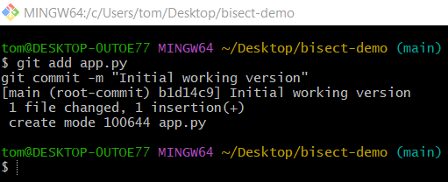

3️⃣ Add More Good Commits
# Source: ScreenShots Source: Provided by: [Persons Table -> ID Column: 1, Name_En Column: Motasem Essam] -> Tool: [Lightshot Program] -> From [Site: https://github.com] on [2/19/2026]
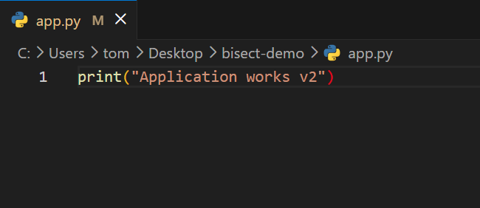
print("Application works v2")
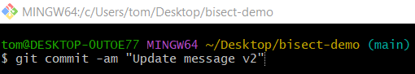
git commit -am "Update message v2"
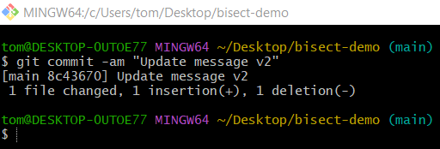
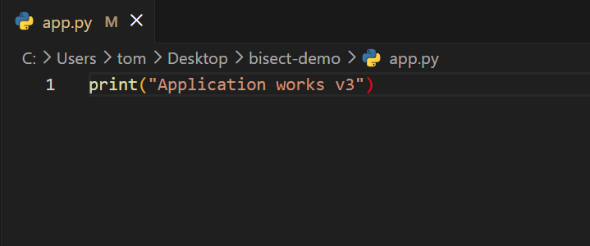
print("Application works v3")
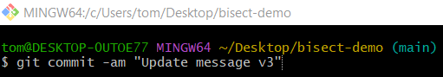
git commit -am "Update message v3"
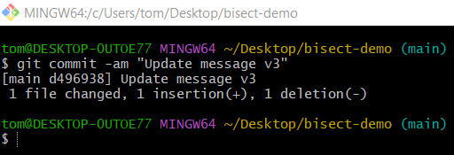

4️⃣ Introduce a Bug
# Source: ScreenShots Source: Provided by: [Persons Table -> ID Column: 1, Name_En Column: Motasem Essam] -> Tool: [Lightshot Program] -> From [Site: https://github.com] on [2/19/2026]
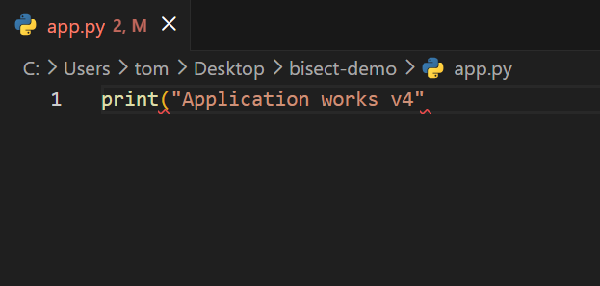
print("Application works v4"
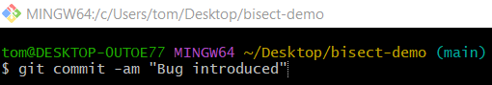
git commit -am "Bug introduced"
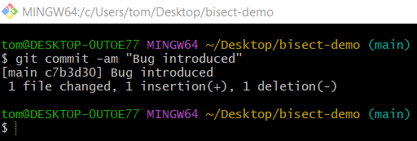

5️⃣ Add Another Commit After Bug
# Source: ScreenShots Source: Provided by: [Persons Table -> ID Column: 1, Name_En Column: Motasem Essam] -> Tool: [Lightshot Program] -> From [Site: https://github.com] on [2/19/2026]
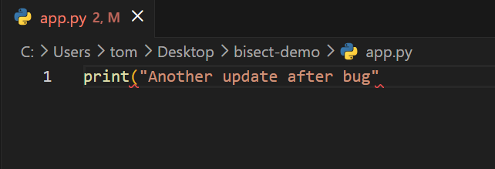
print("Another update after bug"
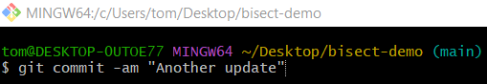
git commit -am "Another update"
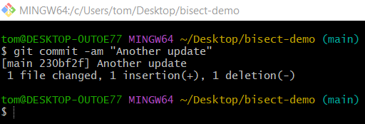

6️⃣ Start Git Bisect
# Source: ScreenShots Source: Provided by: [Persons Table -> ID Column: 1, Name_En Column: Motasem Essam] -> Tool: [Lightshot Program] -> From [Site: https://github.com] on [2/19/2026]
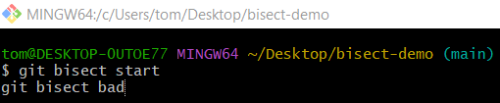
git bisect start
git bisect bad
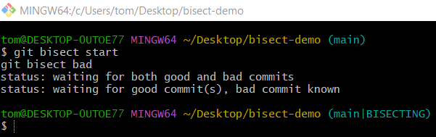
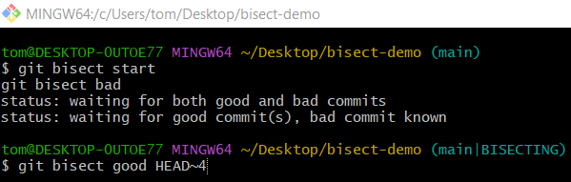
git bisect good HEAD~4
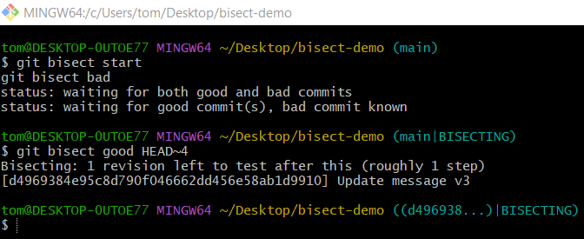

7️⃣ Test the Code
# Source: ScreenShots Source: Provided by: [Persons Table -> ID Column: 1, Name_En Column: Motasem Essam] -> Tool: [Lightshot Program] -> From [Site: https://github.com] on [2/19/2026]
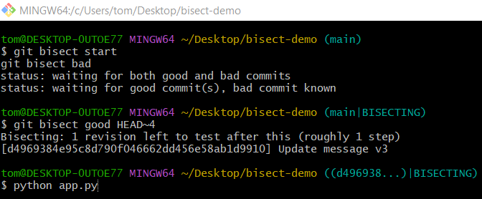
python app.py
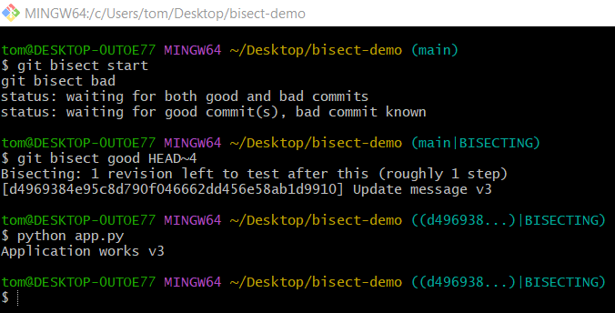
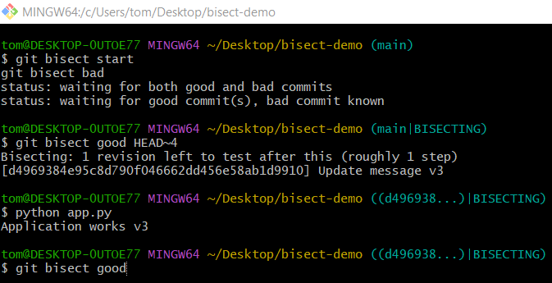
git bisect good
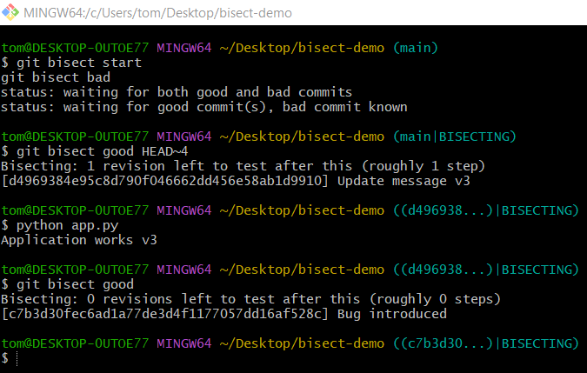
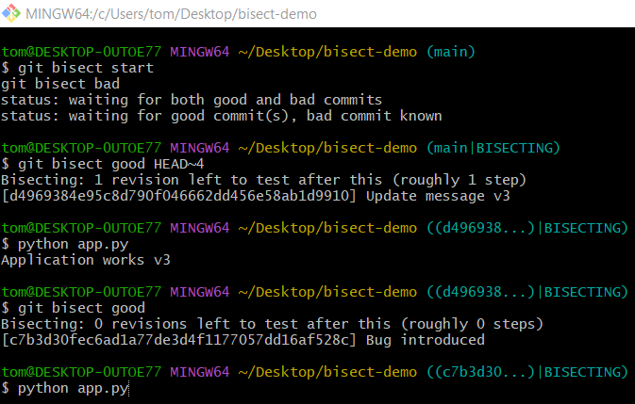
python app.py
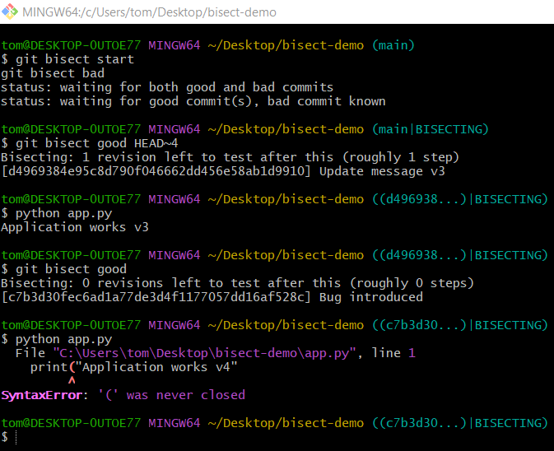
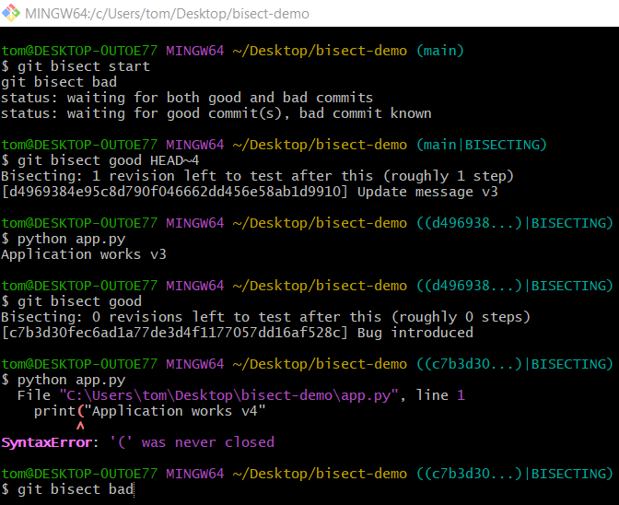
git bisect bad
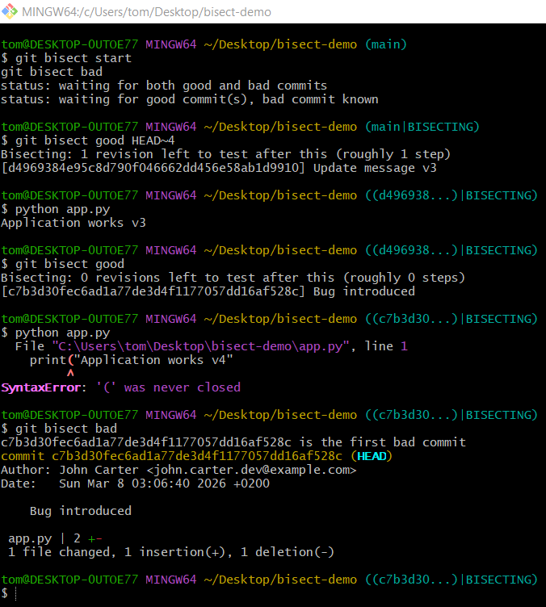

8️⃣ Exit Bisect
# Source: ScreenShots Source: Provided by: [Persons Table -> ID Column: 1, Name_En Column: Motasem Essam] -> Tool: [Lightshot Program] -> From [Site: https://github.com] on [2/19/2026]
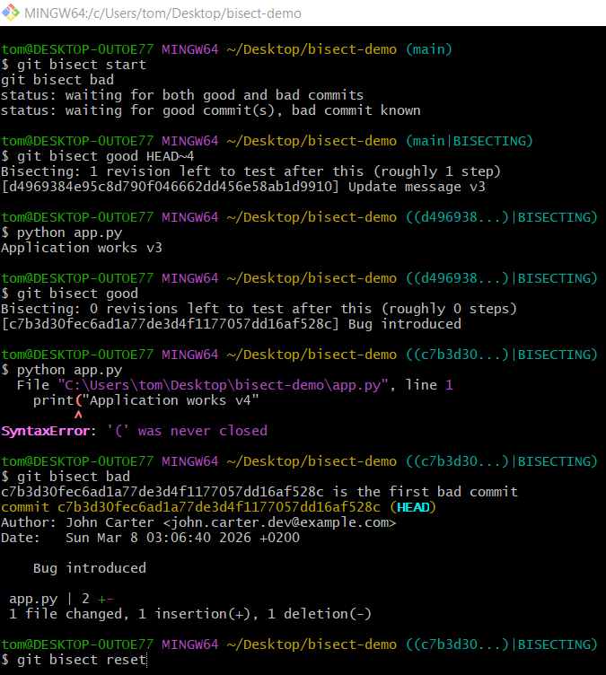
git bisect reset
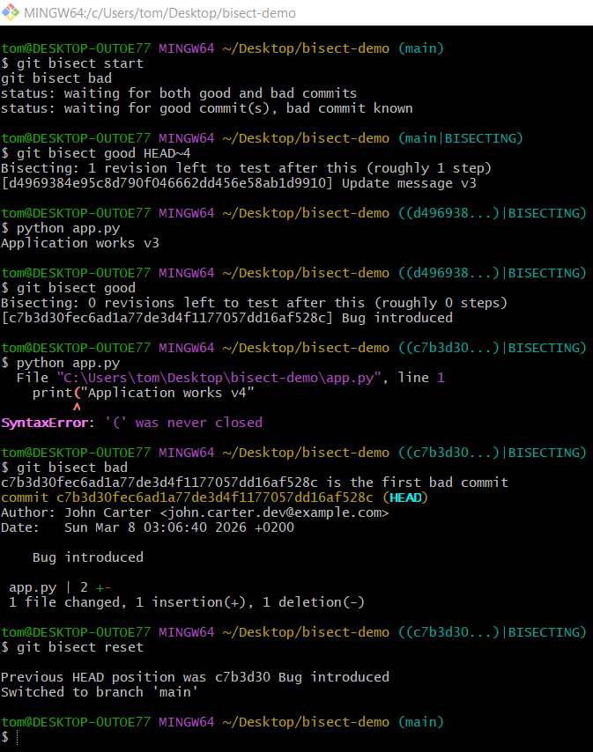

Verify
# Source: ScreenShots Source: Provided by: [Persons Table -> ID Column: 1, Name_En Column: Motasem Essam] -> Tool: [Lightshot Program] -> From [Site: https://github.com] on [2/19/2026]
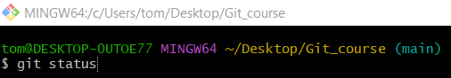
git status
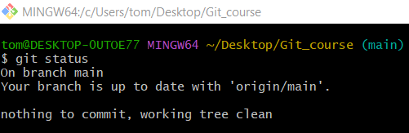

Differences between commits
# Source: AI Source: Provided by: [Data Path: Persons Table -> ID Column: 1, Name_En Column: Motasem Essam] -> From: [ChatGPT] on [2/19/2026]
To differentiate between commits in Git, the git diff command is most commonly used. Below are the main options:

Method 1: Compare Two Specific Commits
# Source: AI Source: Provided by: [Data Path: Persons Table -> ID Column: 1, Name_En Column: Motasem Essam] -> From: [ChatGPT] on [2/19/2026]
- Syntax:
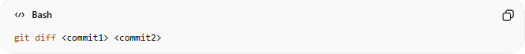
git diff <commit1> <commit2>
- Description:
Shows the exact changes introduced between two specific commits.
- Example: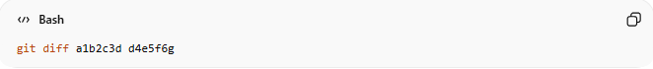
git diff a1b2c3d d4e5f6g
- Output:
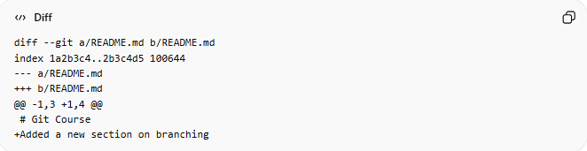
diff --git a/README.md b/README.md
index 1a2b3c4..2b3c4d5 100644
--- a/README.md
+++ b/README.md
@@ -1,3 +1,4 @@
# Git Course
+Added a new section on branching

Explanation:
- diff --git a/README.md b/README.md → The file that changed.
- --- a/README.md → Original version (commit a1b2c3d).
- +++ b/README.md → New version (commit d4e5f6g).
- @@ -1,3 +1,4 @@ → Shows the line numbers affected:
  - -1,3 → lines 1–3 in original
  - +1,4 → lines 1–4 in new
- +Added a new section on branching → Line added (+ means added, - means removed).
✅ Meaning: This shows exactly what changed in the file between the two commits.

Method 2: Compare a Commit with the Latest Version (HEAD)
# Source: AI Source: Provided by: [Data Path: Persons Table -> ID Column: 1, Name_En Column: Motasem Essam] -> From: [ChatGPT] on [2/19/2026]
- Syntax:
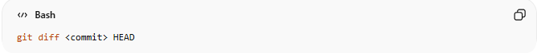
git diff <commit> HEAD
- Description:
Shows what has changed since a specific commit up to your current branch state.
- Example:
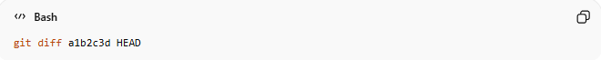
git diff a1b2c3d HEAD
- Output:
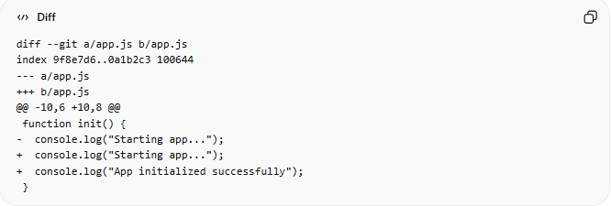
diff --git a/app.js b/app.js
index 9f8e7d6..0a1b2c3 100644
--- a/app.js
+++ b/app.js
@@ -10,6 +10,8 @@
function init() {
- console.log("Starting app...");
+ console.log("Starting app...");
+ console.log("App initialized successfully");
}

Explanation:
- Shows all changes from commit a1b2c3d to the latest commit (HEAD).
- You can see what has been added, modified, or removed since that commit.
✅ Meaning: Useful to see all updates since a specific commit.

Method 3: Compare Using Commit Range (Single Commit Changes)

Option 1: Using git diff <commit>^ <commit>
# Source: AI Source: Provided by: [Data Path: Persons Table -> ID Column: 1, Name_En Column: Motasem Essam] -> From: [ChatGPT] on [2/19/2026]
- Syntax:
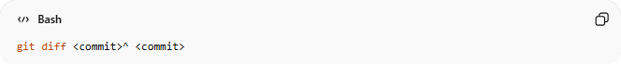
git diff <commit>^ <commit>
- Description:
Shows the changes introduced by a single commit.
- Example:
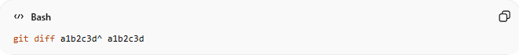
git diff a1b2c3d^ a1b2c3d

- Output:
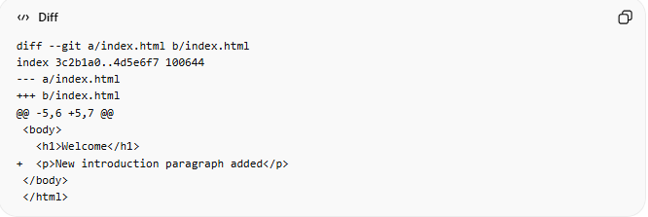
diff --git a/index.html b/index.html
index 3c2b1a0..4d5e6f7 100644
--- a/index.html
+++ b/index.html
@@ -5,6 +5,7 @@
<body>
<h1>Welcome</h1>
+ <p>New introduction paragraph added</p>
</body>
</html>
- Explanation:
  - a1b2c3d^ → Refers to the commit before a1b2c3d.
  - The diff shows only the changes introduced in this single commit.
  - Lines starting with + → Added lines; lines with - → Removed lines.
  - Great for reviewing what a single commit actually did, especially in code reviews.

Option 2: Shortcut Using git show <commit>
# Source: AI Source: Provided by: [Data Path: Persons Table -> ID Column: 1, Name_En Column: Motasem Essam] -> From: [ChatGPT] on [2/19/2026]
- Syntax:
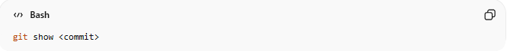
git show <commit>
- Description:
Displays the same changes as the git diff command plus the commit message and metadata (author, date, etc.).
- Example:
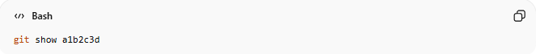
git show a1b2c3d
- Output:
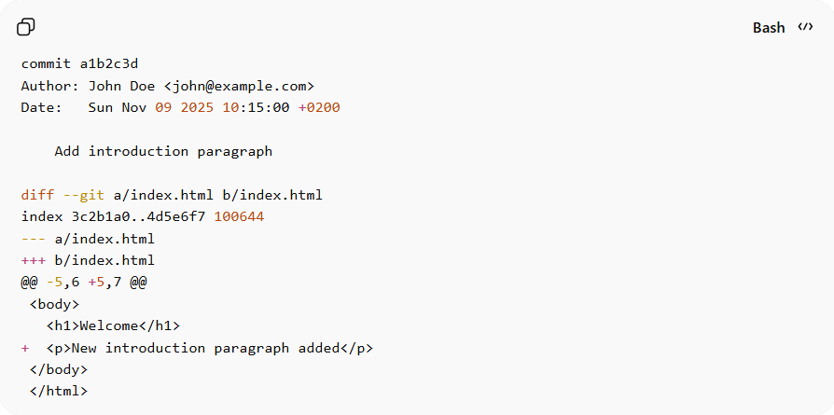
commit a1b2c3d
Author: John Doe <john@example.com>
Date: Sun Nov 09 2025 10:15:00 +0200

Add introduction paragraph

diff --git a/index.html b/index.html
index 3c2b1a0..4d5e6f7 100644
--- a/index.html
+++ b/index.html
@@ -5,6 +5,7 @@
<body>
<h1>Welcome</h1>
+ <p>New introduction paragraph added</p>
</body>
</html>
- Explanation:
  - Shows both the commit metadata (author, date, message) and the changes made.
  - Useful if you want context about why the change was made, not just what changed.

Method 4: See Only File Names That Changed
# Source: AI Source: Provided by: [Data Path: Persons Table -> ID Column: 1, Name_En Column: Motasem Essam] -> From: [ChatGPT] on [2/19/2026]
- Syntax:
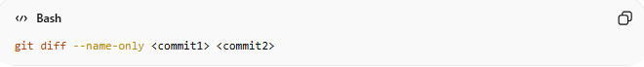
git diff --name-only <commit1> <commit2>
- Description:
Lists only the files that differ between the two commits.
- Example:
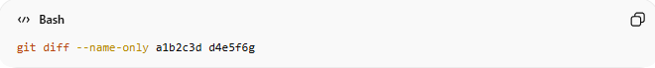
git diff --name-only a1b2c3d d4e5f6g

- Output:
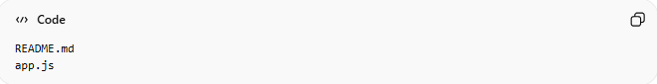
README.md
app.js

Explanation:
- Only lists the files that changed, not the contents.
- Useful if you just want a quick overview of affected files.

Method 5: See Summary of Changes (Insertions / Deletions)
# Source: AI Source: Provided by: [Data Path: Persons Table -> ID Column: 1, Name_En Column: Motasem Essam] -> From: [ChatGPT] on [2/19/2026]
- Syntax:
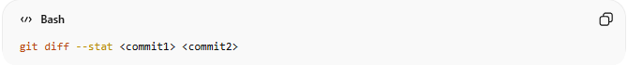
git diff --stat <commit1> <commit2>
- Description:
Shows a summary including the number of insertions, deletions, and files changed.
- Example:
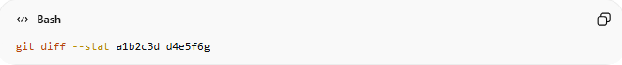
git diff --stat a1b2c3d d4e5f6g

- Output:
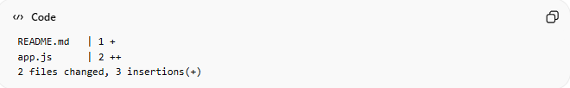
README.md | 1 +
app.js | 2 ++
2 files changed, 3 insertions(+)

Explanation:
- Shows a summary of changes per file.
- 1 + → 1 line added in README.md
- 2 ++ → 2 lines added in app.js
- Total: 2 files changed, 3 lines added overall.
✅ Meaning: Good for a quick glance at how many files and lines were affected.

Method 6: Visual Comparison (GUI Recommended)
# Source: AI Source: Provided by: [Data Path: Persons Table -> ID Column: 1, Name_En Column: Motasem Essam] -> From: [ChatGPT] on [2/19/2026]
- Description:
Use a graphical interface for easier visualization of changes.
- Tools:
  - VS Code → Source Control tab
  - GitKraken
  - GitHub / GitLab branch compare

Bonus Option: Find Differences in Commit Messages
# Source: AI Source: Provided by: [Data Path: Persons Table -> ID Column: 1, Name_En Column: Motasem Essam] -> From: [ChatGPT] on [2/19/2026]
- Syntax:
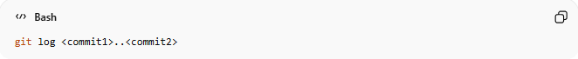
git log <commit1>..<commit2>
- Description:
Shows commits and messages between two commits.
- Example:
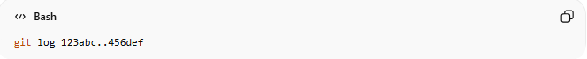
git log 123abc..456def

- Output:
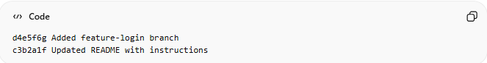
d4e5f6g Added feature-login branch
c3b2a1f Updated README with instructions

Explanation:
- Shows all commits between two points, along with their messages.
- Useful to review history and purpose of changes.

🔥 Quick Practical Example
# Source: AI Source: Provided by: [Data Path: Persons Table -> ID Column: 1, Name_En Column: Motasem Essam] -> From: [ChatGPT] on [2/19/2026]
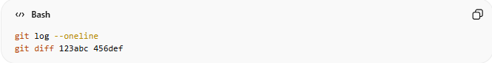
git log --oneline
git diff 123abc 456def
- Lists commits in short form and compares changes between two example commits.

🔥 Summary of Outputs
# Source: AI Source: Provided by: [Data Path: Persons Table -> ID Column: 1, Name_En Column: Motasem Essam] -> From: [ChatGPT] on [2/19/2026]
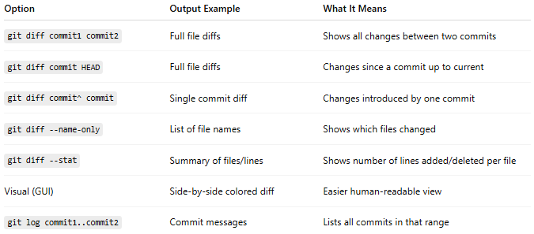
Option | Output Example | What It Means
git diff commit1 commit2 | Full file diffs | Shows all changes between two commits
git diff commit HEAD | Full file diffs | Changes since a commit up to current
git diff commit^ commit | Single commit diff | Changes introduced by one commit
git diff --name-only | List of file names | Shows which files changed
git diff --stat | Summary of files/lines | Shows number of lines added/deleted per file
Visual (GUI) | Side-by-side colored diff | Easier human-readable view
git log commit1..commit2 | Commit messages | Lists all commits in that range

Example

Method 1: Compare Two Specific Commits
# Source: ScreenShots Source: Provided by: [Persons Table -> ID Column: 1, Name_En Column: Motasem Essam] -> Tool: [Lightshot Program] -> From [Operating System: Windows] on [2/19/2026]
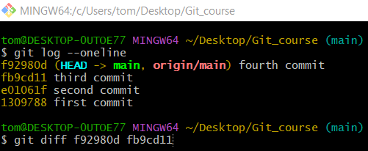
git diff f92980d fb9cd11
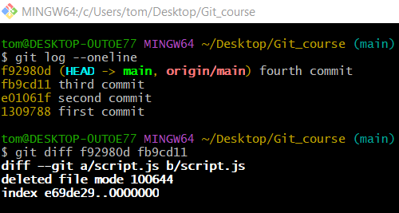

# Source: AI Source: Provided by: [Data Path: Persons Table -> ID Column: 1, Name_En Column: Motasem Essam] -> From: [ChatGPT] on [2/19/2026]
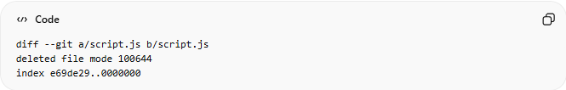
diff --git a/script.js b/script.js
deleted file mode 100644
index e69de29..0000000

Breakdown:
- diff --git a/script.js b/script.js → Git is comparing the file script.js between the two commits.
- deleted file mode 100644 → This file was deleted in the newer commit (f92980d).
  - 100644 is the file’s permission mode (normal file).
- index e69de29..0000000 → Internal Git reference for the file content:
  - e69de29 → File in the older commit (fb9cd11).
  - 0000000 → File in the newer commit (f92980d), all zeros means the file no longer exists.
✅ Meaning:
- Between fb9cd11 (third commit) and f92980d (fourth commit), the file script.js was completely deleted.
- Git doesn’t show line-by-line diff because the file no longer exists—it just reports deletion.

Method 2: Compare a Commit with the Latest Version (HEAD)
# Source: ScreenShots Source: Provided by: [Persons Table -> ID Column: 1, Name_En Column: Motasem Essam] -> Tool: [Lightshot Program] -> From [Operating System: Windows] on [2/19/2026]
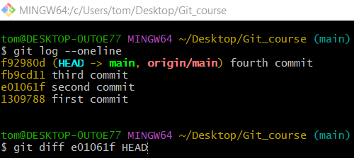
git diff e01061f HEAD
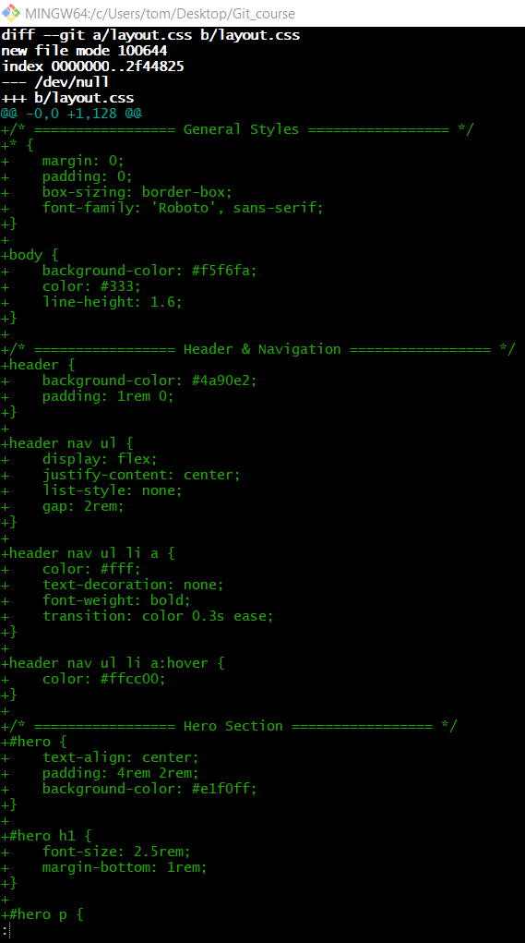
# Source: AI Source: Provided by: [Data Path: Persons Table -> ID Column: 1, Name_En Column: Motasem Essam] -> From: [ChatGPT] on [2/19/2026]
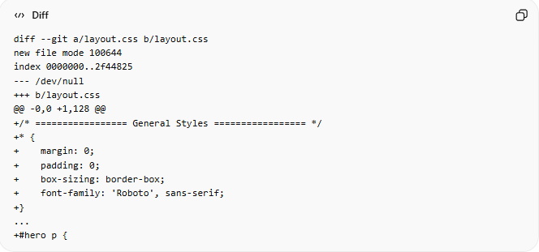
diff --git a/layout.css b/layout.css
new file mode 100644
index 0000000..2f44825
--- /dev/null
+++ b/layout.css
@@ -0,0 +1,128 @@
+/* ================= General Styles ================= */
+* {
+ margin: 0;
+ padding: 0;
+ box-sizing: border-box;
+ font-family: 'Roboto', sans-serif;
+}
...
+#hero p {
Breakdown line by line:
- diff --git a/layout.css b/layout.css
  - Git is comparing the file layout.css between e01061f (older commit) and HEAD (latest commit).
- new file mode 100644
  - This file is newly created in the latest commit (HEAD).
  - 100644 = normal file permissions.
- index 0000000..2f44825
  - 0000000 → File did not exist in the older commit.
  - 2f44825 → File exists in HEAD (the new file content hash).
- --- /dev/null
  - Represents the file in the older commit (doesn’t exist, so /dev/null).
- +++ b/layout.css
  - Represents the file in the new commit (HEAD).
- @@ -0,0 +1,128 @@
  - Shows line numbers affected:
    - -0,0 → Original file had 0 lines.
    - +1,128 → New file has 128 lines added.
- Lines starting with +
  - Every line with + is added.
  - Example:
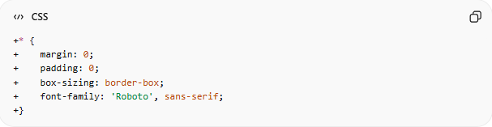
+* {
+ margin: 0;
+ padding: 0;
+ box-sizing: border-box;
+ font-family: 'Roboto', sans-serif;
+}
→ This is the new CSS code added in layout.css.

Method 3: Compare Using Commit Range (Single Commit Changes)

Option 1: Using git diff <commit>^ <commit>
# Source: ScreenShots Source: Provided by: [Persons Table -> ID Column: 1, Name_En Column: Motasem Essam] -> Tool: [Lightshot Program] -> From [Operating System: Windows] on [2/19/2026]
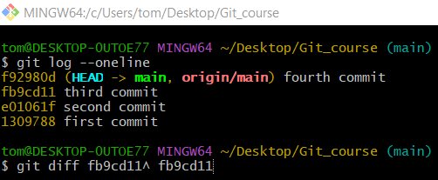
git diff fb9cd11^ fb9cd11
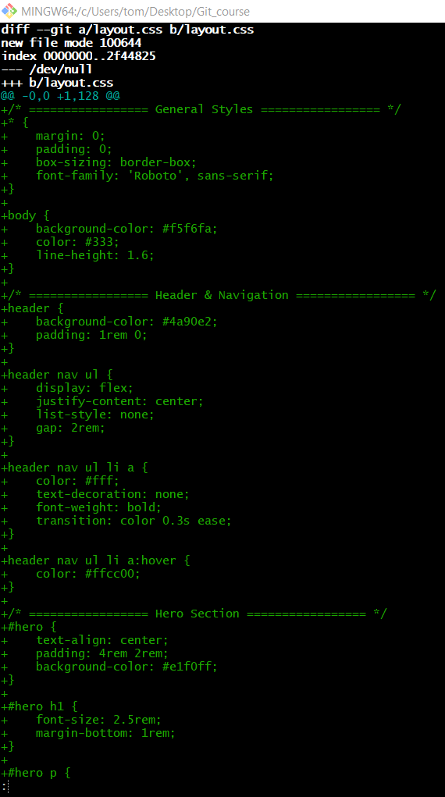
# Source: AI Source: Provided by: [Data Path: Persons Table -> ID Column: 1, Name_En Column: Motasem Essam] -> From: [ChatGPT] on [2/19/2026]
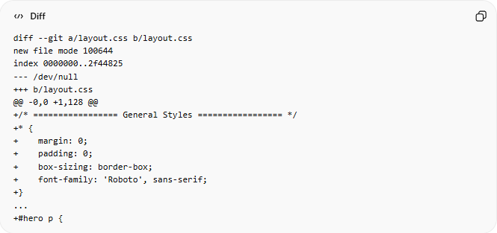
diff --git a/layout.css b/layout.css
new file mode 100644
index 0000000..2f44825
--- /dev/null
+++ b/layout.css
@@ -0,0 +1,128 @@
+/* ================= General Styles ================= */
+* {
+ margin: 0;
+ padding: 0;
+ box-sizing: border-box;
+ font-family: 'Roboto', sans-serif;
+}
...
+#hero p {
Breakdown line by line:
- diff --git a/layout.css b/layout.css
  - Git is comparing the file layout.css between two commits:
    - fb9cd11^ (the commit before fb9cd11)
    - fb9cd11 (the commit you are inspecting).
- new file mode 100644
  - Indicates that layout.css was created in this commit.
  - 100644 = normal file permissions.
- index 0000000..2f44825
  - 0000000 → File did not exist in the previous commit.
  - 2f44825 → File hash in this commit (new content).
- --- /dev/null
  - The file didn’t exist before (/dev/null represents “empty” in Git).
- +++ b/layout.css
  - Shows the new file content in commit fb9cd11.
- @@ -0,0 +1,128 @@
  - Shows line numbers affected:
    - -0,0 → Original file had 0 lines.
    - +1,128 → 128 lines added in this commit.
- Lines starting with +
  - Every line beginning with + is added.
  - Example:
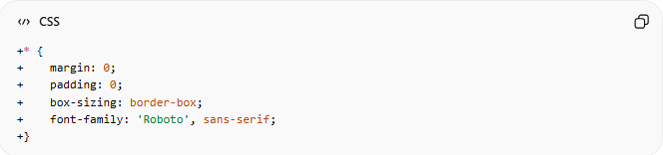
+* {
+ margin: 0;
+ padding: 0;
+ box-sizing: border-box;
+ font-family: 'Roboto', sans-serif;
+}
- These lines are newly introduced in layout.css.

Option 2: Shortcut Using git show <commit>
# Source: ScreenShots Source: Provided by: [Persons Table -> ID Column: 1, Name_En Column: Motasem Essam] -> Tool: [Lightshot Program] -> From [Operating System: Windows] on [2/19/2026]
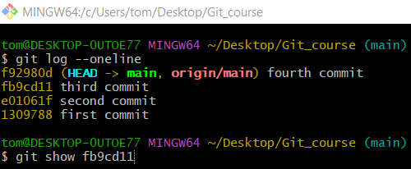
git show fb9cd11
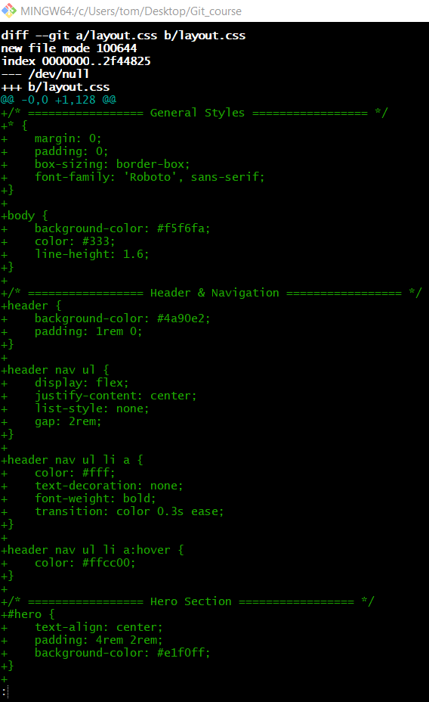
# Source: AI Source: Provided by: [Data Path: Persons Table -> ID Column: 1, Name_En Column: Motasem Essam] -> From: [ChatGPT] on [2/19/2026]
Let’s break down your git show fb9cd11 output line by line so it’s completely clear what everything means.

1️⃣ The Commit Header
commit
Author:
Date:

third commit
Explanation:
- commit
  - The full commit hash (long version) of this commit.
- Author:
  - Who made the commit, including name and email.
- Date:
  - When the commit was created.
- third commit
  - The commit message describing the purpose of the commit.
✅ Meaning: This header gives metadata about the commit (who, when, why).

2️⃣ The Diff Header
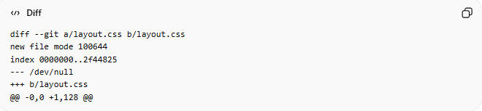
diff --git a/layout.css b/layout.css
new file mode 100644
index 0000000..2f44825
--- /dev/null
+++ b/layout.css
@@ -0,0 +1,128 @@
Explanation:
- diff --git a/layout.css b/layout.css
  - Git is comparing the file layout.css between the previous commit (fb9cd11^) and this commit (fb9cd11).
- new file mode 100644
  - This file is newly created in this commit.
  - 100644 = normal file permissions.
- index 0000000..2f44825
  - 0000000 → File didn’t exist in the previous commit.
  - 2f44825 → File hash in this commit (Git’s internal content reference).
- --- /dev/null
  - Original file didn’t exist (/dev/null = empty).
- +++ b/layout.css
  - New file in the commit.
- @@ -0,0 +1,128 @@
  - Line numbers affected:
    - -0,0 → Previous file had 0 lines
    - +1,128 → 128 lines added
✅ Meaning: This commit added a new file layout.css with 128 lines of content.

3️⃣ The Diff Content
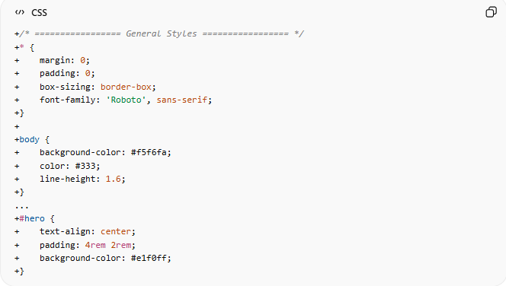
Lines starting with + are added lines:
+/* ================= General Styles ================= */
+* {
+ margin: 0;
+ padding: 0;
+ box-sizing: border-box;
+ font-family: 'Roboto', sans-serif;
+}
+
+body {
+ background-color: #f5f6fa;
+ color: #333;
+ line-height: 1.6;
+}
...
+#hero {
+ text-align: center;
+ padding: 4rem 2rem;
+ background-color: #e1f0ff;
+}
Explanation:
- Every line with + → added in this commit.
- This includes general CSS styles, header & navigation styling, and hero section.
- No lines start with -, because nothing was deleted (this is a new file).
✅ Meaning: The commit introduces all 128 lines of layout.css.

4️⃣ Overall Summary
- Commit fb9cd11 (third commit) created layout.css from scratch.
- Metadata includes author, date, and message.
- Diff shows all lines added to the new file.
- git show is helpful because it combines commit info + full diff, unlike git diff which only shows the changes.

💡 Extra Tips for Reading git show
- See just filenames added/modified/deleted:
git show --name-status fb9cd11
Output:
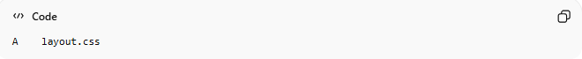
A layout.css
- A → Added file
- See a diff summary with lines added/removed:
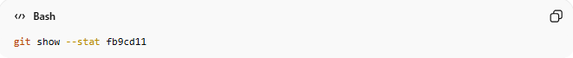
git show --stat fb9cd11
Output:
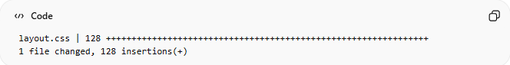
layout.css | 128 +++++++++++++++++++++++++++++++++++++++++++++++++++++++++++++++
1 file changed, 128 insertions(+)
- Gives a compact overview instead of all 128 lines.

Method 4: See Only File Names That Changed
# Source: ScreenShots Source: Provided by: [Persons Table -> ID Column: 1, Name_En Column: Motasem Essam] -> Tool: [Lightshot Program] -> From [Operating System: Windows] on [2/19/2026]
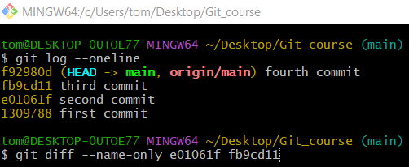
git diff --name-only e01061f fb9cd11
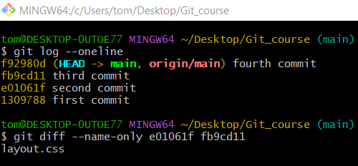

Method 5: See Summary of Changes (Insertions / Deletions)
# Source: ScreenShots Source: Provided by: [Persons Table -> ID Column: 1, Name_En Column: Motasem Essam] -> Tool: [Lightshot Program] -> From [Operating System: Windows] on [2/19/2026]
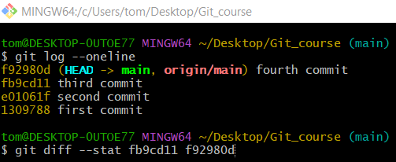
git diff --stat fb9cd11 f92980d
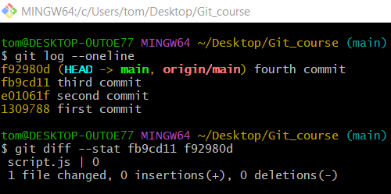
# Source: AI Source: Provided by: [Data Path: Persons Table -> ID Column: 1, Name_En Column: Motasem Essam] -> From: [ChatGPT] on [2/19/2026]
🧩 Breaking Down the Output
Line 1:
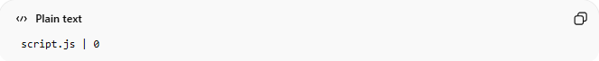
script.js | 0
- script.js → This is the file that changed.
- | 0 → Git is showing a change indicator width of 0.
This looks strange at first. Why 0?
It usually means the file was deleted entirely, not modified line-by-line.

Line 2:
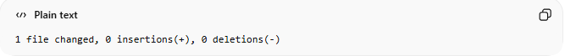
1 file changed, 0 insertions(+), 0 deletions(-)
- 1 file changed → Only one file differs between the two commits.
- 0 insertions(+) → No lines were added.
- 0 deletions(-) → No lines were removed line-by-line.
⚠️ Important:
When a file is completely deleted, Git does not count its lines as deletions in --stat.
Instead, it reports it as a file-level change.

🧠 What Actually Happened
Between:
- fb9cd11 (third commit)
- f92980d (fourth commit)
The file:
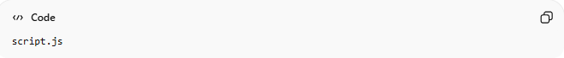
script.js
was deleted completely.
That’s why:
- No insertions
- No line-by-line deletions
- Just one file changed

🧪 How To Confirm It Was Deleted
Run this:
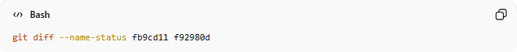
git diff --name-status fb9cd11 f92980d
You will likely see:
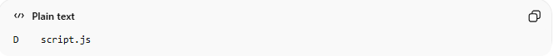
D script.js
- D = Deleted
- A = Added
- M = Modified
This is clearer than --stat when dealing with full file deletions.

